Preparing for your first year at
The Sheffield Sixth Form

Welcome
Tim Binns
Head of Sixth Form
At The Sheffield Sixth Form, we have an extensive range of A Levels to choose from. This allows you to tailor your study to a specific career path or university course, or to keep your options open for the future.

A Levels give you a unique opportunity to study three or four different subjects at the same time, as you work towards gaining UCAS points for university entry and developing your knowledge of the subject you choose.

Summer Project – What you can to do to prepare to join us in September.

We have produced a set of tasks that you can complete over the summer to help prepare you for joining us in September.

For each of your chosen A Level subjects, there is a separate set of guides and tasks for you to complete over the summer. Each task is designed to take you about 15 hours of study to finish. When you join us in September, we will expect that you complete 1 hour of study in your own time for every hour you spend studying in the classroom. These tasks will help you prepare subject knowledge but also for studying at home.

If you want to do more than 3 summer tasks, please go ahead! If you decide that you prefer another subject to the ones you’ve applied for, please let us know and we can arrange for things to be changed around.

Competition

With each A Level summer project, there is a competition with a prize of £30 Amazon voucher*.

Hand in your completed summer task in the relevant lesson during before 4pm on Friday 18th September and we will announce the winners by Monday 28th September. Entries are limited to one per person.

We wish you all the best with your preparation but if you need any help with the tasks and the competition please could you email our A Level Administrator, Cheryl Jones on Cheryl.jones@sheffcol.ac.uk

Please note*. The winner can claim their £30 Amazon Voucher only if they are enrolled as an A level student as at 11am on Tuesday 1st December 2020.

The Sheffield Sixth Form has its own Common Room exclusive for A Level students and is equipped with a small kitchen area, comfortable seating and study area.
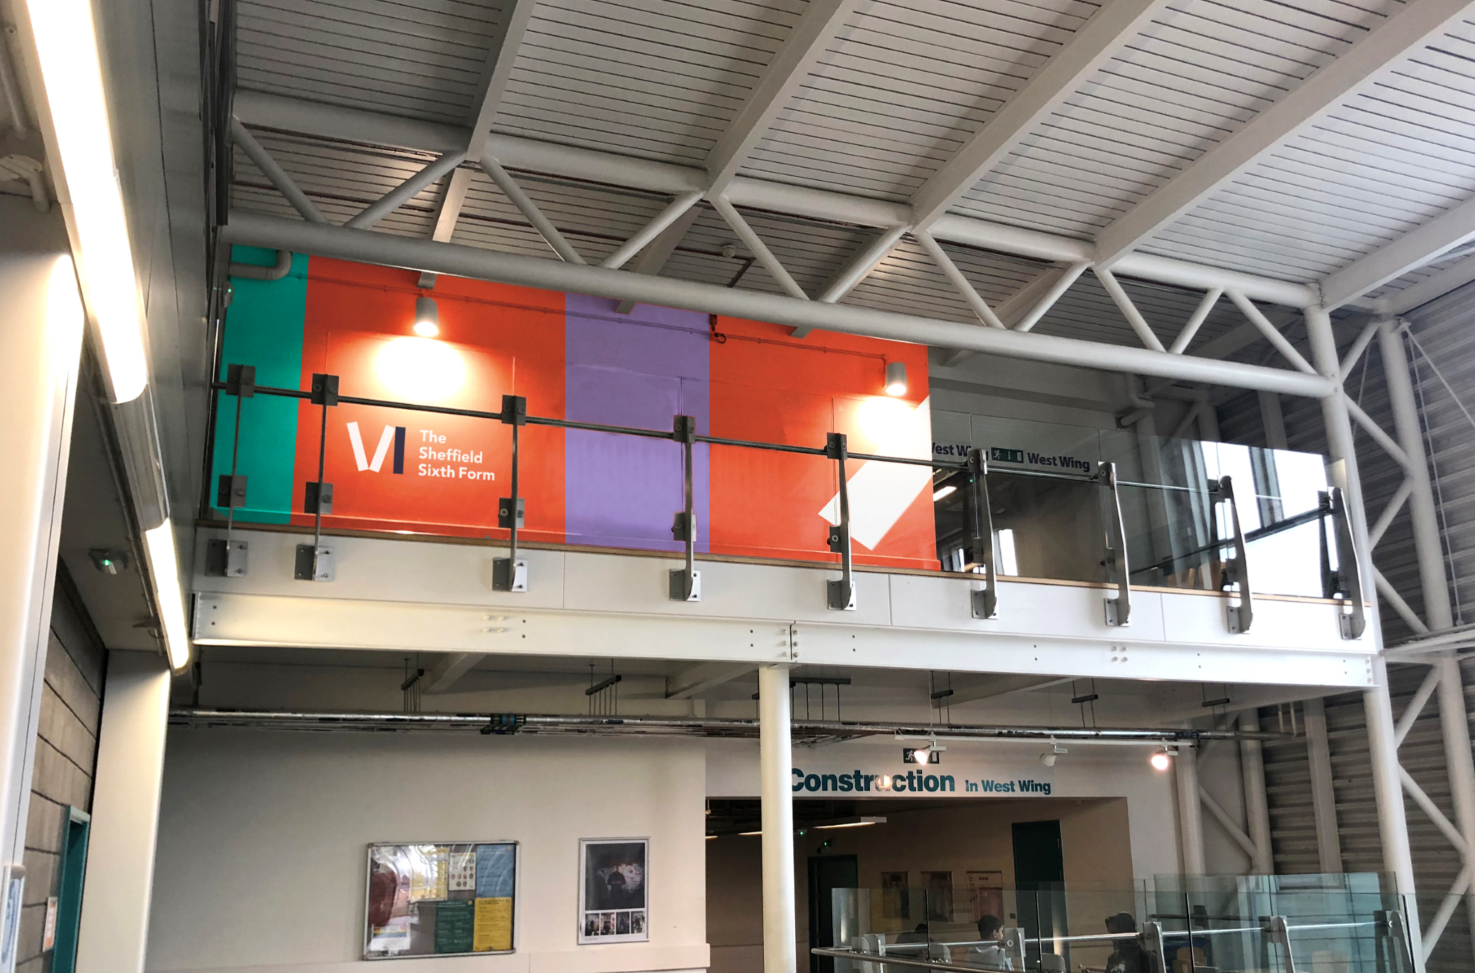
Nearly all of your lessons will be taught in the West Wing of the City Campus. This picture shows the entrance to the West Wing via the balcony and The Sheffield Sixth Form Common Room.

How is each A Level assessed?
Courses are assessed through coursework and end of year exams. Academic study skills (such as research, referencing and essay writing) are also embedded within all our A Levels as we help you develop transferable skills required for university and your career.

Our current A Level offer is listed below. The table explains how each A Level is assessed. We will practice exam techniques every 4 weeks to prepare you for exam questions and include at least 2 mock exams under exam conditions during each academic year. We will give you feedback to help you improve and gain a higher grade.

A level | How is it assessed
Fine Art | Coursework and Timed Assessment
Biology | Practical Endorsement and Exam
Business | Exam only
Chemistry | Practical Endorsement and Exam
Criminology | Course work and Exam in year 1 and year 2
Computer Science | Coursework and Exam
English Language | Coursework and Exam
English Literature | Coursework and Exam
Economics | Exam only
Film Studies | Coursework and Exam
Geography | Coursework and Exam with 4 educational mandatory visits
Law | Exam only
History | Coursework and Exam
Media Studies | Coursework and Exam
Maths | Exam only
Photography | Coursework and Timed Assessment
Physics | Practical Endorsement and Exam
Politics | Exam only
Psychology | Exam only
Sociology | Exam only

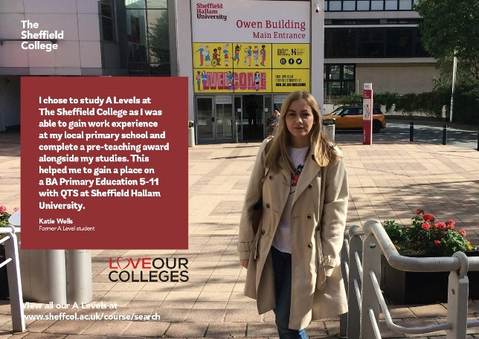

Student Support
We have a range of support available to help you study. Have a look at the following information and see if you are eligible for any of the financial support options. If you would like to check your eligibility or want to enquire further, please talk to us as soon as possible.

Free college meals
If you meet the eligibility criteria, we'll be able to support you with free meals. You'll get a set amount of money that you can use within the college shops and diners each day you're in. This will be added to your student ID card which allows you to purchase items via our contactless system.
19 + Advanced Learner Loan
If you are aged 19 or over, there could be a loan available to help fund your study. You can find full details at www.gov.uk/advanced-learner-loan

Travel Pass
Students who live in South Yorkshire are eligible for a 16-18 Travel Pass, entitling pass holders to cheaper travel on buses and trams in South Yorkshire. Pass holders are also entitled to half fare on Northern train services in South Yorkshire.
You can apply for a student pass at www.travelsouthyorkshire.com/student-passes or purchase a value pass from us at reception, including a college-specific product for all ages.

Student Support Fund
Students who are enrolled with us may receive support towards the cost of:
- travel
- books and materials
- uniform and equipment
- essential course trips
- NUS card
- DBS checks needed for your course (previously known as CRB)
- childcare
If childcare is affecting your opportunity for further study and you are aged 19 or under, you may be able to get extra help via the Care to Learn Scheme.
Go to www.gov.uk/care-to-learn for more information.
If you are aged 20+, you can apply for the 20+ Childcare Fund - contact our Financial Support Team for more details on all of the above at financial-support@sheffcol.ac.uk

