**ENGLISH LANGUAGE Summer Project**

**Welcome**

Welcome to A Level English Language. We are very much look forward to welcoming you in September and as part of your preparation we have developed this booklet.

English Language A Level – Taster Pack

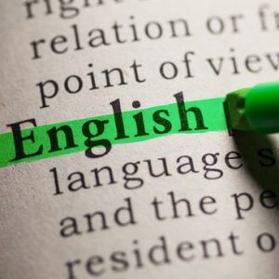

In this taster pack for the English Language A Level course you should find three items:

* A course handbook

The course handbook goes into a lot of detail regarding the content and structure of the course, the topics covered and the way it is marked. This should really answer any questions you may have.

* A transcript of Barak Obama’s first speech when he became president of the United States of America (his ‘inauguration speech’).

The transcript of Obama’s speech is an example of a ‘text’ that we may analyse in class or you might be set as homework.

* A short terminology chart – linguistics

The terminology chart gives a range of linguistics that you may find in the speech.

**TASK**

For a taste of this A Level, go through Obama’s speech and see how many of the linguistics you can find. Then ask yourself how Obama is using linguistics to create his message to the American people as their new President.

You should apply the same techniques to Boris Johnson’s speech to the nation when he announced the lockdown: <https://www.gov.uk/government/speeches/pm-address-to-the-nation-on-coronavirus-23-march-2020> or the Queen’s address to the nation, on the same subject: <https://www.royal.uk/queens-broadcast-uk-and-commonwealth>

**Chart for taster class**

**Repetition** – **Repetition**, for emphasis

**Nouns –** naming words

* Proper Nouns – a particular person place or thing.
* Common Nouns [concrete nouns= something you can see or touch, abstract nouns = something you can’t see or touch, like ‘love’ or ‘duty’, collective nouns = for a group]
* Pronouns = stand in for nouns i.e. I, me, we, him, her, etc.

**Triad or list of 3**, i.e. we came, we saw, we conquered

**Alliteration** - repetition of sounds (letters) at the beginning of words

**Figurative language** – i.e. **simile** (comparing different things using ‘like’ or ‘as’, **metaphor** (talking about one thing as if it is another), **Extended metaphor** – extending the metaphor

**Modifiers –** adjectives (describing words) and adverbs (describe doing words (verbs) and usually end in -ly)

**Anaphora** – repetition of words and phrases at the beginning of sentences

**Contrast** – comparing things, like ‘new’ with ‘old’

**Allusion** – a reference to something, like religion or history.

**Irregular grammar** – like one word sentences

**Imagery** – words that get the senses working, i.e. visual imagery – you can imagine what something looks like or tactile imagery – can imagine what something feels like.

**Barak Obama’s First Speech**

Our challenges may be new. The instruments with which we meet them may be new. But those values upon which our success depends - honesty and hard work, courage and fair play, tolerance and curiosity, loyalty and patriotism - these things are old. These things are true. They have been the quiet force of progress throughout our history. What is demanded then is a return to these truths.

What is required of us now is a new era of responsibility - a recognition, on the part of every American, that we have duties to ourselves, our nation, and the world, duties that we do not grudgingly accept but rather seize gladly, firm in the knowledge that there is nothing so satisfying to the spirit, so defining of our character, than giving our all to a difficult task.

This is the price and the promise of citizenship. This is the source of our confidence - the knowledge that God calls on us to shape an uncertain destiny.

This is the meaning of our liberty and our creed - why men and women and children of every race and every faith can join in celebration across this magnificent mall, and why a man whose father less than 60 years ago might not have been served at a local restaurant can now stand before you to take a most sacred oath.

So let us mark this day with remembrance, of who we are and how far we have travelled. In the year of America's birth, in the coldest of months, a small band of patriots huddled by dying campfires on the shores of an icy river. The capital was abandoned. The enemy was advancing. The snow was stained with blood. At a moment when the outcome of our revolution was most in doubt, the father of our nation ordered these words be read to the people:

"Let it be told to the future world... that in the depth of winter, when nothing but hope and virtue could survive... that the city and the country, alarmed at one common danger, came forth to meet [it]."

America. In the face of our common dangers, in this winter of our hardship, let us remember these timeless words. With hope and virtue, let us brave once more the icy currents, and endure what storms may come. Let it be said by our children's children that when we were tested we refused to let this journey end, that we did not turn back nor did we falter; and with eyes fixed on the horizon and God's grace upon us, we carried forth that great gift of freedom and delivered it safely to future generations.

Thank you. God bless you. And God bless the United States of America.

**ENGLISH LANGUAGE**

**A LEVEL**

**COURSE HANDBOOK**

[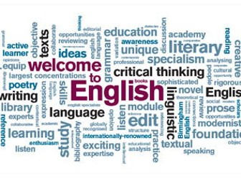](https://www.google.co.uk/url?sa=i&rct=j&q=&esrc=s&source=images&cd=&ved=2ahUKEwiV7JKpoKPcAhXDyIUKHf-gBR0QjRx6BAgBEAU&url=https://www.tes.com/teaching-resource/a-level-english-language-key-terms-11443864&psig=AOvVaw0wu3szneKU8xZD2tMzVfSt&ust=1531817842358206)

**Useful general information about your English Language A Level course**

**WHAT IS ENGLISH LANGUAGE A LEVEL?**

**[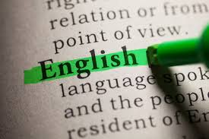](https://www.google.co.uk/url?sa=i&rct=j&q=&esrc=s&source=images&cd=&cad=rja&uact=8&ved=2ahUKEwjA9NmZoaPcAhUrz4UKHWYfCEQQjRx6BAgBEAU&url=https://www.pembrokeshire.ac.uk/courses/igcse-english-language-liveschool/&psig=AOvVaw38yLmO5xTvsvmc_OGkyrRm&ust=1531818078049530)**

The study of the English Language A Level allows you to refine and develop your powers of reading and writing.

This course is both **analytical** and **theoretical**. You will learn hoe English works – technically – how it is used; how it has developed and a wide range of diverse forms of this, our shared language.

The course will greatly help you build up confidence in your powers of analysis and communication – essential for employability and University study.

You will analyze the use of language in a variety of texts, including advertisements, newspaper/magazine articles, speeches, speech transcripts, websites, blogs and message boards.

The course is also creative and you are encouraged to write in different styles to meet the needs of a particular audience and then reflect on the techniques used. There is the opportunity to explore your own interests for the coursework options in inventive and original ways. Past submissions have included radio scripts, film reviews, biographies, newspaper features, short stories, and magazine articles.

You also study theories about language itself - including child language development, language change, language and gender, social class and age, slang, occupational jargon, regional dialects and attitudes towards language use.

**EMPLOYABILITY**

A Level English Language enables you to develop your analytical skills as well as the quality of your written expression, tailoring it to style appropriate to a particular audience - a skill invaluable to careers such as journalism, teaching, law, management, advertising and PR work, etc, etc.

A Level English Language is a subject respected by university admission tutors – it Is properly rigorous and academic – it works well in combination with other subjects and contains invaluable transferable skills. Employers and universities are mainly interested in is your ability to learn new skills and work independently. You can demonstrate all this by completing your A level (remember the A stands for ‘advanced’) in English Language.

**A LEVEL LANGUAGE GUIDELINES: TEXTUAL ANALYSIS**

**Definitions:**

**Analysis:** noun

1. The separating of any material or abstract entity into its constituent elements.

2. This process as a method of studying the nature of something or of determining its essential features and their relations: the grammatical analysis of a sentence.

3. Presentation, usually in writing, of the results of this process.

**Linguistics**: noun

1. The science of language.
2. The constituent parts of language.

**Text**: noun

* The actual wording of anything written or printed.

**1. GASP**

GASP stands for Genre, Audience, Subject and Purpose. The whole point of identifying the GASP of a text is to be clear what type of text you are analysing – once you’ve identified this you can link linguistics to points you’ve made in GASP. A persuasive newspaper article may well try using inclusive personal pronouns (we, us, our) and rhetorical questions to ‘position the audience’ to agree with the writer’s expressed views.

**2. REPRESENTATION**

What is the text about and is the representation positive or negative? For instance does a newspaper article about the homeless (and is therefore a representation of the homeless) present us with a representation that is positive or negative – does it use a term with neutral connotations, like ‘homeless’ or critical terms like ‘beggars’, ‘tramps’ or ‘dossers’. A key concept here is ‘stereotypes’.

**3. LINGUISTICS**

So linguistics are ‘parts of speech’. You have to identify linguistics and say what they do*, in the case of the particular text you are analysing*. For a mid-range mark, you should identify word classes (nouns, adjectives, etc) and sentence functions (like declarative). For a higher mark, you should identify precise word classes (abstract noun, comparative adjective) and sentence type (simple, compound and complex). There is a glossary at the back of this handout – what your examiner is looking for in your essays is a broad range of linguistics under discussion.

**4. REGISTER**

The linguistics you are able to identify depends largely on the text being analysed: there are a couple of linguistics that can apply to any whole text. For instance – register: is it formal, informal or does the register change over the course of the text.

**5. TONE**

The tone is the emotion expressed, or the emotional ‘feel’ of a text – like register it is not necessarily consistent throughout the text

**Writing Discursive Essays –** these are essays where you demonstrate you detailed knowledge on the research, theories, concepts and/or ideas on the topic under discussion, i.e. Child Language Development. Ideally you should evaluate the theories – how convincing are they?

You will be given suggestions on how to structure essays for the various topics we cover over the 2 years of the course – It’s not going to be helpful to try and detail all of that here. However, here is a few general suggestion:

* Look for keywords in the question and take a stance, i.e. you agree, disagree or partially agree that Behaviourism provides a convincing explanation of how children develop the ability to use language.
* Aim for an argument/ counter argument structure to your essays, so you can demonstrate you know both sides of any language debate – then conclude by saying which side of the argument carries more weight

**A Level English Language Assessment Objectives (known as A0s)**



**AO1**: Apply appropriate methods of language analysis, using associated terminology and coherent written expression.

In other words, you are marked on your ability to identify linguistics, and the quality of your written expression.

**A02**: Demonstrate critical understanding of concepts and issues relevant to language use.

So, you are marked on the detailed knowledge you can demonstrate on theories, research and concepts = ideally, your ability to evaluate these concepts, etc – are they convincing?

**A03**: Analyse and evaluate how contextual features are associated with the construction of meaning

You are marked on your commentary of what linguistics are being used for in the particular text you are analysing.

**A04**: Explore connections across texts, informed by linguistic concepts and methods

Also known as comparative analysis

**AO5**: Demonstrate expertise and creativity in the use of English to communicate in different ways

There is some scope for creative writing.

* Note: different combinations of AOs apply to different exam questions and the coursework *

### AQA, the awarding body sets out the components of the course. However, this doesn’t make that much sense if you’ve only just started the course, so there is a more user friendly break down of what you have to do:

**Paper 1**. For the first question, you are given 2 short texts. You have to analyse the use of linguistics in both of them and then compare and contrast them. This question is on both the AS and the A level paper. We spend a lot of time practicing the skill of linguistic analysis.

**The second question on Paper 1** is Child Language Development. We don’t start that until second year as this isn’t on the AS paper. You’re given a choice of either a young child’s written, or spoken language and you have to discuss theories of child language development in relation to the extracts.

**Paper 2**. Question 1 is on either on ‘diversity’ or ‘change’. Diversity is an umbrella terms for the different forms of english someone might use because of their local accent, social class, gender or occupation, etc. We do this in first year. ‘Change’ refers to the ways in which English has developed over time and continues to develop. We cover the change topic in second year as it isn’t on the AS exam.

**Question 2 has the ‘Language Discourses’ question** where you are given 2 extracts – both of which are discussions of language use – you have to analyse and compare in a similar way to the first question on paper 1. You also have **a creative piece of writing** to do (probably an opinion piece) on a connected topic to the one featured in the discourse extracts.

Sound complicated? – it is – you’ll get the hang of it over the 2 years.

**Try to take on board these key points:**

The work we have to do really breaks down into 3 key areas:

Skills – You have to practice you skills of analysis – this will largely be done in the class, with a very wide variety of ‘texts’. In terms of difficulty, I’d say this is at a moderate level.

Knowledge – You have to learn about a wide range of linguistics, theories, concepts and research – none of them is complicated in itself, but there is a lot to learn. Easy to moderate. We’ll do some of this in class and some of this we can set you up to do in study skills classes or outside of college time.

Exam technique – Not only exam essay writing, but exam essay writing to particular formulas – to meet the needs of the different exam questions. Moderate to hard – you’ll get plenty of help. Some of this we may direct you to do in your own time; however, in order to be as supportive as we can, we’ll often do this in class time.

*A couple of general points to finish off on*

* A level is the most long-term project you’ve taken on so far, so it is important to see it in that light. It’s important to stay on top of your work, pushing yourself at a steady, but not brutal pace – then just pull out all the stops on the final run down to the exams.
* ‘Quality not quantity’ – in order to address an anxiety that you need to be working in order to do well, students can fall into the rap of spending large amounts of time on work that isn’t really productive – taking notes of notes of stuff you already know, over reliance on spider diagrams, etc. Half an hour of focussed work really is much more productive than several hours of general low level slog.
* Ask your teachers for advice on how your time can best be spent. We have an individual sense of where you should be heading – your target grades. You should have a clear idea of your strengths with the subject, and which areas you should be developing – again, just ask us if you’re not sure.
* You do have to work very hard to do well at A level – *but you don’t have to work very hard all the time.*

### Assessment of the full A Level English Exam & Coursework

**+**

|  |
| --- |
| **Paper 1: Language, the individual and society** |
| **What's assessed**   * Textual variations and representations * Children's language development (0 – 11 years) * Methods of language analysis are integrated into the activities |
| **Assessed**   * written exam: 2 hours 30 minutes * 100 marks * 40% of A-level |
| **Questions**  **Section A – Textual variations and representations**  Two texts (one contemporary and one older text) linked by topic or theme.   * A question requiring analysis of one text (25 marks) * A question requiring analysis of a second text (25 marks) * A question requiring comparison of the two texts (20 marks)   **Section B – Children's language development**  A discursive essay on children’s language development, with a choice of two questions where the data provided will focus on spoken, written or multimodal language (30 marks) |

|  |
| --- |
| **Paper 2: Language diversity and change** |
| **What's assessed**   * Language diversity and change * Language discourses * Writing skills * Methods of language analysis are integrated into the activities |
| **Assessed**   * written exam: 2 hours 30 minutes * 100 marks * 40% of A-level |
| **Questions**  **Section A – Diversity and change**  One question from a choice of two:  **either:** an evaluative essay on language diversity  (30 marks)  **or:** an evaluative essay on language change (30 marks)  **Section B – Language discourses**  Two texts about a topic linked to the study of diversity and change.   * A question requiring analysis of how the texts use language to present ideas, attitudes and opinions (40 marks) * A directed writing task linked to the same topic and the ideas in the texts (30 marks) |

|  |
| --- |
| **Non-exam assessment: Language in action** |
| **What's assessed**   * Language investigation * Original writing * Methods of language analysis are integrated into the activities |
| **Assessed**   * word count: 3,500 * 100 marks * 20% of A-level * assessed by teachers * moderated by AQA |
| **Tasks**  Students produce:   * a language investigation (2,000 words excluding data) * a piece of original writing and commentary   (1,500 words total) |

**Terminology Framework Chart (the exam board refers to categories of linguistics as ‘levels’**



**Contextual Terminology (these are the terms you may refer to in an introduction to an essay – see GASP on p.3.)**

* **Audience Positioning** – How the writer/author/speaker seems to be imagining the audience
* **Context** – the set of conditions around a text’s production (audience, purpose/genre/mode)
* **Genre** – The category or type of a text
* **Subject position** – The perspective from which events or issues are perceived and recounted
* **Tenor** – the general drift of a text or speech, i.e. professional, informal, intimate, etc

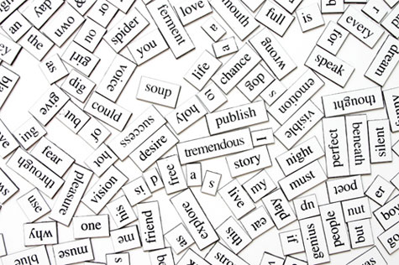

**Grammatical and morphological framework (these can also be classed as part of the Lexis/Semantics and Grammar Levels.**

* **Nouns –** naming words (Proper – a particular person place or thing, Common [concrete = tangible, abstract = intangible, collective = for a group, pronouns = stand in for nouns i.e. I, me, we, him, her, etc)
* **Modifiers –** adjectives (modify nouns) and adverbs (modify verbs)
* **Aspect –** relates to the duration of events
* **Words –** Functional/grammatical words= doesn’t carry meaning but connect lexical words, i.e. a, the, and, at, etc. Lexical words – carries meaning = nouns, verbs, adjectives and adverbs
* **Tense –** past, present or future



**Lexical-semantic framework/level**

**Cliché** - an overused expression

**Cohesion** – how a text fits together as a whole, can be achieved by repeating keywords and/or a consistent register

**Collocation**  - a set of words that are strongly associated, i.e. law and order, a vast majority

**Connotation** – the associations something has

**Euphemism**  - a word or phrase that tries to avoid saying something unpleasant, i.e. having a pet ‘put down’

**Figurative language** – non-literal language, i.e. **simile** (comparing different things using ‘like’ or ‘as’, **metaphor** (talking about one thing as if it is another), **personification** (applying personal qualities to a thing) and **Idiom** – everyday metaphors, i.e. it’s raining cat and dogs

**Register** – formal (grammatically correct, no colloquial or taboo language) or informal

**Lexis** - vocabulary

**Taboo language** – swearing, crude sexual references and non PC

**Semantic/lexical field** – a group of words with associated meaning, i.e. graveyard, funeral, coffin, hearse – all have a semantic field of death or funerals

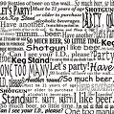

**Syntactical framework/level (a sub-section of grammar – the most challenging to get to grips with, but can get you high marks).**

* **Sentence function**  - **declarative** makes a statement, **interrogative** asks a question, **imperative** gives instruction, **exclamatory** expresses with emphasis and exclamation mark
* **Clause** – a group of words containing subject and verb. **Single or Independent clause**: forms a complete sentence, **Main clause**: single clause with subordinate clauses added, **Subordinate clause**: clause connected by subordinating conjunction. A sub-clause cannot stand alone. **Co-ordinate clause** – clauses of equal importance joined by *and, or, but*
* **Sentence types** - **Simple**: contains one clause with a subject and main verb. **Compound**: contains 2 or more clauses of equal importance joined bt co-ordinating conjunctions – usually *and, or, but*. **Complex**: A main clause followed by one or more subordinating clauses connected by a subordinating conjunction such as when, although, because, or a relative pronoun such as *who, which*
* **Phrase** – a group of words functioning as a single unit. **Noun phrase** *The loud thumping music* **verb phrase** *was getting* **noun phrase** *on my nerves* **adverbial phrase** *with increasing frequency*
* **Syntax** – The linguistic framework dealing with word order and sentence structure. Grammar is a word-level framework, while syntax deals with larger units

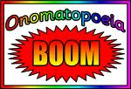

**Phonological framework or level**

* **Alliteration** - repetition of sounds at the beginning of words
* **Prosodic elements** – stress, pitch, volume, tone, pace
* **Onomatopoeia** – a words that creates the sound it’s describing
* **Emphatic stress** – emphasising a word or phrase, i.e. by using bold type



**Graphological framework or level**

* **Colour**
* **Font**
* **Images**
* **Layout**
* **Irregular spelling – deviant (Kwik Fit, Phones for you)/phonetic(Night as Nite)**



**Pragmatics Level** – the gap between what words literally mean and what they actually mean. Pragmatics: **inferred** and **implied** meaning. For instance the answer to any of the following question could be “11 o’clock”, but what is the in,tended/inferred meaning?

*Mum*, “And exactly what time do you call this, then, young lady?”

*Stranger*, “Excuse me, but would you, by any chance, have the time?”

*Teacher*, “Decided to join us, have you, Rob? Would you happen to have the time on you?

[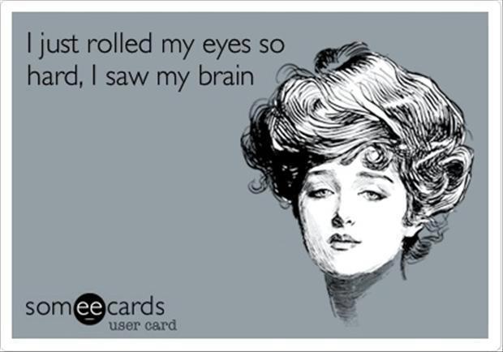](http://www.google.com/url?sa=i&rct=j&q=&esrc=s&frm=1&source=images&cd=&cad=rja&uact=8&ved=0CAcQjRw&url=http://quotespictures.com/quotes/sarcasm-quotes/page/17/&ei=vkNsVcyuIYTlUoXHg4AB&psig=AFQjCNGF1gul_OHExnGo0KlW0bpBmyMWDA&ust=1433244671096266)

So, factors that influence the use of pragmatic rather than literal speech are very varied and these include:

* The intonation of the speaker
* The context in which the interaction takes place
* Politeness
* Humour, including sarcasm
* The use of idioms (metaphors in everyday speech, i.e. “it’s raining cats and dogs”)

**Interaction framework (part of the Discourse Level).**

**Discourse marker** – indicates a change in topic/return to a previous topic

**Reformulation** – rephrasing what someone has just said

**Fillers** – a word, sound or phrase used to fill a gap, i.e. er, like, you know

**Hedges** – a word of phrase used to pad out or soften what’s being said, i.e. sort of, perhaps

**Questions** – open/closed/declarative used as interrogatives/ta

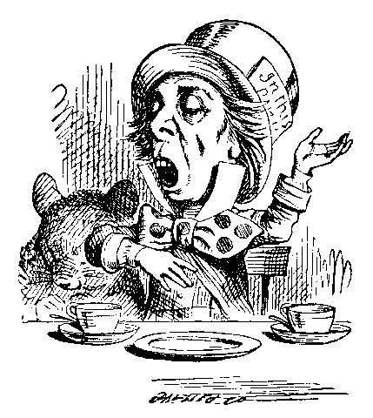

**Rhetorical framework - Discourse**

* **Contrast/antithesis** – contrast or opposition between two things
* **Repetition** – **Repetition**, for emphasis
* **Syntactic parallelism** – repetition of sentence structure
* **Triad**  - list of 3, i.e. we came, we saw, we conquered



**Speech framework - Discourse**

* **Dialect** – the language variety of a geographical region or social subgroup
* **Ellipsis** – the missing out of a word or words in a sentence, represented as ‘…’
* **Non-verbal filler** – a filler that isn’t a word, i.e. ummm
* **Received Pronunciation (RP)** – correct (posh) English, aka the Queen’s English



**Language Levels**

These levels are essentially linguistic frameworks which you will apply to texts. They give you a systematic approach to detailed textual analysis.

**Level 1 = Lexis and semantics**

**Level 2 = Grammar**

**Level 3 = Phonetics, phonology and prosodics**

**Level 4 = Graphology**

**Level 5 = Pragmatics**

**Level 6 = Discourse**

You will apply these language levels when you analyse texts.

You also need to remember the key idea of REPRESENTATION. Always consider **who** or **what** is being represented.

The language levels are used to explain **how** the writer creates this representation.

[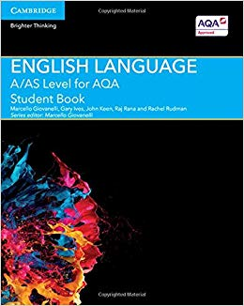](https://www.google.co.uk/url?sa=i&rct=j&q=&esrc=s&source=images&cd=&cad=rja&uact=8&ved=2ahUKEwimjZKg4P3cAhUDRBoKHeuXBjwQjRx6BAgBEAU&url=https://www.amazon.co.uk/Level-English-Language-Student-Book/dp/1107465621&psig=AOvVaw0WFnh6HrojLfk8oqkFdxu1&ust=1534927381596276) [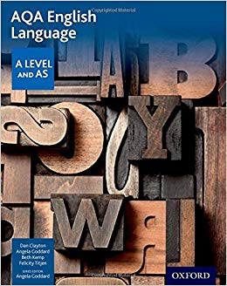](https://www.google.co.uk/url?sa=i&rct=j&q=&esrc=s&source=images&cd=&ved=2ahUKEwia9-i34P3cAhUKxxoKHVohAAUQjRx6BAgBEAU&url=https://www.amazon.co.uk/AQA-Level-English-Language-Student/dp/0198334001&psig=AOvVaw0WFnh6HrojLfk8oqkFdxu1&ust=1534927381596276)

[](https://www.google.co.uk/url?sa=i&rct=j&q=&esrc=s&source=images&cd=&cad=rja&uact=8&ved=2ahUKEwjOjPPw4P3cAhUlxYUKHZJ6BVIQjRx6BAgBEAU&url=http://taylorlmarshall.blogspot.com/2015/04/language-diversity.html&psig=AOvVaw2FhpjgQsThvXx1DWtu5r0e&ust=1534927533104572)

**Language Diversity**

You will explore how geographical and social factors influence our language use. Topics covered include:

**\*Geographical varieties -** exploration of various regional **accents and dialects**, looking at case studies, concepts and theories, discussing and evaluating attitudes towards regional variety, exploring stereotypes and representation

**\*Personal and social varieties:**

**\*Language and Gender –** exploring gender representation (language and media images), gender research on speech – deficit, dominance, difference, performativity, power/powerless language

**\*Language and Occupation –** exploring the language of the workplace, occupational register, power

**\*Language and Age/Teen sociolect –** exploring new research around increased focus on age in linguistic studies, comparing language use across generations, teen sociolect, impact of technology

**\*Language and Sexuality –** exploring how sexuality can influence language use, historical overview (criminalisation), Polari, Anti-language, the pronoun debate

**Language Change**

Language is in a constant state of change. Language changes because the way in which we use it, and our experience of the world, is constantly evolving and the language we use needs to keep up with these developments. Topics covered include:

\***Diachronic change** – how language has changed over time (historical development).

\***Synchronic change** – how language has changed at a particular moment in time.

\***Lexical and semantic change** – how words and their meanings have developed and changed.

\***Orthography, spelling and punctuation** – changes, developments, reform.

**\*Grammatical change** – how grammar has changed over time, including word classes, syntax, non-standard-usage, diversity and creativity.

**\*Standardisation –** attempts to standardise the language throughout history.

**\*Attitudes towards language change** – prescriptivism vs descriptivism, progress or decay, language reform, political correctness.

**\*Why and how does change happen** – social change, technology, education, travel, fashion.

**\*How does change spread** – various theories try to explain – Random fluctuation, S-curve, Borrowing, Functional – Language contact, World Englishes, English as a lingua franca.

[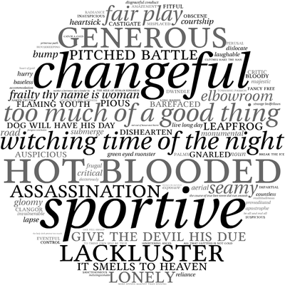](https://www.google.co.uk/url?sa=i&rct=j&q=&esrc=s&source=images&cd=&cad=rja&uact=8&ved=2ahUKEwiqnoP54f3cAhWh4IUKHehMDpcQjRx6BAgBEAU&url=https://www.memrise.com/course/299534/english-language-a2-language-change/&psig=AOvVaw2oYgOXC1g3K1FTkqUlBpCz&ust=1534927795411410)

**Child language development**

You will explore early talk and literacy, including theories and research on language acquisition.

Topics will include:

**Early speech:**

**\*Stages of acquisition** – pre-verbal, holophrastic, two word, telegraphic, post-telegraphic.

**\*Theories and research** – exploring how different studies have tried to explain language acquisition, often in terms of nature or nurture – behaviourism, nativism, cognitive development, social interactionism, child directed speech, caregiver input.

**\*Development -** politeness, turn-taking, influence of peers, discourse structure, lexis and semantics, language functions, grammar (pronoun acquisition).

**Learning to read and write:**

**\*Early reading** – types of books/experiences, look and say, phonics, the literacy debate (approaches in schools).

**\*Early writing** – motor skills, cognitive awareness, emergent writing, theory of stages – preparatory, consolidation, differentiation, integration.

**\*Theories and attitudes on learning to write** – creative vs rule-based approach, genre, expressive, poetic, transactional.

**\*Development** – social and geographical influences, teacher input, handwriting and orthography, spelling, lexical and grammatical development.

[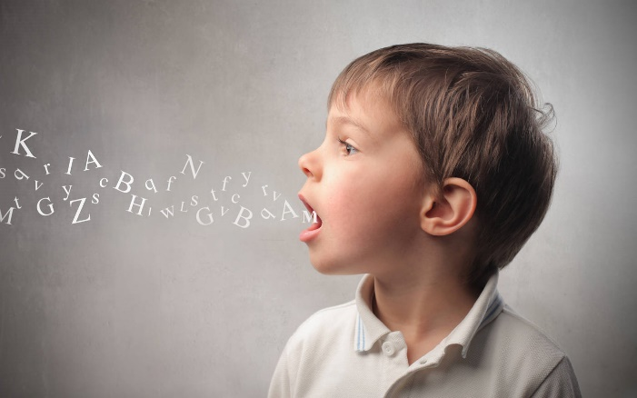](https://www.google.co.uk/url?sa=i&rct=j&q=&esrc=s&source=images&cd=&ved=2ahUKEwipi8vy4v3cAhUhzYUKHSTPAAAQjRx6BAgBEAU&url=http://blog.nurturey.com/helping-your-child-with-language-development/&psig=AOvVaw27fZ1-gF3xv3eo9mL7aSie&ust=1534928082911799)

|  |
| --- |
| **NOTES** |