ENGLISH LITERATURE Summer Project

Welcome
Welcome to the A Level English Literature Studies summer project. We very much look forward to welcoming you in September. As part of your preparation we have developed this booklet.

Y11 Transition Research Competition: English Literature
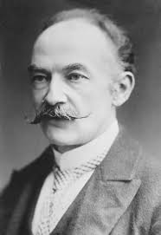

In the study of English Literature, we pay close attention to the ways in which context informs our understanding of literary works. Therefore, it is important that you have some background knowledge about the writers we will study and how societal values influenced their writing.

To prepare you for September, the English team have come up with a competition that will involve finding out more about one of the key writers on this course: Thomas Hardy. One of the first texts you will study in A Level English Literature is Hardy’s novel Tess of the D’Urbervilles, so this is a great opportunity to develop your research skills and give yourself a head start ready for the new academic year!

The task:

Create a research poster about Thomas Hardy. The best posters will include:

- Biographical information about the author
- The author’s place within literary traditions (i.e. the Victorian novel)
- The reception of Hardy’s writing (i.e. were his novels reviewed positively?)
- Social and historical context about the time period (e.g. does Hardy address any of the significant events/issues of the period in his writing?)

Extra credit will be given to the most detailed and creative posters.

These are the reading list for A level English Literature.

Literature set texts – Year 1
Paper 1 – Love Through the Ages
Tess of the d’Urbervilles – Thomas Hardy
Othello – Shakespeare
AQA Anthology of Love Poetry (provided)

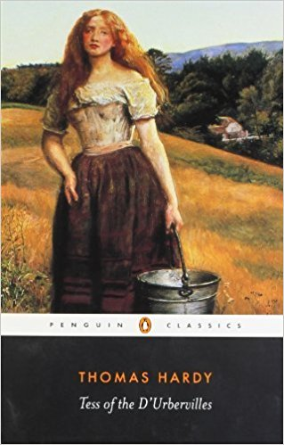 https://www.amazon.co.uk/d/Books/Tess-DUrbervilles-Penguin-Classics-Paperback/B00IIAZZTU/ref=sr_1_10?s=books&ie=UTF8&qid=1497885719&sr=1-10&keywords=tess+of+the+durbervilles
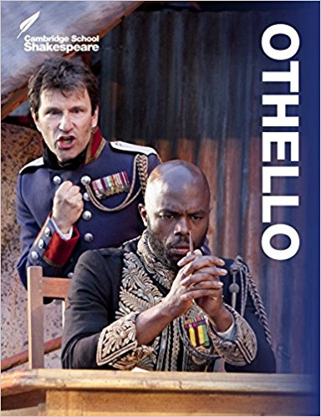 https://www.amazon.co.uk/Othello-Cambridge-School-Shakespeare-William/dp/1107615593/ref=sr_1_5?s=books&ie=UTF8&qid=1497885873&sr=1-5&keywords=othello

Literature set texts – Year 2
Paper 2 – WW1 and its Aftermath
Birdsong – Sebastian Faulks
My Boy Jack – David Haig
Wilfred Owen Poetry – selected by Jon Stallworthy
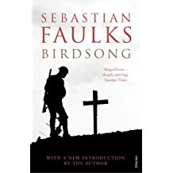 https://www.amazon.co.uk/Birdsong-Vintage-War-Sebastian-Publisher/dp/B00SLUI9G8/ref=sr_1_13?s=books&ie=UTF8&qid=1497885483&sr=1-13&keywords=birdsong+sebastian+faulks
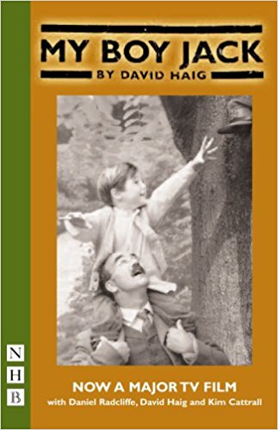 https://www.amazon.co.uk/d/cka/Boy-Jack-NHB-Modern-Plays-David-Haig/1854595830/ref=pd_bxgy_14_img_2?_encoding=UTF8&psc=1&refRID=QQVBRZV97RW5K58HDG40
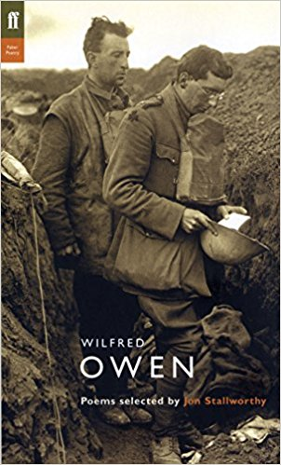 https://www.amazon.co.uk/Wilfred-Owen-Poems-Selected-Stallworthy/dp/0571207251/ref=sr_1_fkmr1_1?s=books&ie=UTF8&qid=1497885637&sr=1-1-fkmr1&keywords=wilfred+owen+ed+stallworthy

A LEVEL
ENGLISH
LITERATURE
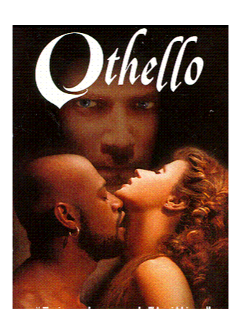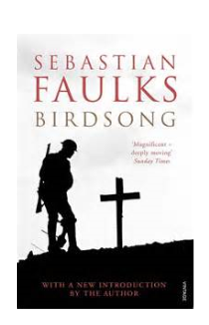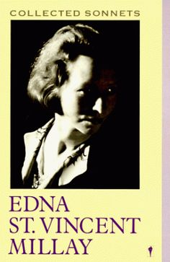

COURSE HANDBOOK FOR STUDENTS

Name ________________________________

Gail Holmes 2020

WELCOME TO A LEVEL ENGLISH LITERATURE

This is a varied, demanding, useful and enjoyable course. This booklet is designed to provide you with important information and guidance. Keep it in your file and use it regularly.

CONTENTS

1. COURSE OUTLINE

2. ASSESSMENT OBJECTIVES

3. BASIC POINTS: GET ORGANISED

4. IMPORTANT POINTS

5. READING AND RESEARCH SKILLS

6. READING LITERATURE TEXTS

7. MAKING NOTES ON LITERATURE TEXTS

8. WRITING AN ESSAY

9. PLAGIARISM

10. ASSESSMENT AND FEEDBACK

11. TRACKING PROGRESS AND TARGET-SETTING

12. GLOSSARY OF USEFUL TERMS

COURSE OUTLINE

The course is AQA A Level English Literature (Specification A).

AS – 2 exams , no coursework  Paper 1: Love Through The Ages: Shakespeare and Poetry  Closed book, 2 tasks.  - A: one passage based question on set Shakespeare play.  - B: one question on a previously studied poem.  Paper 2: Love Through The Ages: Prose  Open book, 2 tasks. Students study two prose texts and exam contains one unseen prose extract. Choice of texts. 2 sections:  - A: one compulsory question on unseen extract.  - B: choice of two comparative question on two prose texts.  NOTE Most students do the full 2 year course  And sit the full A Level exam in Year 2. | A Level – 2 exams and coursework  Paper 1: Love Through The Ages:  Shakespeare, Prose and Poetry  Closed Book (A) Open book (C), 3 tasks.  - A: Closed book section - one passage based question on Shakespeare play.  - B: Compulsory essay question on two unseen poems.  - C: Open book section - one essay question from two options linking poetry and prose.  Texts studied this year: Othello, Tess of the d’Urbervilles and AQA Poetry Anthology.  Paper 2: Texts in Shared Contexts:  Open book, 3 tasks.  - A: one essay question on set prose text.  - B: one compulsory question on unseen prose extract AND one essay question linking the play and poetry.  Texts studied this year for Option 2A World War 1 and its Aftermath:  Birdsong (prose), Wilfred Owen’s Poetry and My Boy Jack (play).  NEA (coursework) – Comparative essay on two texts (one pre-1900)

THE EXAM
Paper 1 Love Through the Ages
3 hours
Section A: Shakespeare (Closed book – no plays allowed in exam)
Othello – a passage-based question. An extract from the play will be provided.
Section B: Unseen Poetry
A comparative question on the two unseen poems provided.
Section C: Comparing Texts (Open book – clean copies of the novel and poetry allowed)
A choice of questions (choose one). You will write about Tess (pre-1900 text) and the AQA poetry anthology.
Each question is worth 25 marks.

Paper 2 Texts in shared contexts – Option 2A WW1 and its aftermath
2 hours 30 minutes Open Book (clean copies of all texts allowed)
Section A: Option 3 Prose set text
Birdsong – a choice of questions (choose one).
Section B: Drama and poetry contextual linking
Answer both questions:
*A question about an unseen extract.
*A comparative question on Drama and poetry. You will write about My Boy Jack (post-2000) and Owen’s poetry.
Each question is worth 25 marks
Note
The exam is worth 80% of your final A Level (40% each paper). The NEA (coursework) comparative essay is worth 20%.

Layout of papers
It is important to familiarise yourself with the layout of the exam papers. Both papers will include the following on the front page. It is worth remembering the key points listed as these are connected to the AO’s which are assessed:

Information
• The marks for questions are shown in brackets.
• The maximum mark for this paper is 75.
• You will be marked on your ability to:
– use good English
– organise information clearly
– use specialist vocabulary where appropriate.
• In your response you need to:
– analyse carefully the writers’ methods
– explore the contexts of the texts you are writing about
– explore connections across the texts you have studied
– explore different interpretations of your texts.

Types of question
The following are specimen questions provided by AQA in their exemplar materials. Make sure you are clear about the type of questions you will be asked for each section.
Paper 1 Love through the ages
Section A: Shakespeare
Note there are questions provided on a few Shakespeare plays so you need to find the question on your set text, Othello:
‘Typically, texts about husbands and wives present marriage from a male point of view.’
In the light of this view, discuss how Shakespeare presents the relationship between
Othello and Desdemona in this extract and elsewhere in the play.
Extract provided – spend a bit of time annotating this. Make sure you refer to the extract and the rest of the play in your answer.

Section B: Unseen poetry

It has been said that Rossetti’s poem is conventional and celebratory, whereas Millay’s poem offers a very different view of love.
Compare and contrast the presentation of love in the following poems in the light of this comment.
Spend time reading and annotating, particularly for ways you can compare and contrast.
Section C Comparing texts (Tess and Poetry Anthology)
Either
Compare how the authors of two texts you have studied present ideas about passion.
Or
Compare how the authors of two texts you have studied present barriers to love.

Paper 2 WW1 and its aftermath (Option 2A)

Section A: Option 3 Prose set text (Birdsong)
Examine the view that Faulks’ use of the material about Elizabeth Benson, set in 1978 and 1979, adds little to the novel.
Or
‘Faulks uses birdsong to suggest a range of possible ideas within the novel.’
Examine the significance of the title of the novel in the light of this comment
Section B: Drama and poetry contextual linking (Unseen extract, My Boy Jack, Owen’s poetry)
Explore the significance of suffering in this extract. Remember to include in your answer relevant detailed analysis of the ways that Malouf shapes meanings.

And

‘Suffering in war comes in many different forms.’
Compare the significance of suffering in two other texts you have studied. Remember to include in your answer reference to how meanings are shaped in the texts you are comparing.
You must use the drama text written post-2000 (My Boy Jack) and one poetry text in your response.

Remember

*Bring the relevant texts to each exam:
Paper 1 Tess (a clean poetry anthology will be provided.)
Do not bring Othello – extract provided for this closed book section.
Paper 2 Birdsong, My Boy Jack, Owen’s poetry.
Make sure they are CLEAN copies – no notes in them.

*Focus on time management:
All questions are worth equal marks so try to give them roughly equal time.
Paper 1 is 3 hours so you have one hour for each task. (There is more reading on this paper, hence the longer time)
Paper 2 is 2 hours 30 minutes so you have 50 minutes for each task.
Where there are texts provided to read (unseen and Othello extract), make sure you spend time annotating with the question in mind.
Good planning is essential. Don’t launch straight into answering without having given thought to the structure of your answer.

NEA – Non-Exam Assessment (Coursework)

Independent critical study: texts across time
The NEA (non-exam assessment) is an essay comparing two texts:
*Word count = 2,500
*The essay should allow you to write about comparative similarities and differences
*It should include a bibliography
*One text must be pre-1900 (both can be if you wish)
*Two different authors must be studied
*Equal attention must be paid to both texts
*Shorter poems are not suitable, but longer narrative poems can be used
*Texts in translation regarded as significant and influential may be used
*Texts listed in the A-level core set text and comparative set text lists studied for the exam cannot be used for the NEA

You will begin preparing for this in the summer term of year 1. Texts and essay titles will be negotiated with English staff.

ASSESSMENT OBJECTIVES

AOs below are common to AS and A Level

* AO1: Articulate informed, personal and creative responses to literary texts, using associated concepts and terminology, and coherent, accurate written expression.

* AO2: Analyse ways in which meanings are shaped in literary texts.

* AO3: Demonstrate understanding of the significance and influence of the contexts in which literary texts are written and received.

* AO4: Explore connections across literary texts.

* AO5: Explore literary texts informed by different interpretations.

A top band answer will demonstrate:

AO1 – perceptive and sophisticated argument, assured use of literary concepts and terminology, mature, impressive expression (fluent, sharp focus on task, plenty of literary terms/concepts used accurately).

AO2 – perceptive understanding of authorial methods and how meaning is shaped by these methods (analysis of language, form and structure – particular focus on the structures of texts as a form of shaping).

AO3 – perceptive understanding of the significance of relevant contexts and assuredness in the connection between those contexts and the texts studied (explore various contextual factors – social, historical, literary – consider contexts which arise out of the text, the task and the period being studied).

AO4 – perceptive exploration of connections across literary texts and sees possible meanings and interpretations arising out of the wider and broader contexts which comes from the study of period. A text will be seen as being framed by a wider network of texts and contexts to which it connects (connecting texts – to task, wider literary context, and similarities/differences – in comparative questions).

AO5 – perceptive and confident engagement, showing debate and interpretation arising out of the response addressing AO’s 1-4. In some cases (NEA essay) there will be perceptive engagement with wider interpretations and acknowledgement that the interpretation of texts is not a fixed process but a dynamic one (own interpretations/debate – using tentative language – “This could suggest … using critical material to support/challenge own views – NEA in particular).

BASIC POINTS: GET ORGANISED
You will have been told about buying set texts on the Transition Day. It is important that you bring these texts to lessons. You must not write in the texts for the open book exam. Texts examined in closed book exams (Othello) can be annotated. Always ensure that you bring the relevant texts to your lessons.

You will need to bring other materials to lessons:

- Pens, pencils, highlighters.
- A file for your notes (A4 ring binders are more useful than wallet files for finding notes quickly).
- Invest in file dividers and keep your notes in order. Try to put notes in different sections (texts) rather than chronologically.
- Use a diary/calendar (on your phone?). Note down deadlines and times in the week that you will set aside to do a particular piece of work.

IMPORTANT POINTS

Avoid leaving work until the last minute. Your tutors will be pleased to check work in progress but it is sensible to ask for advice before a deadline.

The NEA (coursework) requires you to be very organized and independent. Keep a note of important dates for tutorials, drafts, final deadlines.

Make sure you file all handouts, notes and assessed work. These are all important materials to revise from. A good model for organising folders into sections would be:

*Paper 1 – Othello
Poetry Unseen
AQA Poetry Anthology
Tess of the d’Urbervilles

*Paper 2 – Birdsong
Prose Unseen
My Boy Jack
Owen’s poetry

*NEA

READING AND RESEARCH SKILLS

You will have a wide range of books and handouts to read during the course, and you should get into the habit of following up on class work with reading and research of your own. Books are available from the English Class Libraries for you to dip into, and you should make use of the college (LRC) and local libraries. You can also use the excellent local university libraries – just remember to show your college student card.

It helps to know how to get the most out of your reading:

- Don’t be afraid of books or handouts which seem difficult (This is Advanced Level after all). With a little perseverance you will be able to handle them - the secret is to read actively.

- Be confident when you read. Be prepared to challenge the writer with ideas or evidence of your own.

- Read a section of the text, close the book and try to recall the main ideas. Jot these down - use a system which works best for you e.g. spider diagrams, numbered points.

- Get used to looking for the main ideas in a paragraph. Jot them down and see how they link in with what comes before and after.

- Skim-read a text by reading only the first sentence of each paragraph, then go back to see if that gives you a reasonably accurate outline.

- Make your notes and handouts work for you by highlighting key points and adding extra ideas. Because our visual memories are often stronger than our verbal memories, it’s a good idea to scribble appropriate pictures or cartoons in your notes. You’ll be amazed at how they help you remember.

- Experiment with writing brief summaries of lengthy sections of notes. This is useful exam practice.

- Be responsive to the structure/pattern/style of a text and be alert for hidden meanings.

- Read with a dictionary next to you.

- Read as widely as possible.

READING LITERATURE TEXTS

Examiners advise that set texts for literature should be read at least four times:

- Read to grasp the story/plot/content;

- Read to become aware of the characters, relationships, ideas and the organisation of the text to influence the reader;

- Read to discover the effects of choices of form, structure and language to create meanings. This will reveal the need to read the text again;

- Start to see things you missed: more complex forms, structures ideas. You will have been affected by others’ reading of the text and you will be forming your critical response.

MAKING NOTES ON LITERATURE TEXTS

What notes can I make in the texts I am studying?

The open book exams require you to bring ‘clean’ (no annotation) copies of the text into the exam. So, basically, it is only Othello which you can annotate as this is the only closed book section.

For NEA coursework you should have your own texts and it makes sense to annotate (or use post-its) with your essay question in mind.

What notes should I make about my texts?

You will need to make detailed notes in class and keep these in your file in an organised way. It is a definite skill to be able to take effective notes. Here are some guidelines:

i) Make it clear in your notes what the topic of the lesson is. Are you studying a scene from a play, a chapter from a novel, exploring imagery etc.? Make sure you are clear about the topic and ask if you are not.

ii) Always expand on the key points made in class so that your notes make sense to you when revising. Develop a system of abbreviations for speed.

iii) You can’t write everything down that is said, so be selective about what is important. Your teacher won’t always prompt you by telling you what to write down and therefore you need to be prepared to note down important points. If you don’t get into the habit of note-taking you won’t have command of the detail needed for essays and exams.

iv) Make sure you make a note of key quotes which you can use to support your answers.

v) In exam answers and coursework you are given credit for referring to the work/ideas of others, so learn how to do it properly by writing down the source of the idea.

vi) Always go over notes again and write them up in a clearer, more expansive way - remember that you will need to revise from them months afterwards.

WRITING AN ESSAY

1. Carefully examine the title. You must answer the question! Underline key words in the question to help give focus to your planning.

2. Make a plan. This will help you organise your thoughts and structure an argument. There is no set rule about how to plan - flow chart, spider diagram, bullet points - just use the approach which suits you best.

3. Using your plan, write the essay. Remember these points:

a. Start with an introductory paragraph which refers to the question. Avoid saying “I am going to discuss …”. This sounds too GCSE.

b. Use paragraphs throughout the rest of the essay.

c. Start each paragraph with key or topic sentence(s) which tell(s) the reader what the paragraph’s main idea will be. EG The primitive elements that lurk beneath the superficial civilisation of the American South are revealed to us early in the play.

d. Everything in the paragraph must be connected to the key idea of that particular paragraph – i.e. be relevant.

e. In each paragraph, give evidence for what you’ve said. This can be a reference to the text or a direct quotation.

f. Finish with a concluding paragraph. Don’t just repeat yourself here; try to make a good summary point to clinch the argument.

4. How to use quotations. You must use quotes in the exams and the coursework.
For the open book exam you will have the text with you. Do not use overlong quotes as this wastes time and little credit will be given since you have the text to copy from. It will be seen by an examiner as ‘padding’ your essay through lack of ideas.
In the closed book exam you are most likely to use short quotes anyway as these are easier to memorise. Make sure you learn some really useful quotes. You will have an extract from the play provided, too, so only quote sparingly from this – avoid ‘padding’.

Short quotations. These are less than a line long. Just embed them into your essay like this:

When Brick says to Maggie, “jump off the roof”, it is clear that he is wanting Maggie the “cat” to jump down and stop being so anxious.

Longer quotations. These are more than a line in length. These must be set out with great care if they are from blank verse (EG Shakespeare) or poetry. You must respect the lines’ structure like this:

The roles are reversed in the final stanza:

“It is my father who keeps stumbling
Behind me, and will not go away.”

We now see Heaney’s father in the position of ‘follower’.

5. Always proof-read your essays. Quality of expression and technical accuracy really do matter at A Level.

PLAGIARISM

This is when you copy someone else’s work and pass it off as your own. This might involve copying from a study guide, book, and website or from a friend. If you copy particular phrases (even if they are short) and don’t acknowledge them, then this is cheating.

This does not mean that you shouldn’t use study guides etc. In fact awareness of different views and interpretations is a vital part of A Level. Just make sure that:
a) You know the title and author of any book, or the exact web address used. You will be asked to record these in a bibliography for coursework.
b) Put in quotation marks any extract you are using.
c) If you are summarising the argument of a critic then acknowledge the authorship of the argument you are paraphrasing.

ASSESSMENT AND FEEDBACK

There are regular key Progress Assessments where you complete practice questions in timed conditions, including Mock Exams. The aim is to gradually build your confidence in tackling all aspects of the exam.

Homework is essential to reinforce what is done in class and to broaden and deepen your understanding of the subject. It is also important in developing your skills of independent learning. You will be set a range of homework tasks during the course and we expect you to approach them all with equal effort and enthusiasm. It is particularly important that you meet deadlines regularly and this will be monitored rigorously.

We will make sure that work is marked clearly, pointing out the strengths of the piece and indicating possible improvements. Grades will be given based upon A Level assessment criteria.

TRACKING PROGRESS AND TARGET-SETTING

You will be given a Progress Diary at the start of the course. This will be kept in college as part of our progress-tracking but you will update it regularly in class.

You will record:

*Assessment tasks and grades, commenting on your progress towards your target grade – what did you do well and what do you need to improve?
*Learning in class, commenting on aspects such as - which texts, activities, topics have you enjoyed/found challenging? Have you identified opportunities for wider reading/research? Have you any questions for tutors?

These Progress Diaries are intended to support your learning and to help to identify particular strengths and areas for improvement. It also gives you the chance to reflect on your own learning and to set individual targets. It is also part of the student/tutor dialogue. You may raise something here which will lead on to a discussion about your progress and any other aspects of the course which you raise.

GLOSSARY OF USEFUL TERMS

Adjective - A word that describes a noun, EG the sinister street.

Adverb - A word that describes the action of a verb, EG the cat jumped swiftly.

Allegory - A story which has a deeper meaning below the surface. A modern
example is George Orwell’s Animal Farm, which on a surface level is about animals who take over a farm, but on a deeper level is an allegory of the Russian Revolution and the shortcomings of Communism.

Alliteration - The repetition of the same consonant sound, especially at the beginning of words, EG “Five miles meandering with a mazy motion” (Kubla Khan by S.T. Coleridge).

Allusion - A reference to another event, person, place or work of literature. The allusion is usually implied rather than explicit, and often provides another layer of meaning to what is being said.

Ambiguity - Use of language where the meaning is unclear or has two or more possible interpretations. It is often deliberately used by writers to create layers of meaning in the mind of the reader.

Ambivalence - The situation where more than one possible attitude is being displayed by the writer towards a character, theme or idea.

Anachronism - Something that is historically inaccurate, EG the reference to a clock chiming in Shakespeare’s Julius Caesar. The Romans did not have chiming clocks, of course.

Antithesis - Contrasting ideas or words that are balanced against each other, EG “To be, or not to be” (Shakespeare’s Hamlet).

Antonyms - Words that are opposite in meaning (dark/light, fast/slow).

Archaism - Use of language that is old-fashioned - words or phrases that are not completely obsolete, bit no longer in current usage (these are archaic).

Assonance - The repetition of similar vowel sounds, EG “There must be Gods thrown down and trumpets blown” (Hyperion by John Keats). This shows the paired assonance of must, trum, and thrown, blown.

Attitude - A particular stance or viewpoint adopted by a writer or speaker.

Ballad - A narrative poem that tells a story (traditional ballads were songs) usually in a straightforward (colloquial) way. The theme is often tragic or contains a whimsical, supernatural or fantastical element. Structural features typically include refrains and repetition.

Ballad metre – a quatrain of alternate 4 stress and 3 stress lines, usually roughly iambic, rhymed either abcd or abab.

Bathos – a ludicrous descent from the elevated treatment of a subject to the ordinary and commonplace.

Blank Verse - Unrhymed poetry that adheres to a strict pattern in that each line is an iambic pentameter (a ten-syllable line with five stresses). It is close to the natural rhythm of English speech or prose and is used a great deal by many writers, including Shakespeare and Milton.

Cadence – the rising and falling rhythms of speech which writers reproduce in their works.

Caesura – a pause within a line of poetry, caused by the natural organisation of the language into phrases, clauses and sentences, which do not conform to the metrical pattern.

Canon – a literary canon is a body of writings approved by critics as worthy of study.

Caricature - A character described through the exaggeration of the features that he or she possesses. Used for comic effect.

Colloquialism – the use of the kinds of informal expression and grammar associated with ordinary everyday speech

Compound-epithet – hyphenated adjectival phrase used to describe the unique aspects of a person, animal or thing. EG The wine-dark sea

Conceit - An elaborate, extended, and sometimes surprising comparison between things that, at first sight, do not have much in common, EG in John Donne’s poem A Valediction: Forbidding Mourning he compares the souls of himself and his lover with the legs of a draughtsman’s compasses.

Couplet - Two consecutive lines of verse that rhyme,
EG
“Had we but World enough and time,
This coyness, lady, were no crime.”
(Andrew Marvell, To His Coy Mistress)

Denouement - The ending of a play, novel or short story where ‘all is revealed’ and the plot is unravelled.

Diction - The choice of words that a writer makes - another term for vocabulary.

Didactic - A term describing a work that is intended to preach or teach, often containing a particular moral or political point.

Dramatic Irony – In Shakespeare plays, for e.g., the audience may know more than others on stage – ‘Honest’ Iago!

Dramatic Monologue – A poem where a single person, not the poet, is the ‘speaker’. EG Robert Browning’s My Last Duchess.

Egotistical Sublime – a phrase used by Keats to describe what he considered to be the excessively self-centered quality of Wordsworth’s poetry.

Elegy - A meditative poem, usually sad and reflective in nature. Sometimes, but not always, it is concerned with the theme of death.

Enjambment - A line of verse that flows on into the next line without pause.

Epic - A long narrative poem or story recounting the deeds of a heroic character.

Epigraph – A quotation or fragment placed by a writer at the beginning of a text as a clue or hint towards its meaning. See Tess and Birdsong.

Epitaph – An inscription on a tomb, or a piece of writing suitable for that purpose. EG Hardy – ‘Stilled at last’.

Existential – The adjective derived from the noun ‘existentialism’, a philosophy expressed in much C20th literature, which argues that, in the absence of God, the only meaning in life is that which individual humans create for themselves.

Euphemism - A word that replaces a word or term that is unpleasant, could offend or is a taboo word, EG pass away meaning to die.

Figurative language - Language that is symbolic or metaphorical and not meant to be taken literally.

Foot – In order to determine the metre of a line of poetry it is necessary to divide it into feet, which are weakly or strongly stressed syllables. We can talk about iambic feet in Shakespeare’s Blank Verse.

Free verse - Verse written without any fixed structure (either in metre, rhythm or form).

Genre - A particular type of writing, EG prose, poetry, drama. Each genre has its own rules and conventions and different genres can often be subdivided. In novels, we might talk about science-fiction, crime etc.

Hyperbole - A deliberate and extravagant exaggeration.

Iambic Pentameter – One of the most widely used poetic rhythms (in classical and modern), it is the rhythmical shape and length of a line. An iamb is a metrical unit consisting of a short (unstressed) syllable followed by a long (stressed) one, EG Disdain (ti-tum). Five iambic feet = five ti-tums. Shakespeare used this because it is the closest rhythm to speech.

Ideology – The collection of ideas, opinions, values, beliefs and preconceptions which combine to create an intellectual framework through which people can view things.

Imagery - The use of words to create a picture or image in the mind of the reader. The term is often used to refer to the use of descriptive language, particularly the use of metaphors and similes.

Irony - At its simplest level, irony means saying one thing while meaning another. It occurs where a word or phrase has one surface meaning but another contradictory and possibly opposite meaning is implied.

Juxtaposition - To juxtapose is to place things side by side, sometimes to form a contrast, EG youth and old age.

Lament - A poem expressing intense grief.

Lyric - Originally a lyric was a song performed to the accompaniment of a lyre (a stringed harp-like instrument) but now it can mean a song-like poem or a short poem expressing personal feeling.

Metaphor - A comparison of one thing to another in order to make a description more vivid. Unlike a simile, a metaphor states that one thing is the other. EG The wind was a knife cutting through me.

Metre - The pattern of stresses occurring in poetry and arranged within a fixed number of syllables.

Modernism – A term applied to trends in C20th literature, often involving fragmentary images and complex allusions.

Motif – A literary device (theme, image, symbol) which recurs frequently in a single text or a body of literature. EG Birdsong in Birdsong.

Movement – The name of a group of poets of the 1950’s whose work was collected in New Lines (1956) – included Philip Larkin, Elizabeth Jennings,
Ted Hughes. It marked a move away from what it saw as the excesses of Modernism.

Narrative – A story, tale or any recital of events, and the manner in which it is told. There are narrative poems with narrators (as distinct from the poet) as well as prose narratives (novels, short stories). In prose we need to be clear about narrative types and viewpoint – First/second/Third Person, Reliable/Uunreliable, Omniscient (all-seeing), and Intrusive etc.

Onomatopoeia - The use of words whose sounds copy the sounds of the thing or process they describe. On a simple level, words like bang, hiss, splash are onomatopoeic, but it also has more subtle uses.

Oxymoron - A figure of speech that joins together words of opposite meanings, EG the living dead, bitter sweet.

Paradox - A statement that appears contradictory, but when considered more closely is seen to contain a good deal of truth.

Parody - A work that is written in imitation of another work, very often with the intention of making fun of the original.

Pastoral - Generally, literature concerning rural life with idealized settings and rustic characters. Often pastorals are concerned with the lives of shepherds and shepherdesses, presented in idyllic and unrealistic ways.

Pathos - The effect in literature that makes the reader feel sadness or pity.

Personification - It is a kind of metaphor, where human qualities are given to inanimate objects or abstract ideas.

Prose - Any kind of writing that is not verse - usually divided into fiction and non-fiction.

Protagonist - The main character or speaker in a poem, play or story.

Pun - A play on words that have similar sounds but quite different meanings, EG “Ask for me tomorrow, and you will find me a grave man.” The dying Mercutio says in Romeo and Juliet.

Repetition - A device that emphasises an idea through repetition.

Romantic – The literary period from 1879 (French revolution) to about 1830. Principal romantic figures were Keats, Byron, Shelley, Wordsworth and Coleridge. Find out more about their writing and beliefs.

Rhyme - Corresponding sounds in words, usually at the end of each line of verse, but not always.

Rhyme scheme - The pattern of rhyme in a poem.

Rhythm - The movement of a poem as created through the metre and the way that language is stressed within the poem.

Satire - The highlighting or exposing of human failings or foolishness within a society by ridiculing them. It can range from gentle fun-poking to bitter swiping.

Simile - A comparison of one thing with another in order to make a description more vivid. Similes use like or as to make the comparison.

Soliloquy - A speech in which a dramatic character, alone on stage, expresses his or her thoughts and feelings aloud for the benefit of the audience, often in a revealing way.

Sonnet - A fourteen-line poem, usually with ten syllables in each line.

Stanza - The blocks of lines into which a poem is divided. These are sometimes referred to, less precisely, as verses.

Structure - The way that a poem, play or other piece of writing has been put together. This can include metre pattern, stanza arrangement, the ways ideas are developed etc.

Style - The individual way in which a writer has used language to express his or her ideas.

Sub-plot - A secondary storyline in a play or novel, often this can mirror the main plot or provide comic relief from the main action.

Symbolic language - The use of words or phrases to represent something else.

Synonyms - Different words with the same or nearly the same meanings, EG shut, close and icy, freezing.

Syntax – the grammatical structure of sentences.

Theme - The central idea or ideas that a writer explores through his or her text.

Tone - The tone of a text is created through the combined effects of a number of features, such as diction, rhythm etc. The tone can be a major factor in establishing the overall impression of a piece of writing.

Tragedy - A play, novel or narrative that depicts serious events and which ends
unhappily, EG Othello.

Victorian – The time Queen Victoria reigned (1837-1901). Often referred to as a homogenous literary period but in reality it manifested huge changes in society, outlook and literary output. Try to find out more about set authors such as Hardy (who lived to write in the C20th, too) but read widely about other Victorian writers, too.

Note

This is a long list but by no means an exhaustive list. There may well be other terms which you come across during the course which you might want to add. Likewise, there will be some of these terms which you may never use. Nevertheless, this glossary should provide a useful reference for you.

