GEOGRAPHY Summer Project
Welcome
Welcome to the A Level Geography summer project. We very much look forward to welcoming you in September and as part of your preparation we have developed this booklet.

This work pack is designed to provide 15 hours of work (5 hours a week over 3 weeks) to prepare you for studying A Level Geography. You may have studied Geography for GCSE, or you may never have heard of it before.

TASK
Use Google Earth or similar mapping system to select and research 8 different locations.
THESE ARE THE EIGHT LOCATIONS YOU ARE TO RESEARCH
1. A volcano that is currently active.
2. A coastal landform such as an arch, a stack, a spit or some cliffs.
3. The headquarters (HQ) of a large global corporation e.g. Apple in Cupertino, California.
4. A megacity in Asia. Megacities are those with a population of greater than 10 million people.
5. A megadam project. A megadam is a large, often transboundary water project to provide water, hydroelectricity and income, carried out on a large international river system, e.g. The Grand Ethiopian Renaissance Dam on the River Nile.
6. A renewable energy project such as a windfarm.
7. A monument anywhere in the world that commemorates suffering in war e.g. The Somme Battlefields in northern France which commemorate those who lost their lives in World War I.
8. A city or area of a country that is recently, or is currently being affected by an active conflict, e.g. the Syrian city of Homs.
For each geographical location you decide upon yourself, I want you to continue to use Google Earth or similar mapping app. to provide:-
A. A description of the location
B. A photograph or screenshot of the location
C. Reasons why this location is significant

Here is an example:

Mount Etna in Italy

LOCATION
• The active volcano of Mount Etna is located on the Italian Island of Sicily.
• It is 18.5 miles north of the city of Catania.
• The base of the volcano is surrounded by towns and villages such as Maletto to the north west of the summit crater
PICTURE
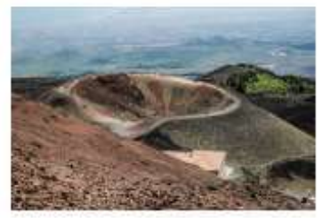

SIGNIFICANCE
• The volcano is 10,922 feet high.
• The volcano is a very significant international tourist attraction for Sicily’s economy.
• Tourists can take a scenic train ride, ski on ski sections and go on a cable car to the crater.
• The volcano is currently active and many residents of the surrounding villages and towns have to regularly abandon their houses due to hot, moving lava.

