HISTORY Summer Project

A Level History
Welcome to the A Level History guide. The activities within this guide will take about 15 hours in total. Please bring your completed activities to your first lesson.

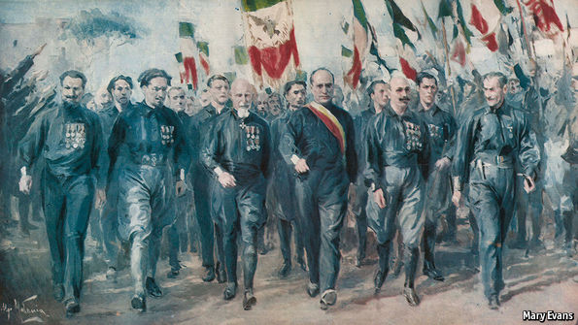
A little bit about A Level History
There are 3 exams in total with each exam. Paper 1 and Paper 3 are 2 hours and 15 minutes each and account for 60% of your total marks with Paper 2 lasting 1 hour 30 minutes and 20% of your total marks. Finally the coursework element that you will begin around Easter time in your first year, accounts for 20% of your total marks.
A Level History numbers is becoming a popular topic at the college and goes well with many different A Levels including Sociology and Geography. We have educational visits and visiting speakers to complement the curriculum.
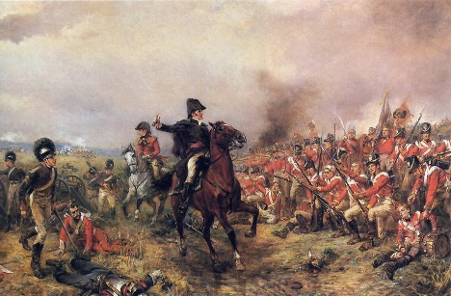
Topics that we will cover is the British Experience of Warfare, Nationalism, Dictatorship and Democracy including Germany, West Germany and Fascist Italy and for the coursework we will look at the Russian Revolution.

How you can prepare for your first year
Here are 2 tasks to complete. They should take you about 15 hours in total.
Task 1
Pretend you are a podcast host, create a 15 minute episode about a historical subject of your choosing. You can either record the Audio or write a script, send you submission to jules.plant@sheffcol.ac.uk

Task 2

How did these key historical events from 1910 to no later than 1989 effect German people?

Create a newspaper article about 2 fictional German characters, one born in Berlin in 1910 the other born in Berlin in 1930. Use the following questions to help you create the article.
- What key events will they live through? - Write how these events they lived through shape their lives.
- What was their childhood like?
- How did they spend their teen years?
- Did they make it old age?
- Did they have a family?

