LAW Summer Project
A Level Law
Welcome to the A Level law study guide. This guide will help you prepare for your studies with us in September.
A brief bit about what you study.
Have you ever thought of being a judge? Perhaps you would like to be a solicitor or a legal secretary, a Barrister, Judicial assistant, Chartered legal executive or a conveyancer. There are many careers in law and law continues to be a growing area for employment, whether you want to go to university to study a law related subject or you want to complete one of the new law apprenticeships.

The A Level law course will help provide you with the foundations for your law career. There are 3 exams at the end of your 2 years that will introduce you to the foundations of law along with an examination of legal cases. The table below shows you how the curriculum is split over the 2 years and how they are assessed.

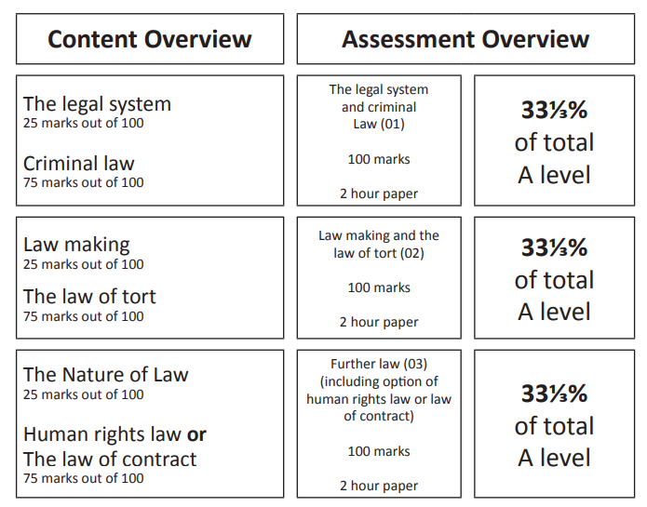

We will study the court system, the people who work in them, how people can access government funding, what are criminal offences, fatal and non-fatal offences against the person, who makes law and how law is reformed. We will also look at the law of wrongs (tort) and what happens in terms of negligence, public and private nuisance, law in society, how technology has changed law and finally we will look into either Contract law or Human Rights law depending on the career aims of students.
This year we have had visiting speakers from a judge and victim support as well as educational visits to courts of law.

How to prepare for joining us.
To help you prepare for your law classes you will need to understand the English legal sentencing and get used to the language of law. Law is a still a language that is very old English and much of its terminology is derived from old Latin terms.

- Click or copy and paste the link below. This will take you to the sentencing
https://www.sentencingcouncil.org.uk/about-sentencing/

- There are 3 videos on:
How offenders are sentenced (5 mins),
The work of Magistrates (4 mins)
The work of Judges (4 mins)

These will introduce you to the personnel who work in the court and how they sentence people. These are essential in the first few weeks of your A level course.

- Next click on the Information for victims and About guidelines links on the left-hand side. These gives you information about Victim Support and also sentencing guides on Murder, Manslaughter and Death by dangerous driving and how sentences are worked out and what happens in the different courts. Again, during the first few weeks of your A level course you will go into detail on these and these will form part of your first test. At your first test you will start your legal career by starting to give advice to your caseload of `clients’. Although these are merely case studies, you will start to practice being a solicitor.

- Once you have read through all the guidelines you will be the judge. Click on the link on the left-hand side You Be The Judge. There are 8 cases for you to judge. Make sure you click on the relevant guideline (there is no guideline for criminal damage and these have changed and have not been updated yet).

- Click on your first case – Domestic Burglary. This year we used this case in your second test (you are tested every 4 weeks on the course). Read the guidance first. It says the Domestic Burglary is a Triable Either Way offence (we will look at this in your first few weeks), carries a maximum of 14 years custody.

The guidance then gives you information about whether the sentence can be extended due to what was involved in the crime such as GBH or if it was their 3rd burglary. It also takes you through steps to determine the sentence.

Step 1 determines the offence category and a possible sentence. When you listen to the case you will need to tick off factors in the case, such as Occupier at home. This will add a lot more custody time onto the sentence and you may tick things like Limited damage, which will add a little more time. Do the same for culpability.
Go through Step 2 to decide the sentence and then look at factors increasing seriousness (called aggravating factors) which will add more time onto the sentence (again tick the ones that apply on the sheet or make a note) and then tick the ones that apply to mitigating circumstances (these reduce the amount of custody). At the end of the case you will be asked to identify the sentence that you will give. Hope you are right!

- Do the same for the other cases. Do not worry if you get it wrong.

- Finally work your way through the other information on the left – Sentencing Basics, Types of sentence, how sentences are worked out, who does what?, Sentencing myths and Young people and sentencing.

- All together it should take you about 15 hours to complete.

On behalf of the A level Law team, we wish you all the best and look forward to seeing you in September.

If you want to extend your reading you may wish to buy the first year text books (but you do not need them until you start the course).

OCR AS/A Level Law Book 1
Author:
Jacqueline Martin, Nicholas Price
ISBN:
9781510401761
Publisher:
Hodder Education
Date:
June 2017
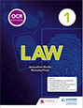
These engaging and accessible textbooks provide detailed coverage of the new 2017 OCR AS and A level Law specification. From leading law authors Jacqueline Martin, Richard Wortley and Nicholas Price, they comprehensive, authoritative and updated with important changes to the law

OCR AS/A Level Law Book 1 Student eTextbook
Author:
Jacqueline Martin, Nicholas Price
ISBN:
9781510401488
Publisher:
Hodder Education
Date:
July 2017
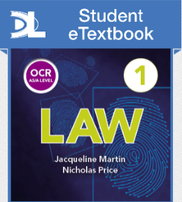
These engaging and accessible textbooks provide detailed coverage of the new 2017 OCR AS and A level Law specification. From leading law authors Jacqueline Martin, Richard Wortley and Nicholas Price, they comprehensive, authoritative and updated with important changes to the law.
Student eTextbooks are downloadable versions of the printed textbook, available via Dynamic Learning

