SOCIOLOGY Summer Project
Welcome
Welcome to the A Level Sociology Summer Project. We very much look forward to welcoming you in September. As part of your preparation we have developed this booklet.

This work pack is designed to provide 15 hours of work (5 hours a week over 3 weeks) to prepare you for studying A Level Sociology. You may have studied Sociology for GCSE, or you may never have heard of it before.

Sociology Summer Project
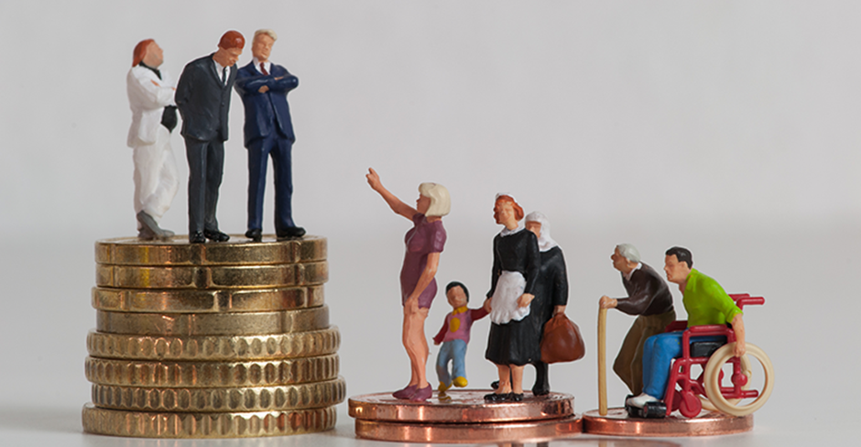
Name:

Contents:
- A Level Sociology
- Introduction to sociology and key words
- Perspectives in sociology
- Key question: is modern British society fair?
- Is the education system fair?
- Is the family fair?
- Is the criminal justice system fair?
- Conclusion
- Further reading and watching

A-Level Sociology
We study the AQA specification, and study the following topics:
- Education
- Families
- Beliefs in society
- Crime and deviance
- Theory and Methods

These are divided into three papers, which are each 2-hour exams and make up 100% of your final grades. You can find the specification here.
Previous students have said:
‘Sociology is just a great subject as it picks apparent the flaws in our world and tries to give us solutions to try and solve these problems. I personally have really enjoyed learning it, there hasn’t been a day that I didn’t enjoy coming to class and learning. Sociology has given me a range of skills such as breaking apart complex ideas, structuring my paragraphs in coherent ways, motivation to learn and discover more about the world and even general skills like to be more aware of my treatment of people to be more kind and patient with others.’
‘Through studying sociology it has changed my view on society significantly. Society for me can never be seen as black and white as external and internal factors affect all individuals differently, meaning all do not get the same opportunities or chances in life, some sociologists argue. The inequalities within society are highlighted’
‘In sociology I have learnt and understood that sociology is constantly involved in all of our lives. I was able to better understand how our lives change and how they are shaped by social constructs and social structure. I was able to understand the behaviour and struggle of different types of people in society, for example the struggles that ethnic minorities face in and out of school with factors such as parenting, material deprivation and home life playing a big part in how well they are able to achieve in school.’

Introduction
This work pack is designed to provide 15 hours of work (5 hours a week over 3 weeks) to prepare you for studying A Level Sociology. You may have studied Sociology for GCSE, or you may never have heard of it before.
Sociology refers to the study of society – the way people interact together in society, and how society shapes us and our decisions. Studying sociology will help you to understand different perspectives, to write analytic essays and crucially, to understand the same issue can be seen from multiple perspectives. One of the main issues we study in sociology is equality – how and why society is unequal, and why different people have different chances of succeeding in life. This will be the focus of this work pack.
Sociologists believe society can be broken down into different parts: social institutions. These include: education, the family, the mass media (TV and newspapers), the criminal justice system, health and religion. These different parts work together and play an important role in shaping our lives. They also believe that every society has a culture, which means a way of life, and a set of norms (expected behaviours) and values (what we hold to be important).
How do we become part of society? Sociologists argue that children go through a process called socialisation, which means learning society’s norms and values. At home, children go through primary socialisation, where they learn how to speak, share and other basic behaviours and norms. Secondary socialisation comes later, at school and beyond, where individuals learn from their peers and others.
Our behaviour is influenced by those around us – we are encouraged to conform to society’s expectations and norms (obey the rules and do what is expected) and discouraged from deviating from this. These expectations are enforced by sanctions from others – positive sanctions when we do the right thing, eg a smile, a laugh, or a reward, and negative sanctions when we do the wrong thing, a disapproving frown, a shake of the head, or a detention. The way society encourages us to confirm and discourages us from deviating is known as social control.

Quick check: find and write out the definitions of the following word in the text above, or online.
Sociology
Sociologist
Social institutions
Norms
Values
Sanctions
Primary socialisation
Secondary socialisation
Social control

In Sociology, there are three main different sociological perspectives, or ways of looking at society:

- Functionalists: these sociologists believe society runs smoothly, and is made up of different parts which all work together to keep society stable. They believe people agree on what is important (there is a value consensus) and people generally conform to the norms of society. They tend to focus on the positive functions of different parts of society. Watch this video to find out more:

https://www.youtube.com/watch?v=-83vVeSC2_g

- Marxists: based on the ideas of Karl Marx, they focus on inequalities based on social class (how much or little money someone has). They believe this is the main inequality in society. They argue there are two main classes: the working class (proletariat) and ruling class (bourgeoisie) and believe the ruling class own and exploit the workers, treating them badly and giving them low pay so they can make more money for themselves. Watch this video and find out more:

https://www.youtube.com/watch?v=fSQgCy_iIcc

- Feminists: see gender inequality, inequality between men and women, as the main inequality in society. They argue women are treated badly and exploited by men, and that society is patriarchal (male-dominated). Watch this video to find out more:

https://www.youtube.com/watch?v=D6Dl-9pSW-4

Complete the table to summarise the different perspectives:
 | Summary | Image
Functionalism
Marxism
Feminism

Key question: is Britain fair?
Two babies are born on the same place. Do they have an equal chance of … being healthy?
… going to university?
… getting a well-paid job?
… avoiding prison?
… succeeding in school?

- One third (30%) of children in Britain live in poverty
- People born into the most deprived (poor) areas of the UK are likely to live, on average, 10 years less than those in affluent (well off) areas
- Only 30% of those receiving Free School Meals (FSM) (low family income) achieve a pass in English and Maths at GCSE compared to 60% of those who do not receive FSM
- Only 7% of the population go to fee-paying schools, but they make up 42% of students at Oxford and Cambridge and dominate top jobs in law, journalism, politics and health
- Last year, there was a 13% increase in food bank use
These statistics paint a bleak picture of whether or not Britain is a fair society. Before we engage in the debate of whether or not Britain is fair, we must define what we mean by this.

In Sociology, a ‘fair’ society is a society where everyone has equality of opportunity – everyone has an equal chance of achieving success and their background does not determine this. Sociologists call this a ‘meritocracy’ – a society where status is based on merit (hard work and talent) rather than the position you are born into. In a meritocracy, effort should be the only factor determining the position someone gains in life.

Functionalists believe contemporary (modern) Britain is a meritocracy and that success is determined only by hard work.

Quick check: look at the following cartoons and reflect on the statistics above. In your opinion, does everyone have an equal chance to succeed? Why or why not? Write your response in the box provided.
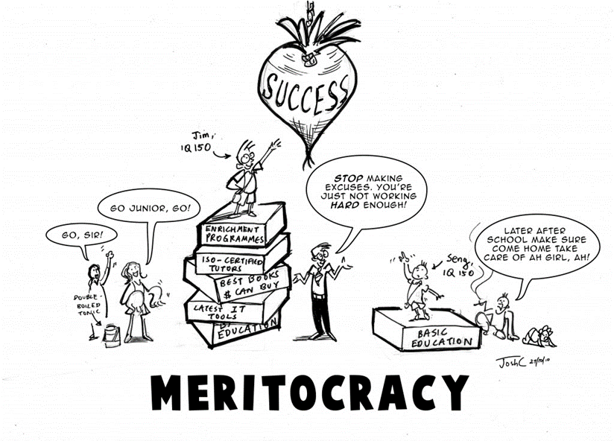
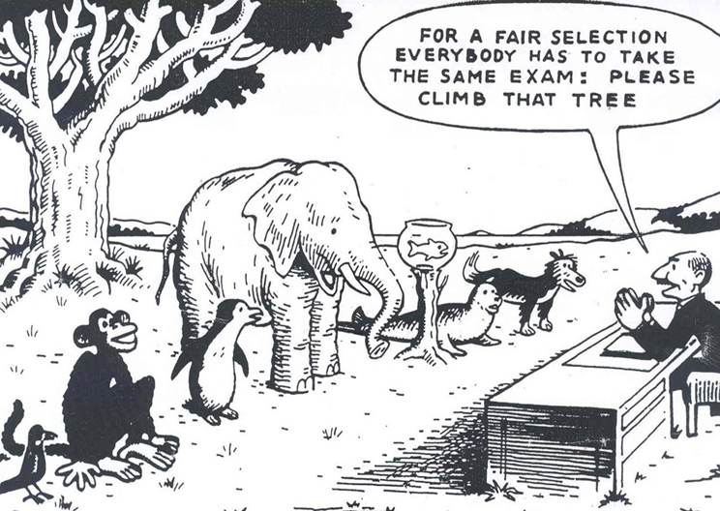

Marxists disagree with functionalists, arguing society is not a meritocracy. They believe those born into the working class (poorer members of society) have less chance of succeeding in life. They believe the upper class (the rich) have a much higher chance of succeeding and dominate the top positions in society.
Feminists also disagree, arguing women have less chance of succeeding than men. They argue society is patriarchal, meaning that men have an inbuilt advantage compared to women, and that women are disadvantaged and oppressed.
Other sociologists believe people from ethnic minority backgrounds are disadvantaged, due to individual and institutional (embedded) racism.
Is the education system fair?
- Education policy institute found disadvantages children were 18 months behind their peers by the time they took their GCSEs
- More affluent (advantaged) students have heard 30 million more words than disadvantaged students by the time they are 5
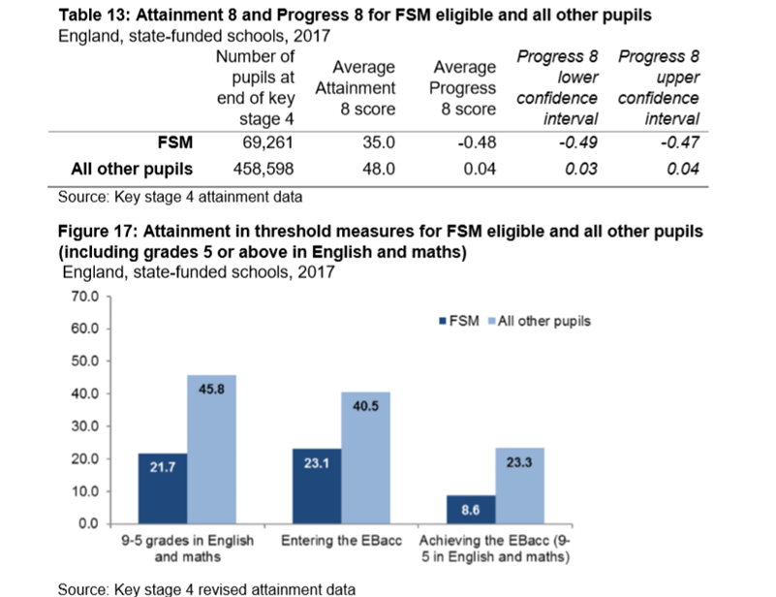
Pupils can claim Free School Meals if their household income is less than £16,000, so it is used as a measure of social class or poverty.
- What percentage more students not on FSM achieve a grade 5 in English and Maths compared to students on FSM?
- What does this show about which students do better in education?
- Can you think of any reasons for this?
At school, children from different backgrounds receive very different outcomes in education. Here are some of the main reasons:
- Material deprivation – students may lack the physical resources they need to study, like books and internet access. How might this impact their exam results?
- Labelling – students may be labelled as lower achieving by teachers. This is when teachers attach a label to students and treat them differently. They may see working class students as less motivated, less able and less hard working. How might this impact their results?
- Parental attitudes – parents from working class backgrounds may be less involved and less engaged in their children’s education, possibly because they had a bad experience of school themselves.
Many wealthy parents can afford to send their children to independent schools too.
Some sociologists also argue ethnic minorities have a worse experience of education, because they experience racism and institutional racism. Some also argue these inequalities are due to differences in the family structures of different ethnicities.
Research task: read the articles and watch the documentaries and listen to the podcast to get a better understanding of the inequalities in education. Use the information to write 500 words explaining why education in contemporary Britain may not be fair, including which groups may be more disadvantaged.
Source | Key points
Podcast: Professor Cecil Wright discussing the ethnic inequalities in education, including her experiences at school
Article: Diane Reay explaining the unequal treatment of working class children in education

Report (just read the executive summary): The impact of attitudes and expectations on educational attainment
Documentary: Too Poor for Posh School?
Clip: Should we abolish private schools?
Documentary: Professor Green, Living in Poverty

Write your response here: 500 words only!!!

Is family life fair?
If we were to rewind to the 1950s, we would see that family life used to be very unequal. Women were expected not to have a paid job, but to complete all the housework and childcare, whilst men would go out and work. Look at this page from a home economics textbook in the 1950s:
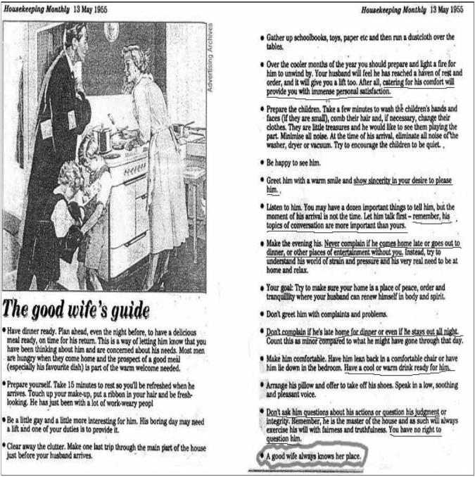
- What does this show about the role of women in the family?
- What would feminists think about this?
- How has this changed?
Today, men and women are more equal. Women are likely to have a paid job as well as men, and men and women are both likely to contribute to family life and tasks. However, there are still inequalities between men and women in the family. Men are usually paid more than women, and so have more power, and women often still complete up to 60% more housework and childcare than men.
Many women must perform the ‘double shift’ – which means doing two shifts of work, one in their paid role, and one at home. Some sociologists also argue that women perform more emotional labour – remembering birthdays, comforting people when they are upset, scheduling appointments and so on.
In your opinion, should women do more housework and childcare than men? Why/ Why not?

Research task: read/ watch/ listen to the sources below and record the key points. Then write 500 words explaining whether or not family life in the UK is fair in your opinion. Try to use evidence and examples where possible.
Source | Key points
Article: Why is there still a housework inequality gap?
Article: What is emotional labour?

Clip: Sociologist Arlie Hoschild discussing the second shift
Documentary: What stands in the way of women becoming equal to men?
Article: The ‘tradwife’ movement, encouraging young women to revert to 1950s expectations
Write your response here:

Is the criminal justice system fair?
The criminal justice system refers to all parts of the system that creates and enforces the laws. This includes the government, who create and pass laws, police officers, who enforce the laws, judges, who decide sentences for those convicted of crimes and prison and probation officers.
Here are some statistics on the criminal justice system:
- Black people are 9 times more likely to be stopped and searched by the police
- The police are 3 x more likely to use force against black people
- Young, black males are overrepresented in prison
There are many explanations for these statistics, summarised below:
- Institutional racism: this means racism embedded in the criminal justice system. The murder of Stephen Lawrence in 1993 by five white youths led to the Macpherson Report of 1998 and revealed the huge extent of institutional racism in the police force – the report recommended increasing the diversity of the police force and establishing an independent police complaints service, but there are still concerns of institutional racism in the police today.
- Family structure: Tony Sewell argues lone parent families are likely to lead to black boys being involved in crime
- Poverty: people from some ethnic minority backgrounds are more likely to live in poverty and therefore more likely to commit crime.
The treatment of different groups, particularly different ethnicities, in the criminal justice system demonstrates one of the main inequalities which remains an issue in the UK, affecting people’s life chances significantly.
This results both in it appearing that more ethnic minority groups, especially black people, commit more crime (when they may just be targeted more by the police) and ethnic minority individuals not being taken seriously as victims of crime.
In addition, feminists argue women are often not taken seriously as victims of crime like domestic violence and sexual assault. They argue the patriarchal criminal justice system are keen to blame women for making themselves into victims of these crimes by dressing/ acting a certain way.
Even though there are a specific set of laws that everyone must follow, sociologists argue that these rules and the enforcement of the law are applied differently, unequally, to different groups of people, resulting in these inequalities.

Research task: read/ watch/ listen to the sources below, and write 500 words describing whether or not the criminal justice system is fair and why/ why not.

Source | Key points
Documentary: Stephen Lawrence, Time for Justice
Article: Institutional Racism 20 years after Stephen Lawrence’s murder

BBC Teach Clip: Institutional Racism
Article: David Lammy describing why stop and search is unfair
Clip: Tony Sewell explaining his perspective that lone parent families lead to black boys being involved in gangs
Clip: David Lammy discussing racial bias in the Criminal Justice System
Write your response here:

Conclusion: How can we make society fairer?
Analysing the negative aspects of society can paint a bleak picture of both society and Sociology, but an important part of sociology is considering society’s problems in order to think about how we can improve society.
Making society better and more equal starts with individuals – how we treat other people, interact with others and what we expect and ask of others.
Use this space to record what you will do differently to try to improve society. I have written some examples to help you.
Examples:
- Be kind to everyone, regardless of their background and my differences
- Make sure housework is divided equally between myself and my siblings

There are also bigger changes we can encourage and lobby for, for example, by writing to your local Member of Parliament. These could be: reforming the criminal justice system, abolishing private schools or introducing a higher minimum wage. Us the space below to write some ideas of what bigger issues you would like to change to make society fairer.

If you have any questions about any work in this pack, please don’t hesitate to contact me via email: rusia.murwisi@sheffcol.ac.uk

Further reading/ watching/ listening
Documentaries/ TV | - Panorama, Louis Theroux, Stacey Dooley, Mind of a Murderer etc  - I, Daniel Blake (Amazon Prime)  - Years and Years (BBC i-player)  - The ‘Up’ series (eg. 56 Up, 63 Up - on Netflix or Youtube)  - The Secret Life of 5 year olds (Channel 4 series)  - McMafia (Netflix)  - Freedom Writer’s Diary (Amazon Prime)  - When They See Us (Netflix)  - The Society (Netflix)  - Love, Simon (Amazon Prime)  - Ted Talks/Sociology (online)  - Made in Dagenham (BBC i-player)  - Wonder (Netflix)  - The Wife (Netflix)  - Growing up Gifted (iPLayer)
Links to documentaries | Poor Kids: Life on the Breadline (Child Poverty Documentary) | Real Stories  www.ted.com/talks?topics%5B%5D=sociology  BBC Panorama  www.bbc.co.uk/programmes/topics/Sociology_of_culture  Black Mirror  www.channel4.com/programmes/dispatches
Books | - Brave New World – Aldous Huxley  - Animal Farm – George Orwell  - 1984 – George Orwell  - Educated – Tara Westover  - Invisible Women – Caroline Criado Perez  - Chavs: The Demonisation of the Working Class – Owen Jones  - The Establishment and How They Get Away With It – Owen Jones  - Natives - Akala  - The Handmaid’s Tale – Margaret Atwood (also a series)  - Vox – Christina Dalcher  - The God Delusion – Richard Dawkins  - Outsiders: Studies in Sociology of Deviance – Howard S Becker  - Folk Devils and Moral Panics – Stanley Cohen  - A Glasgow Gang Observed – Patrick James  - Gang Leader For A Day – Sudhir Venkatesh
Podcasts | http://podcasts.ox.ac.uk/series/department-sociology-podcasts  https://www.spreaker.com/show/the-sociology-show  www.anchor.fm/allsociology  www.measureradio.libsyn.com/podcast  www.socialsciencespace.com/author/socialsciencebites  www.thesocialbreakdown.com  www.soundcloud.com/thesociologicalreview  www.bbc.co.uk/programmes/b006qy05  www.anchor.fm/digital-sociology-podcast
Websites | www.theguardian.com/education/sociology  www.nytimes.com/topic/subject/sociology  www.tutor2u.net/sociology/blog  www.nortonbooks.typepad.com/everydaysociology/  www.soc.washington.edu/news  www.sociologysal.blogspot.com  www.gendersociety.wordpress.com  www.creativesociology.blogspot.com  www.sociologylens.net  www.blogs.lse.ac.uk/impactofsocialsciences/  https://revisesociology.com/  https://www.senecalearning.com/  https://www.tutor2u.net/sociology  https://www.aqa.org.uk/subjects/sociology/as-and-a-level/sociology-7191-7192  https://thesociologyguy.com/a-level-sociology/  https://www.youtube.com/channel/UC6VpoZj33Df_rNb8KymCczw  https://napierpress.com/
Online courses | - Intro to Sociology (New York University): https://www.courses.com/new-york-university/intro-to-sociology  - Introductory sociology (Indian Institute of Technology, Kanpur): https://www.courses.com/indian-institute-of-technology-kanpur/introductory-sociology  - Foundations of modern social theory (Yale University): https://www.courses.com/yale-university/foundations-of-modern-social-theory  - Reading Marx’s Capital (City University, NY): https://www.courses.com/city-university-of-new-york/reading-marxs-capital  - What do we mean by ‘family’ (intermediate): https://www.open.edu/openlearn/society-politics-law/sociology/what-do-we-mean-family/content-section-0?active-tab=description-tab  - ‘Problem’ populations, ‘problem’ places (intermediate): https://www.open.edu/openlearn/society-politics-law/sociology/problem-populations-problem-places/content-section-0?active-tab=description-tab  - Children’s rights (intermediate): https://www.open.edu/openlearn/people-politics-law/politics-policy-people/sociology/childrens-rights/content-section-0?active-tab=description-tab  - Social problems – who makes them (intermediate): https://www.open.edu/openlearn/people-politics-law/politics-policy-people/sociology/social-problems-who-makes-them/content-section-0?active-tab=description-tab  - Identity in question: https://www.open.edu/openlearn/people-politics-law/politics-policy-people/sociology/identity-question/content-section-0?active-tab=description-tab  - Social construction and social constructionism (intermediate): https://www.open.edu/openlearn/people-politics-law/politics-policy-people/sociology/social-construction-and-social-constructionism/content-section-0?active-tab=description-tab  - Understanding economic inequality: https://www.open.edu/openlearn/society-politics-law/understanding-economic-inequality/content-section-0?active-tab=description-tab  - Beyond the ballot – Women’s rights and suffrage from 1866 to today: https://www.futurelearn.com/courses/womens-rights  - Understanding gender inequality: https://www.futurelearn.com/courses/understanding-gender-inequality  - Religion and conflict: https://www.futurelearn.com/courses/religion-and-conflict  - Why religion matters – religious literacy, culture and diversity: https://www.futurelearn.com/courses/why-religion-matters  - Gender representation in the media: https://www.futurelearn.com/courses/gender-and-the-media

Reading ideas:

