Foundation Degree in Graphic Design

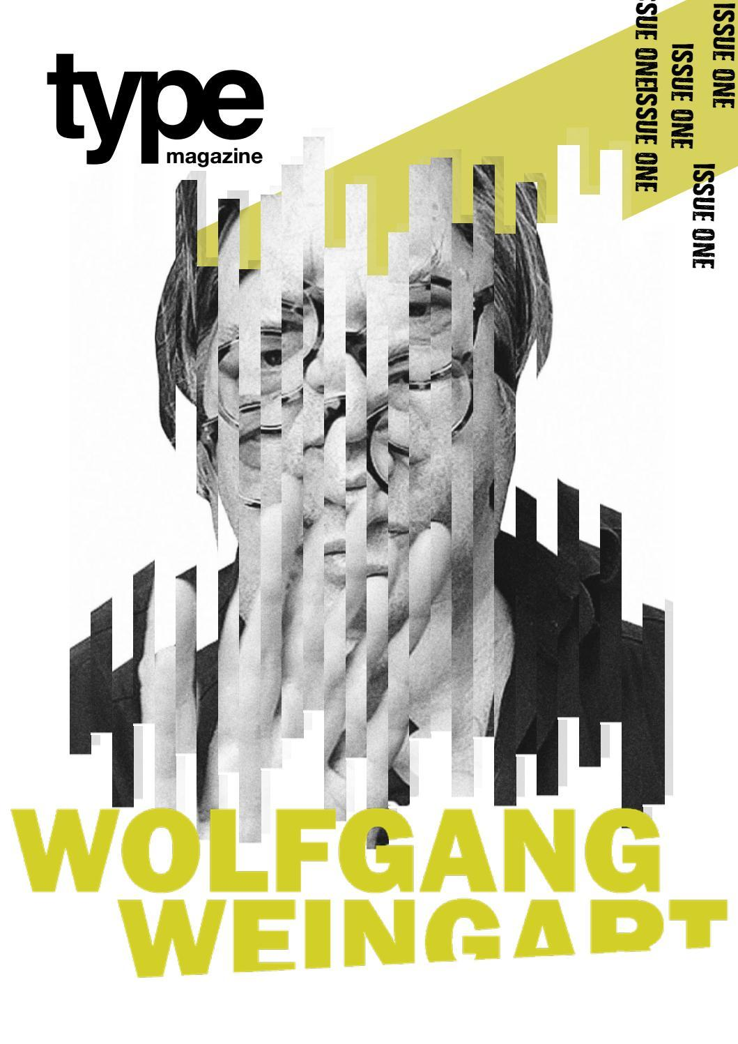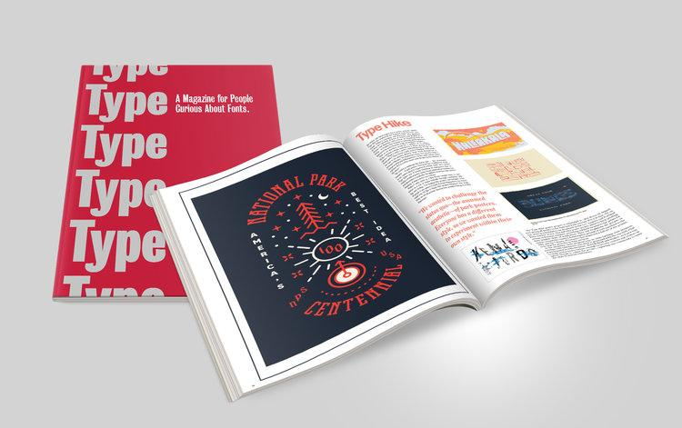

Design a magazine cover for 'Type' magazine on a typographer of your choice (contemporary or historical), with a double page spread to illustrate your skills and understanding of grid systems.
Design the masthead of the magazine called 'Type':
- Any size
- Any format
- Single, 2, 3 or full colour
The dps represents the 'typographical style' of the typographer (adopt his/her visual style)
Images may be used if required/preferred, or pure type.
Caveat:
Be creative.
Be experimental.
Break rules if choice of typographer allows (David Carson) or conventional if typographer choice is based on a more conventional style (J Muller Brockmann/swiss style)

