The Sheffield College

Sport Department Pre-enrolment Pack
Contents:
- Introduction
- Overview of Units
- ‘Participation in sport’ tasks
- ‘Sports coaching’ tasks
- ‘Healthy exercise and nutrition’ tasks
- Extension Tasks

Introduction
Welcome to your online induction pack for the NCFE Level 2 Certificate in Sport programme.
This qualification was designed by NCFE with the aim of creating competent and confident practitioners in sport and physical activities for the future.
Unlike many other qualifications in F.E. this programme has no externally assessed units, so no exams!
So let’s take a look at how your course is structured and the kind of things you can be getting on with to best prepare you for starting your course.
Overview of Units
The course offers two different ‘pathways’ - Sports Coaching and Sport, Exercise and Fitness. Each pathway is made up of four separate topics designed to provide essential information and the experience required to progress into higher level study as well as being successful in the sport and leisure industry.

Below is an outline of the topics you will be covering and the key learning outcomes involved in each topic:
Sport Coaching;
- Participating in sport
  - Organise a sports activity
  - Participate in a sports activity
  - Review participation in a sports activity
  - Rules, regulations and fairplay in sport
- Sports coaching
  - Roles, responsibilities, techniques and skills of a coach
  - Technical process of coaching
  - Plan a sports coaching session
  - Deliver a sports coaching session
  - Review a sports coaching session
- Skills and tactical awareness
  - Technical and tactical skills for a sport
  - Assess technical and tactical skills
  - Goal set for improved performance
- Sports volunteering
4.1 Skills, qualities and values a sports volunteer needs
4.2 Benefits of volunteering
4.3 Prepare for work as a sports volunteer
4.4 Take part in a sports volunteer role

Sport, exercise and fitness
1. Participating in sport
1.1 Organise a sports activity
1.2 Participate in a sports activity
1.3 Review participation in a sports activity
1.4 Rules, regulations and fairplay in sport
2. Anatomy and physiology for fitness
2.1 Structure and function of the skeletal system
2.1 Structure and function of the muscular system
2.1 Structure and function of the respiratory system
2.1 Structure and function of the cardio-vascular system
2.1 Structure and function of the nervous system
2.1 Structure and function of the energy system
3. Healthy exercise and nutrition
3.1 Effects of exercise on the body
3.2 Components of fitness
3.3 Nutrition for different population groups
3.4 Health benefits of good nutrition
4. Sports volunteering
4.1 Skills, qualities and values a sports volunteer needs
4.2 Benefits of volunteering
4.3 Prepare for work as a sports volunteer
4.4 Take part in a sports volunteer role

In the next few sections we have included a range of activities that you will be expected to complete whilst on
your course. Have a go at them. They will be an excellent preparation for the start of your course in September.

Participation in sport
In this topic you will develop the knowledge, understanding, techniques and skills needed to work in the sports sector.
The method of study and assessment is a mixture of theory and practical. There is a strong emphasis on organising, participating and reviewing sports events
Task;
Identify the rules for a sport that you know [4.5] and write your answers in the table below. The table is divided into 3 sections; playing area, scoring and safety. Fill in each section with seven [7] rules, twenty one [21] in total. NB your sport might not fit exactly into these sections - so be imaginative.

Rules for:
Playing area rules:
1
2
3
4
5
6
7
Scoring rules:
1
2
3
4
5
6
7
Safety rules:
1
2
3
4
5
6
7

Sports coaching tasks
In this topic you will develop your knowledge and understanding of the roles, responsibilities and skills of a sports coach. You will have the opportunity to plan, deliver and review your own session. The method of study and assessment involves both theoretical and practical elements.
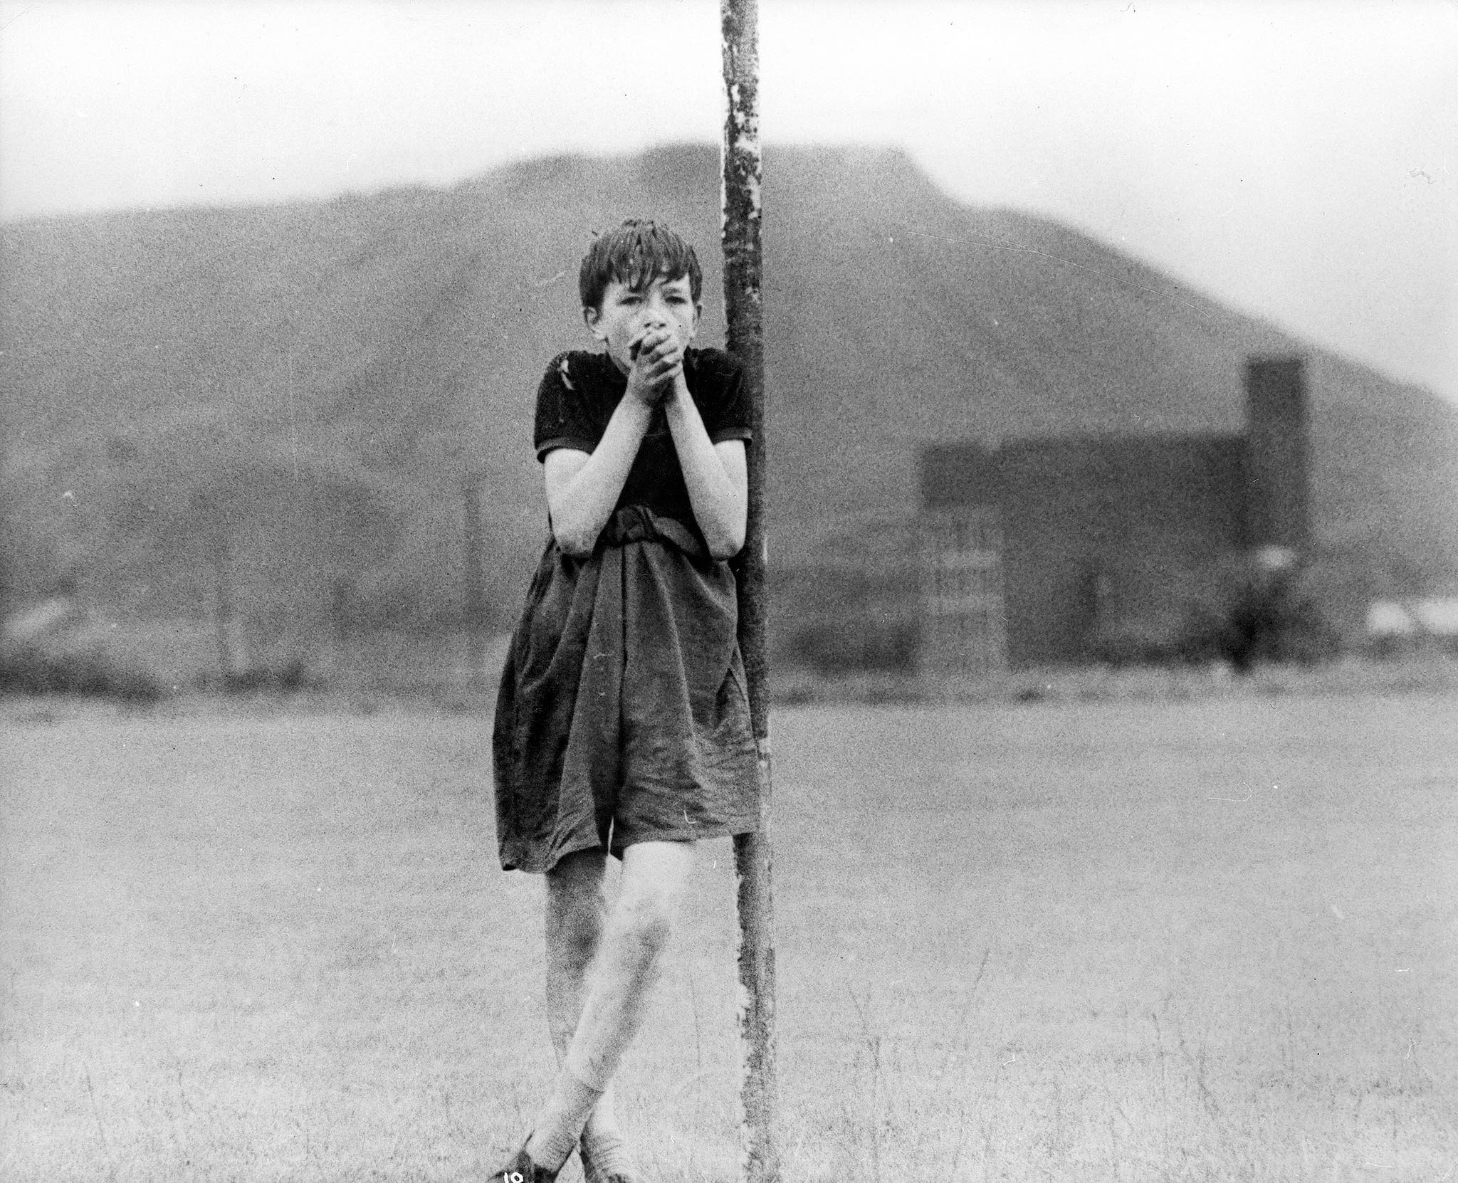
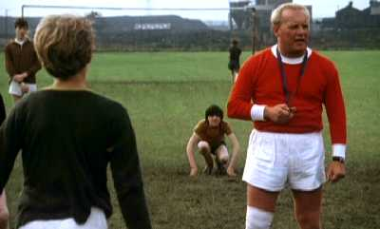
Task;
During your course you will need to assess your own and others performance as coaches.
Watch the video in the link below of a PE lesson and then complete the questions in the table.

https://www.bing.com/videos/search?q=kes+pe+teacher+scene&docid=608034439587498465&mid=D9873C85A03ED9DB5E21D9873C85A03ED9DB5E21&view=detail&FORM=VIRE

Q.1 - Importance of being a role model.
Define what a role model is
Describe the importance of being a role model in teaching/coaching. Describe the type of role model the teacher is in the video will his behaviour have a positive or negative impact on the pupils?
1 Definition;

2 Importance of a role model;

3 Type of role model;

Q.2 - Health and safety.
Health and safety in sport is very important.
Can you identify 3 potential risks to pupil safety in this lesson?
1.

2.

3.

Q.3 - Organisation of the lesson.
Being organised is a vital part of being a successful sports leader.
In the video the teacher picks the teams.
What could be the problems with the way he chose the teams?
What could you do to make choosing teams better and why?
1 Problems;

2 Different approach and why;

Healthy exercise and nutrition tasks
In this topic you will be introduced to exercise and nutrition. You will develop the knowledge and understanding of the effects of exercise, components of fitness, types of training, what nutrition is and the benefits of good nutrition.
The method of study and assessment is a mixture of theory and practical. There is an emphasis on applying what you know to reality.

Task;
Identify ten [10] health benefits of physical activity/exercise and record them in the table below. Divide your benefits into either [physical] Health or [mental] Wellbeing.
Health [physical] | Wellbeing [mental]
1 | 1
2 | 2
3 | 3
4 | 4
5 | 5

What will you do after your course?
You have a number of options once you have completed your 1 year course; some are right here at The Sheffield College.
See the links below for further information:

http://www.sheffcol.ac.uk/courses

Extension Tasks;

Participating in sport
Choose another sport - describe in detail the rules. Use the same three [3] categories [see table above]. Include graphics to improve your presentation.

Sports coaching
Identify a further five [5] risks from the video. Say why you think each one is a risk to the physical health or mental well being of those taking part in the lesson.

Healthy exercise and nutrition
Using the 10 benefits identified above. Describe each one and use examples to support what you have said.

FILMS & DOCUMENTARIES TO WATCH FILMS YOU COULD WATCH
The Program: Lance Armstrong Movie on Netflix
Happy Gilmore on Netflix
Coach Carter on Netflix
Ronaldo on Netflix
Moneyball on Netflix

DOCUMENTARIES YOU COULD WATCH
Mo Farah and the Salazar Scandal on BBC iPlayer
All or Nothing: Manchester City on Prime Video
Game Changers on Netflix
Sir Alex Ferguson: Secrets of Success
Barça Dreams on Netflix
Conor McGregor: Notorious on Netflix

RECOMMENDED WEBSITES
BBC Sport www.bbc.co.uk/sport
Sky Sports www.skysports.com
Guardian Sport www.theguardian.com/profile/guardian-sport Bleacher Report www.bleacherreport.com
TED Talks – Sports www.ted.com
FourFourTwo www.fourfourtwo.com
Planet Rugby www.planetrugby.com
London 2012 Highlights www.olympic.org/london-2012

