Pearson BTEC Level 2
Technical Diploma
in
Animal Care

at The Sheffield College,
Hillsborough Campus
S6 2ET
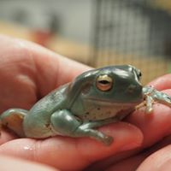
We are looking forward to welcoming you to Hillsborough Campus, where you will study your BTEC Level 2 Technical Diploma in Animal Care.

Throughout your course you will work with a range of animals in college such as;
- guinea pigs
- tortoise, leopard geckos
- royal python
- skink
- frogs and many more small animals and exotics
At Heeley City Farm, you will work with
- cattle
- sheep
- goats
- ponies

You will be expected to take part in all practicals such as preparing feeds, feeding animals, cleaning out accommodation, moving animals and health checking and any other housekeeping tasks.
The Level 2 Technical Diploma in Animal Care is assessed internally through setting of assignments, practical sessions and presentations to name a few.
Units 2 and 4 are assessed externally through exams sat around March/April time.
Your Tutors will ensure you are prepared and ready to take your assessments.

This pack contains some information and activities that will support your preparation for the course.
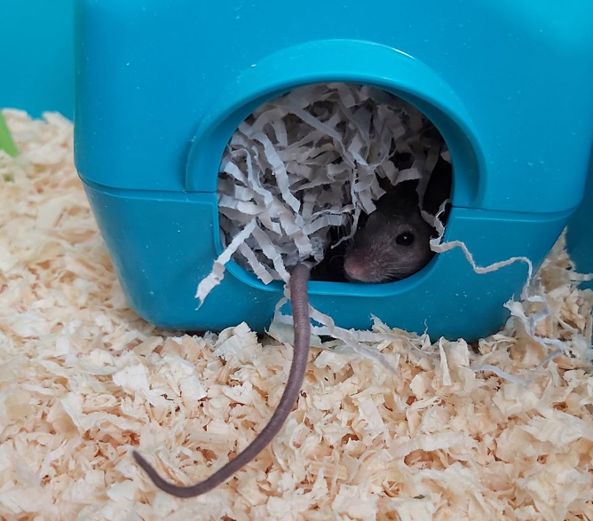
Units you will study and content overview:
Unit 1: Practical Animal Health
- Monitor and maintain the health and wellbeing of animals
- Groom animals and use preventative treatments
- Apply animal first-aid principles and practices
Unit 2: Introduction to Animal Biology and Health
- Mammals
- Avians
- Herptiles
- Fish
- Diseases and infestations in animals
Unit 3: Animal Care Work Placement
- Investigate and apply for an animal care work placement
- Demonstrate work skills relevant to an animal care work placement
- Appraise own animal care work placement
Unit 4: Animal Welfare
- Animal welfare
- Companion animals in a boarding establishment
- Livestock animals on a farm

- Small animals in a pet shop
- Exotic animals in a small collection
- British wildlife in a rehabilitation
Unit 5: Animal Behaviour Assessment and Safe Handling
- Explore normal and abnormal behaviours in animal species
- Explore animal behaviour to determine their mood
- Handle and restrain animals safely
Unit 6: Feeding, Accommodating and Moving Animals
- Plan and provide food and water for animals
- Provide and maintain accommodation for animals
- Move animals safely
You can access further information on what you will study on the course via the college website www.sheffcol.ac.uk
Unit 2: Introduction to Animal Biology and Health
This unit comprises of 5 topics, covering Mammals, Avians, Herptiles, Fish and Diseases and infestations in animals. This unit is assessed through an externally set exam taken around April time.

Knowledge of animal anatomy and physiology is really important.

Complete the tasks below to help prepare you for the 1st topic in Biology.

The Respiratory and Circulatory Systems
(Cardiovascular system)
- Label the structures of the respiratory system
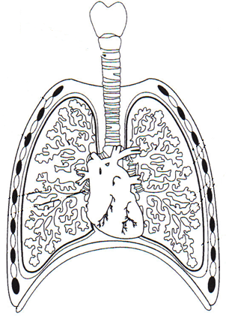

2. Label the structures of the circulatory system
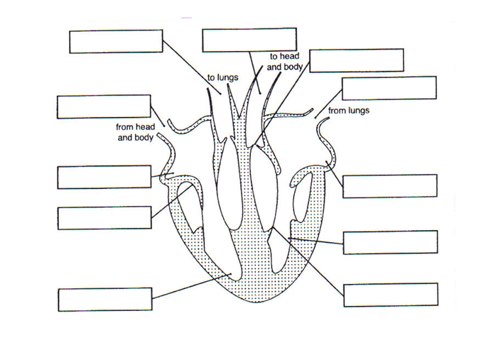

3. Describe the structure and function of arteries, veins and capillaries
 | Structure | Function
Arteries
Veins
Capillaries

The Structure of the Eye
Name | Structure (description) | Function (what is does)
Eyelid

Cornea

Sclera

Retina

Choroid

Iris

Pupil

Lens

Terminology used in Breeding of Animals
Match the correct term to the meaning:
Species |  | The act of mating
Oestrus |  | The time of year when mating usually occurs
Coitus |  | All the animals of the same kind that can mate together and produce fertile offspring
Ovulation |  | The union of the spermatozoon and the ovum
Mating season |  | The time when the female will accept the male, known as ‘heat’ in some species
Fertilisation |  | The shedding (release) of ripe ova (eggs) from the ovary. This can be spontaneous (i.e. takes place regularly, e.g. in dogs) or ‘induced (i.e. stimulated by the act of mating e.g. in cats)
Implantation |  | The act of giving birth
Gestation period |  | Fertilised ovum and developing young (in the very early stages of development in mammals)
Embryo |  | The length of time from mating to giving birth
Foetus |  | The embedding of the embryo into the lining of the uterus
Placenta |  | The more fully developed offspring of mammals whilst still in the uterus
Parturition |  | The organ by which the foetus is connected to the uterus

Nutrition

Animals spend much of their lives obtaining and eating food.
Complete the reasons food is essential to all organisms by filling in the gaps using the words in bold that are below.

Food is essential to all organisms for a number of reasons:

- It provides the energy required for all the body .
- It provides that cannot be synthesised by the body.

- It replaces materials that are lost through .
- It replaces material that has been incorporated into the body e.g. into bones.
- It provides the materials needed for and .

processes, nutrients, repair, excretion, calcium, growth, essential

For each of the 6 main groups of nutrients that are needed by animals, state function and give examples of animal suitable food sources:

- Carbohydrates

- Lipids (Fats and oils)

- Proteins

- Vitamins

- Minerals

- Water.

Unit 3: Animal Care Work Placement
In this unit you will look at professionalism, CV and cover letter production as well as interview skills and techniques in preparation for going out on work placement.
As part of your course, you must complete a minimum of 75 hours real-life working with/around animals.
Many of our previous Level 2 students have completed placements at grooming salons, farms/animal parks, horse riding schools, canine day care centres, catteries and kennels.

To help you get started the few pages will get you thinking about placement preparation including the follow;
- CV template

- Questions you may be asked in interview
- Customer Care and handling complaints
- Possible Placements research log
1. CV (Curriculum Vitae)
Curriculum Vitae, latin for ‘course of life’, is your way of providing a potential employer with an overview of your education and work history.
Whether you have created one before, it is important to update your CV regularly. Your CV can be tailored to suit the roles you are applying for.

Have a go at completing the CV below.

NAME

CONTACT INFORMATION NOT NEEDED AT THIS TIME

Briefly state your career objective. give a small personal introduction about yourself

Education (list all qualifications)

Month/year from- to (most current qualification first)

Qualification title, School/college

grade

Experience (include work experience/placement roles)

Dates From – To

Job Title, Company

Describe your roles within that company (relevant to the job you are applying for)

Skills

Bullet point list of all relevant skills for the position

Activities

use this section to include:

relevant info- hobbies and interests etc.

Extra courses- first aid etc.

references (2 people who are not related to you e.g. school tutors/work experience supervisor)

name

position

contact details

name

position

contact details

- Interview Preparation
List an additional 4 questions you might be asked during an interview.
Write your response for each question, giving a good impression.

- Tell us a bit about yourself

- What experience do you have working with animals?

What should you consider when preparing for an interview?
Example: Plan how you are going to get to your interview

3. Customer Care

Think about your best ever customer experience and what made it good.

Write a short explanation about it in the space below, and remember to include what made it good:

Now think about a situation where you received bad customer care.

Write a short explanation about it in the box below, and remember to include what made it bad:

Handling Complaints

Try to remember a situation when you had complained about a service you received (shop sales, food outlets, animal related outlets, etc) – one that was handled well and one that wasn’t.

A complaint that was handled well - write down what your complaint was & how it was handled:

A complaint that was handled badly – write down what your complaint was & how it was handled. How should it have been handled?

4. Possible Placements

For this part, it is important you have at least 3 possible placements in mind, so you can prepare in the best possible way. Think about where you would like to spend time learning about different careers.

Complete the tables below outlining each placement choice.

Placement 1

Name of Placement
Address of placement
Contact information | Telephone:  Email:
Type of Placement (farm/groomers..)
Positives about this placement | 1.  2.
Negatives about this placement | 1.  2.
Method of travel required to get there
Why have I chosen this placement?

Placement 2

Name of Placement
Address of placement
Contact information | Telephone:  Email:
Type of Placement (farm/groomers..)
Positives about this placement | 1.  2.
Negatives about this placement | 1.  2.
Method of travel required to get there
Why have I chosen this placement?

Placement 3

Name of Placement
Address of placement
Contact information | Telephone:  Email:
Type of Placement (farm/groomers..)
Positives about this placement | 1.  2.
Negatives about this placement | 1.  2.
Method of travel required to get there
Why have I chosen this placement?

Unit 4: Animal Welfare

This unit focuses on the welfare of animals and legislation surrounding working and caring for animals. This unit is assessed through an externally set exam around March time.

To help you prepare for this unit complete the questions below looking at the following legislation;

- Health and Safety at Work etc. Act 1974

- Control of Substances Hazardous to Health Regulation 2002

- Reporting of Injuries, Diseases and Dangerous Occurrences Regulations 2013

1. Name the legislation which governs health & safety in the workplace.

2. Who is responsible for health & safety?

3. Which organisation steps in to investigate when there have been serious health & safety problems in the workplace?

4. What are the responsibilities of an employer?

5. What are the responsibilities of an employee?

- What do the letters COSHH stand for?

7. Explain the following terms & give an example of each:

a. Hazard:

b. Risk:

For the questions below, highlight/underline your answer/s

8. From the following list, select which items you think a First Aid box should contain:

- Triangle bandage
- Plasters
- Sterile unmedicated dressings
- Safety pins
- Antibiotic creams
- Aspirin/paracetamol
- Sterile eye pads

9. What colour are the fire exit signs?

- Red
- Blue
- Yellow
- Green

10. What is the dangerous infection, which can be contracted from animal scratches or bites, soil, rusty nails, etc?

- Typhoid
- Rabies
- Tetanus

11. What do the letters COSHH stand for?

- Concentrate on Safety Half Hour
- Control of Substances Hazardous to Health (Regulations)
- Control of Safety and Health Hazards
- Control of Scaffolding & Hard Hats

12. Which injuries do you put in the accident book?

- When you need to go to the hospital or doctors
- When you had time off work
- All injuries, no matter how small
- Major injuries only

13. On discovering a fire, which is the first thing that you do?

- Fight the fire with the nearest fire extinguisher
- RIng the fire brigade
- Raise the alarm
- Leave by the nearest exit

14. Who is responsible for health and safety at work?

- Your manager
- Your safety officer/safety representative
- You, your workmates & your manager
- You

15. Why is it important to report accidents?
- Compensation/pay reasons
- To stop it happening again
- So that your manager knows why you are not at work
- So that the responsible person(s) can be punished
- A combination of b) & c)

16. Who should you tell when you have an accident at work?

- Your workmates
- Your supervisor/line manager
- No need to tell anyone if only a minor accident

- Your solicitor
- Your safety officer/safety representative
17. What should you do if you discover a hazard in the workplace?

- Ignore it, it is your manager’s responsibility
- If within your ability to safely do so, remove or rectify the hazard, if not possible then warn your workmates.
- Inform your supervisor/line manager
- Wait until you see a person responsible for the particular machine/work area where the hazard is
- A combination of b) & c)

18. What does ‘Good House Keeping’ mean?

- Keeping the workplace clean & tidy
- Something your parents/carers do
- Carry out domestic repairs
- A magazine aimed at women
- Helping out in the canteen

Thank you for completing this pre-enrolment workbook in preparation for:

Pearson BTEC Level 2 Technical Diploma in Animal Care

We look forward to meeting you soon

Stay safe

The Animal Care team

