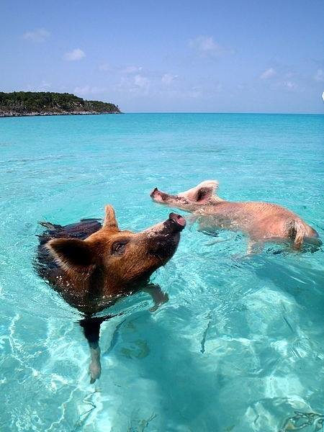

# Name:

## Date:

Level 3

Year 2 Animal Management Progression Workbook

2020

|  |
| --- |
| Be HonestBe Committed Introduction  Level 3 Animal Management Be Ready This Workbook is to give you some of the activities to further your knowledge ready for the second year of study moving onto L3 Extended Diploma. Use this Workbook to prepare yourself for the start of your second year of the college course. Please bring it with you on your first day back so we can see your progress. Be Committed You have now been accepted onto the second year, this does not mean you can take your foot off the gas! Within the Extended Diploma, theoretical study makes up about 70% of the course. You will be required to complete many forms of activities, assessments and yes another exam. Be Honest Continue to practice honesty in answering by using your existing knowledge for as much of the Workbook as you can! You can then go back and research the areas you were not sure of.  Try using two different coloured pens. Demonstrate your existing knowledge in one colour and then where required use a different colour to show answers you have researched.  This can then even be kept and used as revision material when you are completing assignments or preparing for your exams. Be Ready010203 |
|  |

|  |
| --- |
| Prefix and Suffix Definitions  Within the animal industry (especially Veterinary) we use prefixes and suffixes within terminology.  Define the terms:  Prefix:……………………………………………………………………………………………………………………………………………………………………………………………..  Suffix:…………………………………………………………………………………………………………………………………………………………………………………………….. |

|  |  |
| --- | --- |
| Prefixes | |
| Ante; | Anti; |
| Dys; | Ecto; |
| Endo; | Extra; |
| Hemi; | Haem; |
| Hyper; | Hypo; |
| Poly; | Pyo; |
| Infra; | Inter; |
| Intra; | Neo; |
| Peri; | Poly; |
| Post; | Pre; |
| Pseudo; | Retro; |
| Semi; | Sub; |
| Super; | Supra; |
| Trans; | Ultra; |

Provide the meanings for the following prefix and suffix words.

|  |  |
| --- | --- |
| Suffixes; | |
| centesis | cyte |
| ectomy | emesis |
| itis | logy |
| penia | pexy |
| phobia | plasia |
| phonea | phagia |
| stomy | tomy |
| rrhoea | toma |

|  |  |
| --- | --- |
| Label the Dog Skeleton  Use the labels below and place them where you think they are on this dog skeleton diagram. | |
| Skull Scapula Orbit Phalange Metacarpus Maxilla Mandible Humerus Ulna Carpus Radius Fibula Ribs Metatarsus Tibia Pelvis Femur Tarsus Sacrum Cervical Vertebrae Caudal Vertebrae Thoracic Vertebrae Lumbar Vertebrae Phalange |  | |

Restraint Equipment

Look at the listed equipment, list what species they can be used for. Then consider pro’s and con’s

|  |  |  |  |
| --- | --- | --- | --- |
| **Equipment** | **Species** | **Pro’s** | **Con’s** |
| *Muzzle (Basket)* |  |  |  |
| *Muzzle (Nylon)* |  |  |  |
| *Grasper* |  |  |  |
| *Towel / Blanket* |  |  |  |
| *Bag* |  |  |  |
| *Crush Cage* |  |  |  |
| *Gauntlets* |  |  |  |
| *Collar & Lead / Head Collar* |  |  |  |
| *Harness* |  |  |  |
| *Slip Lead* |  |  |  |

Understanding Parasites & Pathogens

Answer the questions below.

1. Describe how you can differentiate between an insect and an arachnid.
2. Describe how you could differentiate between a burrowing mite & a surface mite
3. List the zoonotic Ectoparasites and the zoonotic Endoparasites found in dogs and cats
4. List 4 ways in which dogs can become infected with *Toxocara Canis*
5. State the most common cestode of the dog & cat and describe how this tapeworm is transmitted.
6. Identify the cestode that has to be treated under the Pet Passport Scheme
7. Give examples of the pathogens that ticks are responsible for transmitting.
8. What distinguishes a virus from other organisms?
9. Describe the structure of a bacterial cell.
10. How do bacteria replicate?
11. How is ringworm identified?
12. What type of organism is *Echinococcus granulosus granulosus?*

Why is this an important pathogen to know about?

What is a hydatid cyst?

How is it transmitted? Name the hosts.

Identification of UK Wildlife

Look at each of the pictures below, identify the UK species.

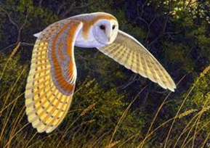

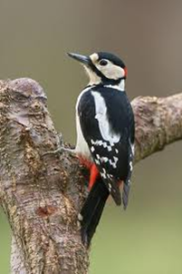

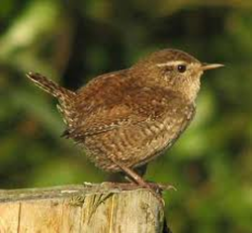

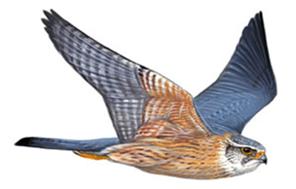

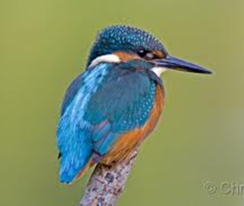

Answers:

List the field signs for any of these birds:

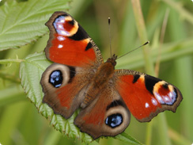

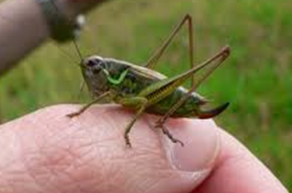

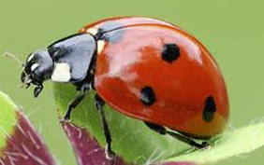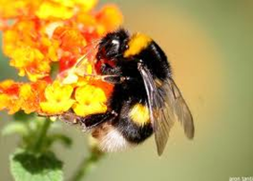

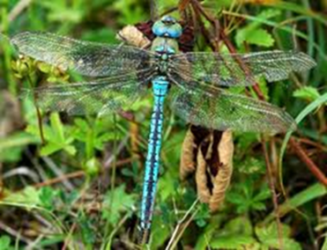

Answers:

List the field signs for any of these invertebrates:

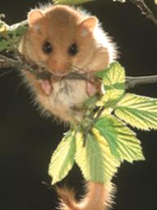

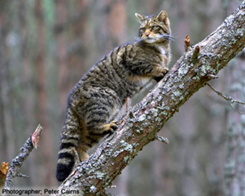

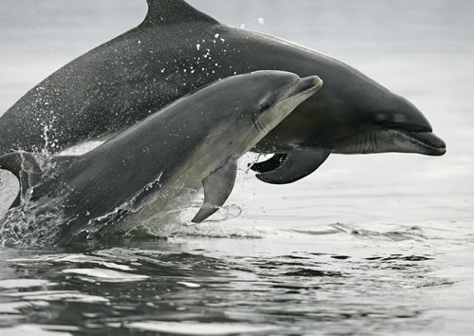

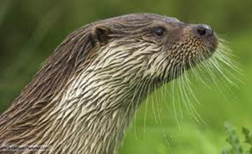

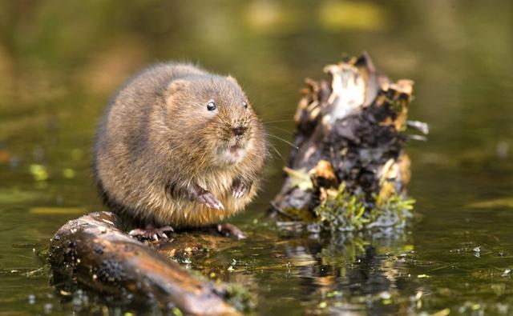

Answers:

List the field signs for any of these mammals:

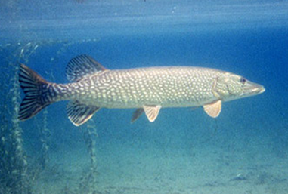

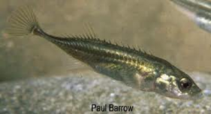

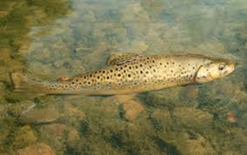

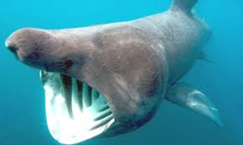

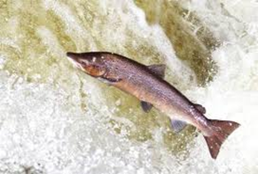

Answers:

List the field signs for any of these fish:

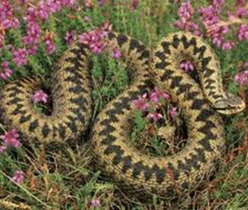

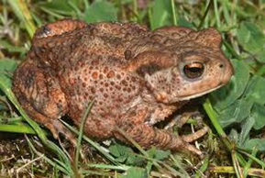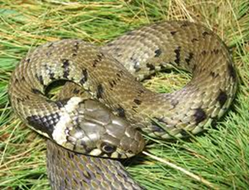

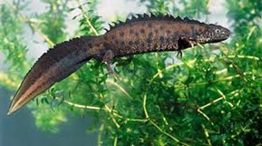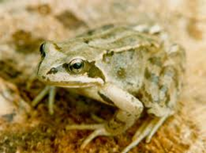

Answers:

List the field signs for any of these reptiles or amphibians:

Essential Nutrients

You have been given the essential nutrients for animal diets, answer the sections below.

|  |  |  |
| --- | --- | --- |
| **Nutrient** | **Function in the diet** | **2 sources in an animal diet** |
| Carbohydrates |  |  |
| Fats |  |  |
| Fibre |  |  |
| Protein |  |  |
| Vitamins |  |  |
| Minerals |  |  |
| Water |  |  |

Food Groups

Answer the questions below.

1. How are vitamins different from minerals?
2. Do all animals need the same amount of these food groups?
3. Cows and sheep etc. are called ruminants. How do their requirements differ from human requirements?
4. What sort of factors might affect how much protein a pig needs in its diet?
5. Which of the seven food groups do these substances belong in:
   1. sugar
   2. cholecalciferol
   3. phosphate
   4. xanthan
   5. triglyceride?
6. What is meant by a balanced diet?

Chemistry Links

You should have covered this in previous years of study, give the meaning to the word provided

|  |  |
| --- | --- |
| **Word** | **Meaning** |
| Atom |  |
| Molecule |  |
| Ion |  |
| Element |  |
| Ionic bond |  |
| Covalent bond |  |
| Acid |  |
| Base |  |
| Polymer |  |
| Monomer |  |

Temperature, Pulse and Respiration

You will learn how to monitor the health of animals and why this is important.

Have a go at the questions below

1. **The normal resting pulse rate range for a dog?**

a) 40 – 80 beats per minute

b) 60 – 180 beats per minute

c) 80 – 120 beats per minute

d )100 – 120 beats per minute

1. **What is the normal body temperature range of a rabbit?**

a) 36.6 – 37.1°C. (97.9 – 98.8°F)

b) 37 – 37.7°C. (98.6 – 99.9°F)

c) 37.8 – 38.2°C (100 – 100.8°F)

d) 38.5 – 40°C. (101.3 – 104°F)

1. **What is the normal body temperature range of a cat?**

a) 38 – 38.5°C. (100.4 – 101.3°F)

b) 39 – 39.3°C. (102.2 –102.7°F)

c) 38.3 – 38.7°C. (100.9 –101.7°F)

d) 37 – 38.5°C. (98.6 –101.3°F)

1. **What is the normal body temperature range of a dog?**

a. 38 – 38.5°C. (100.4 – 101.3°F)

b. 39 – 39.3°C. (102.2 –102.7°F)

c. 38.3 – 38.7°C. (100.9 –101.7°F)

d. 37 – 38.5°C. (98.6 –101.3°F

1. **CRT stands for?**
2. Cat refill Time
3. Capillary Response Time
4. Capillary Refill Time
5. **TPR is?**
6. Tachy Pulse Rate
7. Temperature Pulse Respiration
8. Tachy Pulse Respiration
9. All of the above
10. **The normal resting pulse rate range for a cat is?**

a) 60 – 140 beats per minute

b) 100 – 120 beats per minute

c) 110 – 180 beats per minute

d) 150 – 200 beats per minute.

1. **What is the normal respiration rate range in the dog?**

a) 10 – 30 breaths per minute.

b) 20 – 30 breaths per minute.

c) 20 – 40 breaths per minute.

d) 50 – 60 breaths per minute.

1. **The normal resting pulse rate range for a rabbit is?**

a) 100 – 120 beats per minute

b) 130 – 325 beats per minute

c) 190 – 250 beats per minute

d) 200 – 300 beats per minute.

1. **What is the normal respiration rate range in the cat?**

a) 10 – 30 breaths per minute.

b) 20 – 30 breaths per minute.

c) 20 – 40 breaths per minute.

d) 50 – 60 breaths per minute.

**14. What is the normal respiration rate range in the rabbit?**

a) 10 – 30 breaths per minute.

b) 20 – 160 breaths per minute.

c) 30 – 60 breaths per minute.

d) 40 – 180 breaths per minute.

Coat Types

You need to provide descriptions for the following coat types.

|  |  |
| --- | --- |
| Coat Type | Description |
| Double Coat Type 1 |  |
| Double Coat Type 2 |  |
| Short/Smooth |  |
| Wooly/Curly |  |
| Mixed |  |
| Silky |  |
| Wire |  |

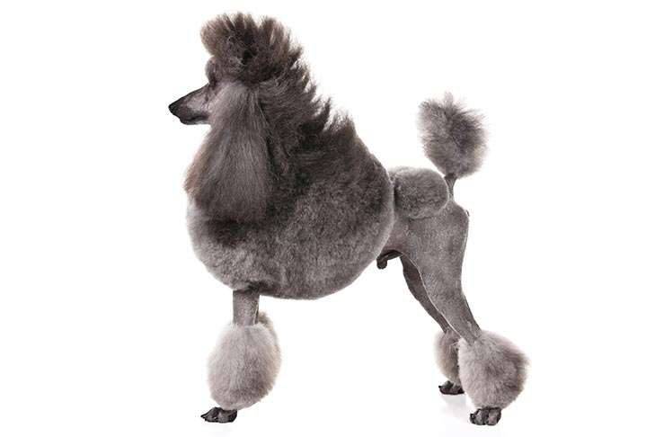What coat type doe these dog breeds have?

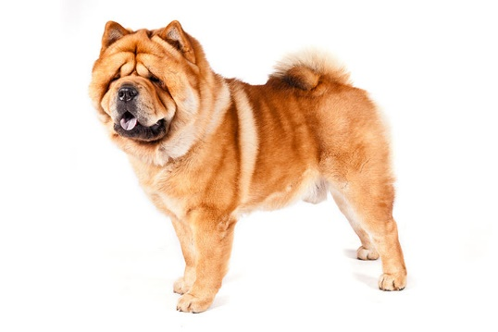

Dog Breed: Dog Breed:

Coat Type:

Coat Type:

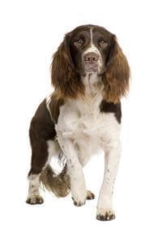

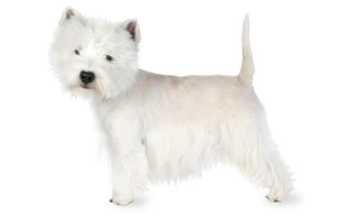

Dog Breed:

Coat Type: Dog Breed:

Coat Type:

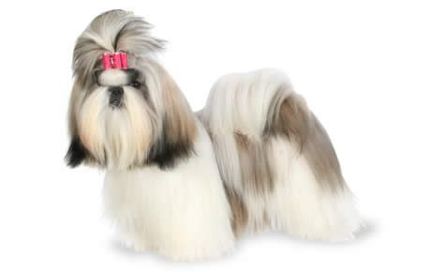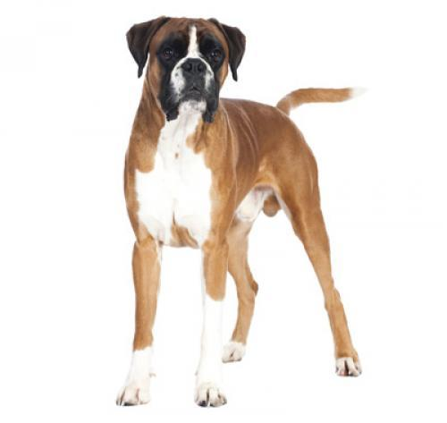

Dog Breed:

Coat Type:

Dog Breed:

Coat Type:

Shampoo!

Look at the listed shampoo examples below, match them with their correct descriptions.

* **Mild**

* **Cleansing**

* **Colour Enhancing**
* **Medicated**

* **Veterinary**

* **Insecticidal**

* **Conditioners**

Contains a strong substance which acts against grease and dirt and is ideal for dogs with a particularly dirty coat.

Removes grease and dirt but is mild enough to leave the natural oils in the coat.

Designed to kill parasites.

Contains a mild antibacterial product which act on the skin.

Prescribed by a veterinary surgeon for specific skin conditions.

Designed to enhance a particular coat colour of dogs.

Aid the grooming out of a knotty coat, they help the grooming out of long, silky and wool coats.

**List as MANY legislations as you can that you think relate to ANIMAL GROOMING**

Livestock Terminology

Write definitions of the following livestock terms.

|  |  |
| --- | --- |
| **Term (Sheep)** | **Meaning** |
| Ewe |  |
| Gimmer |  |
| Shearling |  |
| Lamb |  |
| Ram/Tup |  |
| Broken Mouth |  |
| **Term (Cattle)** | **Meaning** |
| Bull |  |
| Bullock |  |
| Calf |  |
| Cow |  |
| Heifer |  |
| Steer |  |
| Yearling |  |
| **Term (Pig)** | **Meaning** |
| Boar |  |
| Sow |  |
| Gilt |  |
| Piglet |  |
| Weaner |  |
| Finishing/Fattener |  |
| **Term (Chicken)** | **Meaning** |
| Hen |  |
| Pullet |  |
| Cockerel |  |
| Chick |  |
| Broiler |  |
| Layer |  |
| Broody |  |

Genetics Recap

Complete the questions below

1. Using the words below, complete these sentences

**78 chromosomes 39 DNA specific haploid diploid gametes inherited characteristics**

1. Every cell has tiny rod shaped bodies called..............
2. Genes determine the ..............of an animal.
3. Each cell of a dog has 39 pairs of chromosomes. This is a total of ...........single chromosomes.
4. Every organism has a ..............number of chromosomes.
5. The chemical compound that makes up the chromosomes is............
6. A dog sperm or egg has ..............single chromosomes.
7. Body cells have the chromosomes in pairs. These cells are known as ...............cells.
8. Egg and sperm cells are known as .................

i) Egg and sperm cells have a single set of chromosomes. They are known as ...............cells.

2. Add the type of cell division: **Mitosis, Meiosis or Both.**

1. The cell division that produces the sperm and egg is called .............
2. The cell division taking place in all tissues for growth and repair is called.............
3. The cell division that occurs immediately after the ovum is fertilised by the sperm is called ..............
4. The cell division that produces haploid cells is called................
5. The cell division that produces diploid cells is called ...............

3. Circle the correct choice. **Meiosis** only occurs in the:

1. sperm cells
2. egg cells
3. ovary and testis

d) skin

4. Circle the correct choice. During **Meiosis**:

1. the number of chromosomes are doubled
2. the number of chromosomes stay the same
3. the number of chromosomes are halved
4. the chromosomes become DNA

5. A gamete has: half / twice the number of chromosomes that a body cells has.

6. If the gamete of a mosquito has 3 chromosomes, how many chromosomes are there in the body cells?.............

7. If the body cells of chickens have 18 chromosomes, how many chromosomes are there in the sperm cells?..............

8. If the sperm and eggs cells of the housefly have 6 chromosomes, how many chromosomes are there in the maggot?.................

9. If human gametes have 23 chromosomes, how many pairs of chromosomes are there in human body cells?...............

10. The tissue(s) where mitosis occurs most rapidly is the:

brain / muscle / skin / intestinal wall / adult bone / blood / bone marrow

1. Complete the following table:

|  |  |  |
| --- | --- | --- |
|  | MITOSIS | MEOISIS |
| Purpose of division | Growth and repair |  |
| Where process occurs in the body |  |  |
| Number of chromosomes in the daughter cells after division |  | Half the original number |
| Daughter cells are | Identical to the parent cell |  |