Welcome to Art and Design Level 2

The Art and Design team have put together a project for you to complete over the summer which we would like you to bring with you on your first day of Art and Design Level 2.

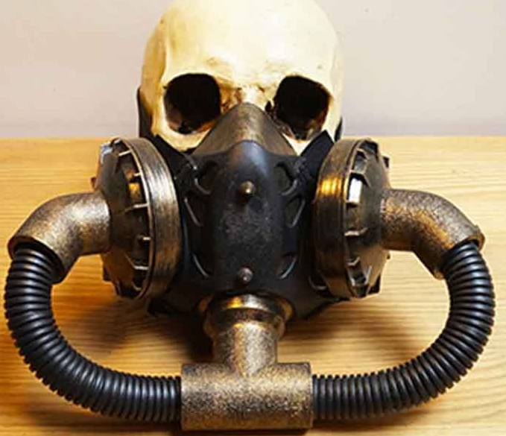
The theme is: Culture/masks
Task 1:
Create a mood board
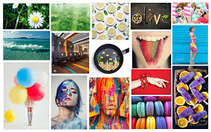
A mood board is a collection of images on an A4 or A3 size paper relating to the theme culture. Look for exciting examples on the internet and print these off to create your mood board. You can look at lots of different cultures, for example Native American, Mexican day of the dead, African, Asian and even steam punk. Look for exciting colour, pattern and materials.
Task 2:
Design your facemask using the face template at the back of this pack. Draw your design so that it only covers your nose and mouth, but the patterns and materials you use might extend out of this area.
You will need to create a half face mask design on a face chart and complete a mood board
Task 3:
Once you have come up with a design, we would like you make the mask at home. Use the recycled pop bottle as shown at the back of this pack. You can use as may pop bottles as you like. Decorate your mask using any materials you have access to.

Task 4:
Take photos and make a video of someone wearing your mask. Think about photographing and filming the person wearing your mask at different angles. Think about close ups. What could the background be? These images can be printed out and stuck onto paper or can be put onto a power point ready to show on the first lesson.

Task 5:
Below is a list of questions that need to be answered in an assignment format. This will also be handed in on your first lesson to your tutor to be marked.
Q1. What different cultures did you find interesting? Explain why?
Q2. What interesting and unusual materials did these cultures use?
Q3. What was the purpose of the masks in each culture?
Q4. When you were making you mask, what did you find difficult?
Q5. How did you solve these problems?
Q6. What other types of masks are there? What is the purpose of these masks? (You can use images from the internet to help you)

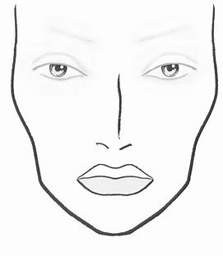
Face Mask Template

Pop bottle Mask template

