**Level 3 Aviation Operations**

____________________________________

INDUCTION TASKS

Dear applicant,

As part of the Induction process on to Aviation Operations Level 3, you will be required to complete a range of tasks.

Every airport has a three letter code to distinguish it from another.

**Task 1** - Find the 3 letter airport codes for the following UK airports:

Aberdeen

Glasgow

Edinburgh

Newcastle

Teeside

Humberside

East Midlands

Manchester

Doncaster Sheffield

Stansted

Luton

Gatwick

Heathrow

Southampton

Bristol

Birmingham

Liverpool

Belfast

**Extension Task**

Locate the airports that you have found on the map of the UK

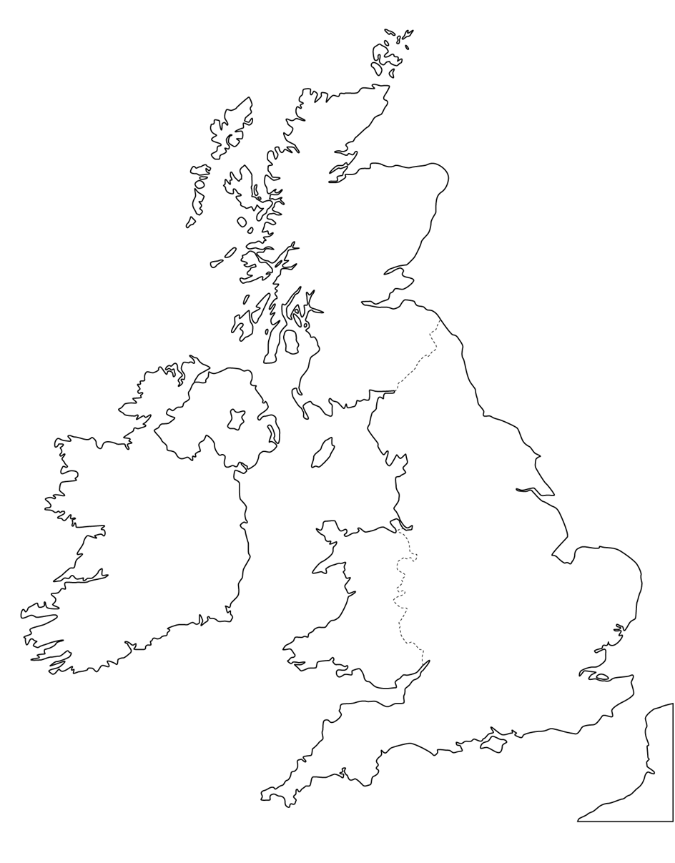

Please bring your completed work to College on the first day of term to be marked.

If you have any questions, please contact me on: Susan.barton@sheffcol.ac.uk

Kind regards,

Sue Barton – Aviation Department, Sheffield College