TROWEL OCCUPATIONS
Diploma in Bricklaying

Pre-enrolment questions 2020

This document will be used to gauge your understanding of brickwork before starting our Brickwork program. Brickwork and Bricklaying is not just about laying bricks it involves many aspects of the built environment.
Answer the questions below, you will be given marks for working out, and correct answers. You are free to use a calculator or your phones calculator.

1 Look at the diagram of the garage below.
What is the area of this garage wall?
- 10.92mm²
- 10.92m²
- 10.92m
- 7.3m²
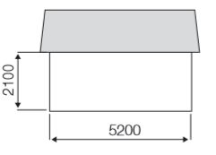

Answer.

2 This wall has a gable end.
What is the total area of the wall and gable end?
- 41.3m²
- 32.55m
- 32.55m²
- D44.45m²

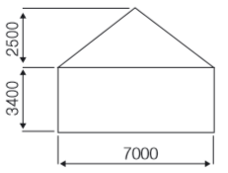

Answer.

3. An experienced bricklayer can lay approximately 1 m² of brickwork per hour. How long will it take to lay 6m² of brickwork?
A. 60 minutes
B. 6 hours
C. 0.17 hours
D. 60 hours
Answer.

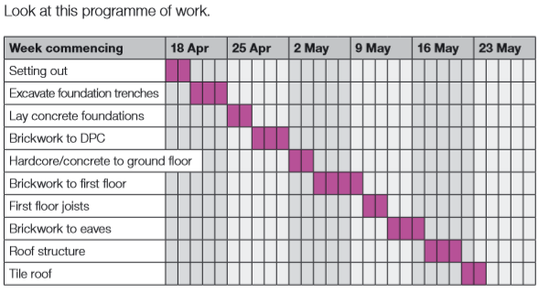

4. On what date is work to excavate the foundation trenches planned to start?
A. 20 April
B. 21 April
C. 22 April
D. 25 April
Answer.

5. On what date is work to the first floor joists planned to start?
A. 9 May
B. 10 May
C. 11 May
D. 12 May
Answer.

6. You have worked out that you need 250 blocks to complete a job. Allowing five per cent for wastage, how many should you order?
A. 262
B. 237
C. 263
D. 238
Answer.

7. Which of these definitions describes a lintel?
A. Beams that support a ceiling
B. Covering or coating on a structure
C. Beams that form part of the framework of a roof
D. A piece of concrete , timber, stone or steel across the top of a door or window
Answer.

8. Look at the plan of the garage
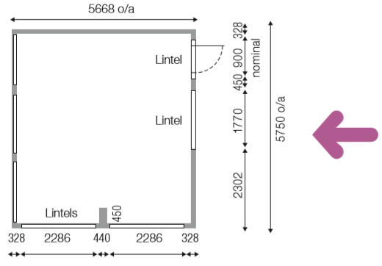

Imagine that you are standing outside the garage, facing the wall that the arrow is pointing to. Which of these four views is the one that you will see?
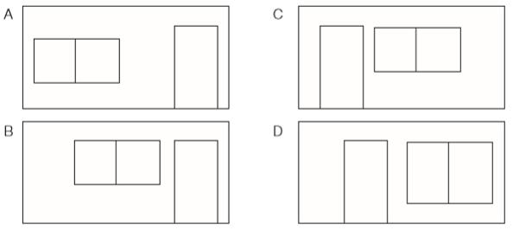

Answer.

9. How wide is the garage door designed for car entry?
A. 900mm
B. 1,770mm
C. 2,286mm
D 2,303mm
Answer.

