To
The Sheffield College
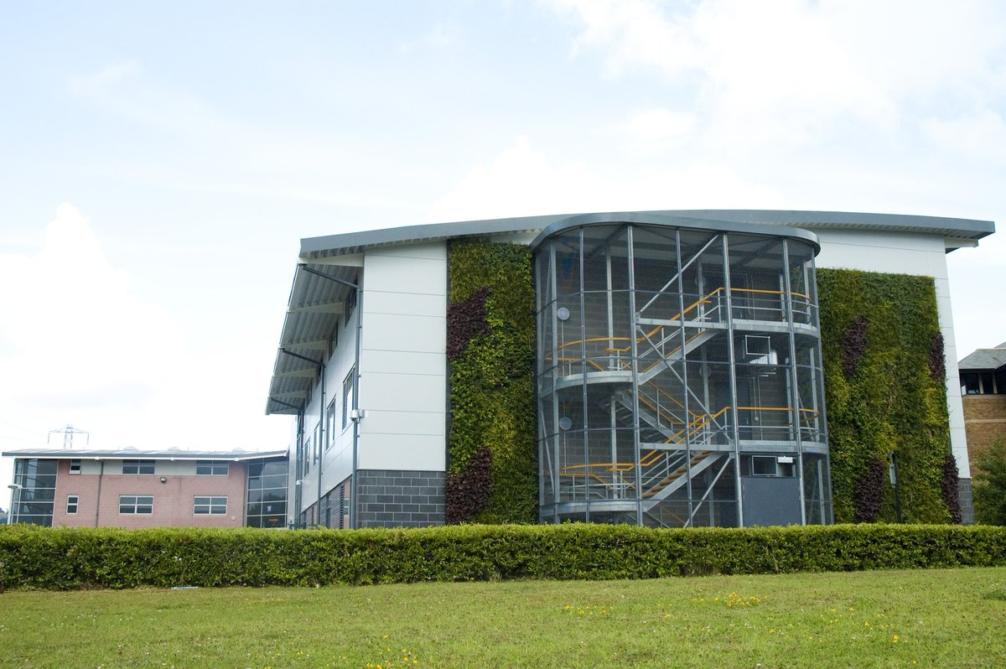

Welcome to Health and Social care

Welcome all prospective students from the Health and Social Care Team at The Sheffield College.

We are looking forward to the next academic year and in preparation for that we have designed a range of tasks to prepare for the diverse topics we will cover.

We will be looking to test your subject knowledge on a range of units we teach on the Level 3 qualification.

Please work through this booklet in preparation for starting the course.
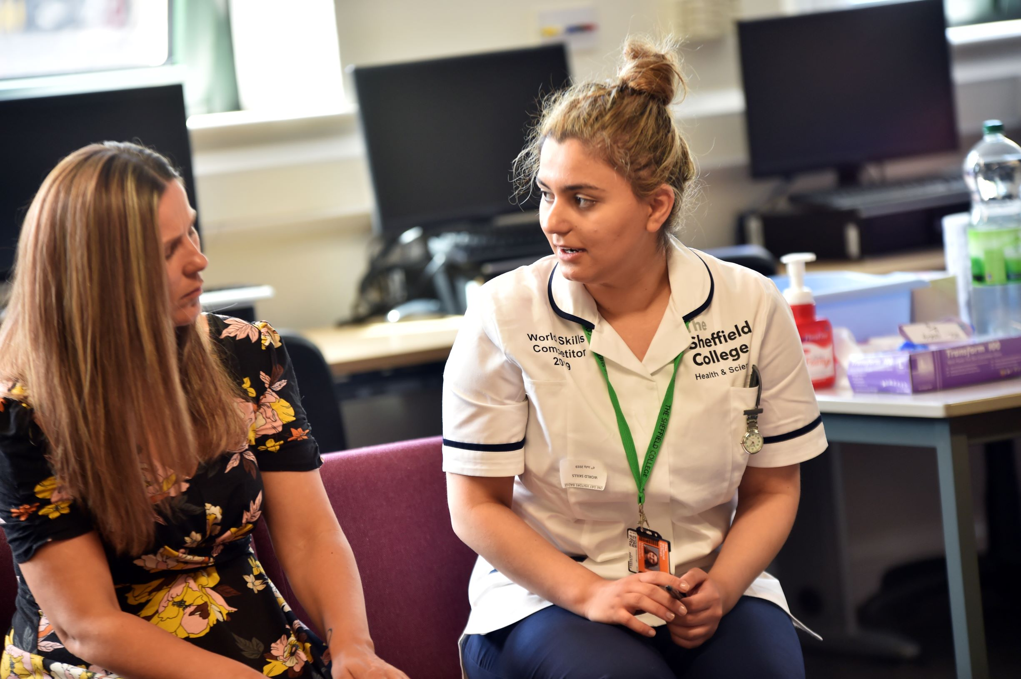
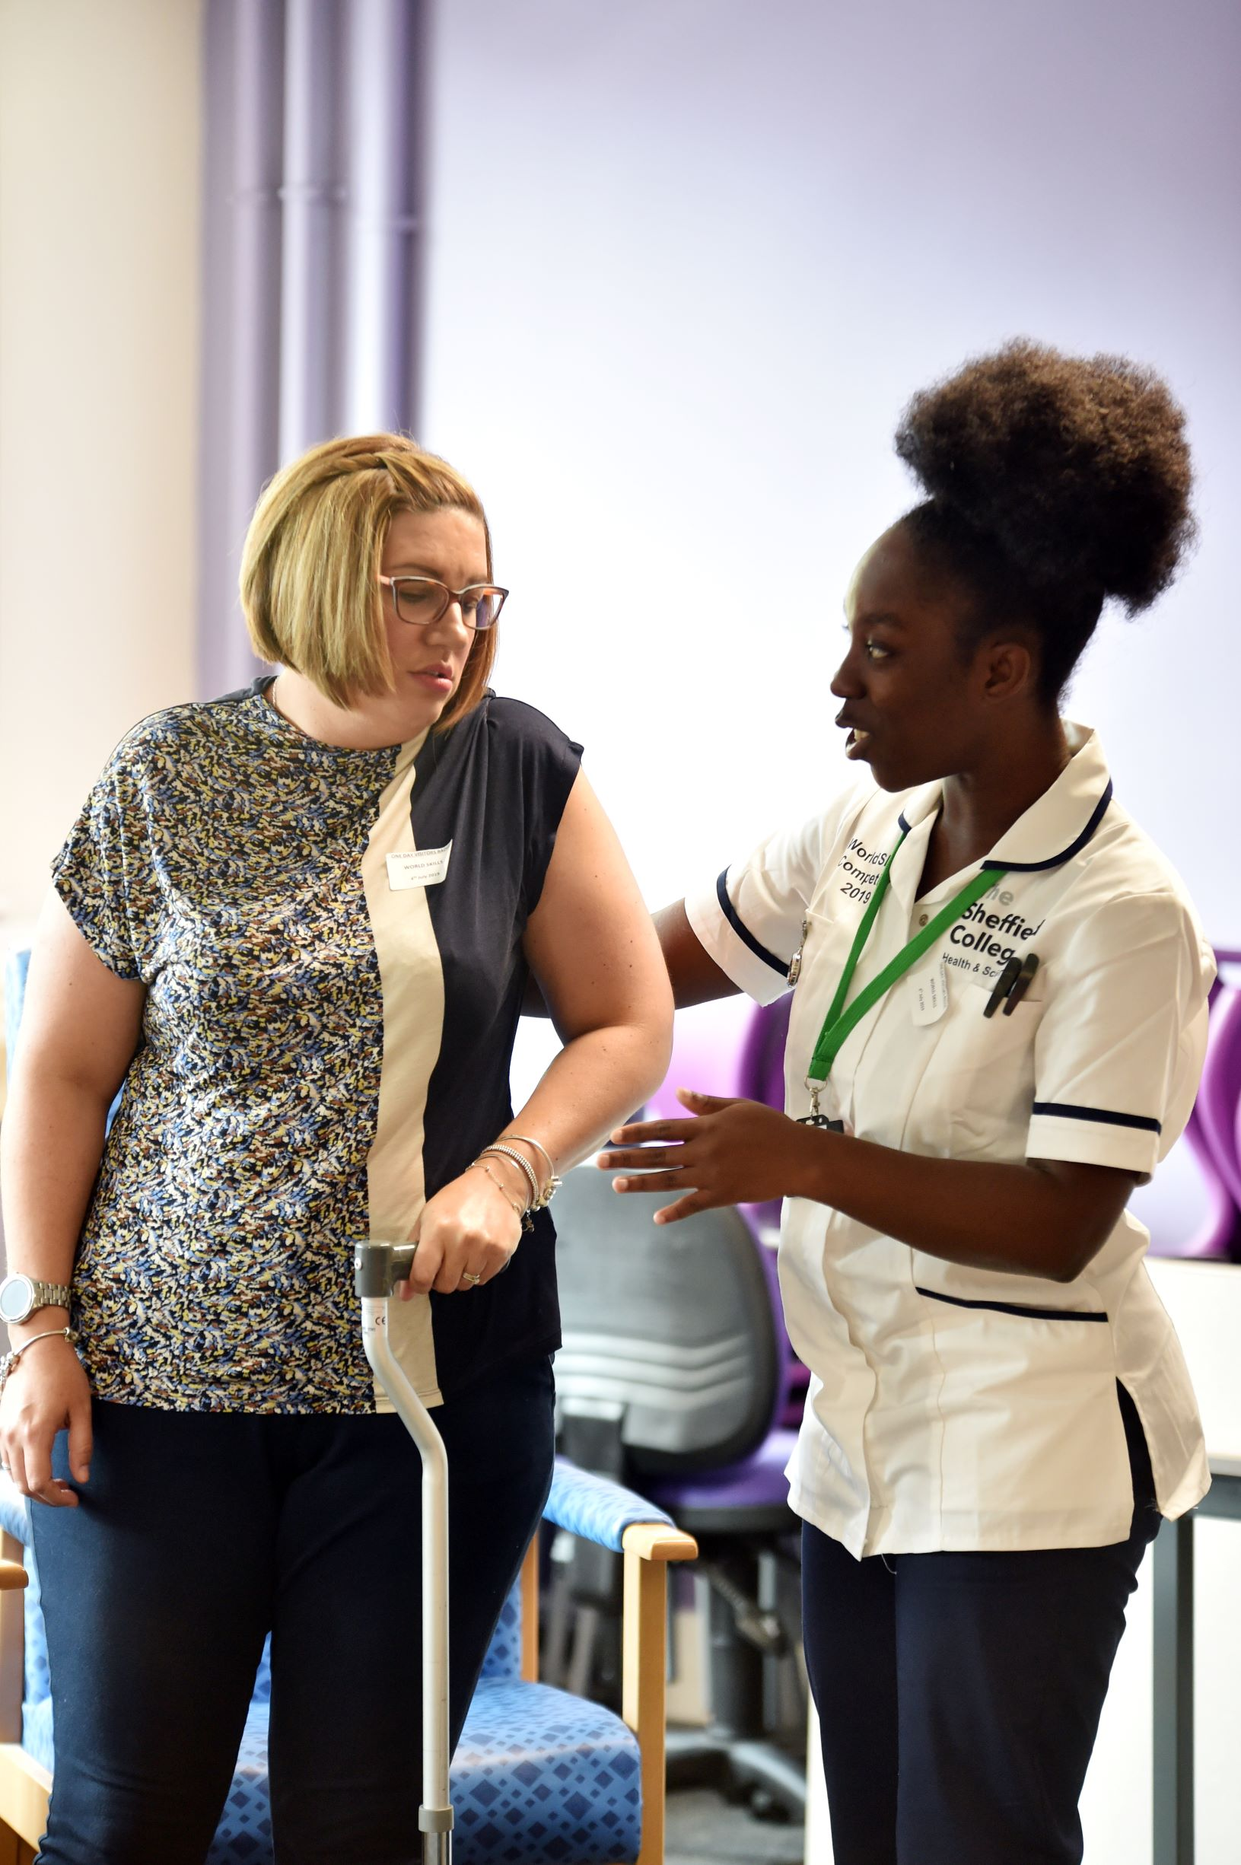

Getting to know you
Double click on the boxes to fill them in. You can use words, pictures or both.

This is me!
My family
My Friends
I like
I don’t like
What is good about me?
What i’d change about me
Life is good because
Life is hard because
If I had a magic wand
If I could have one question answered it would be
The Future

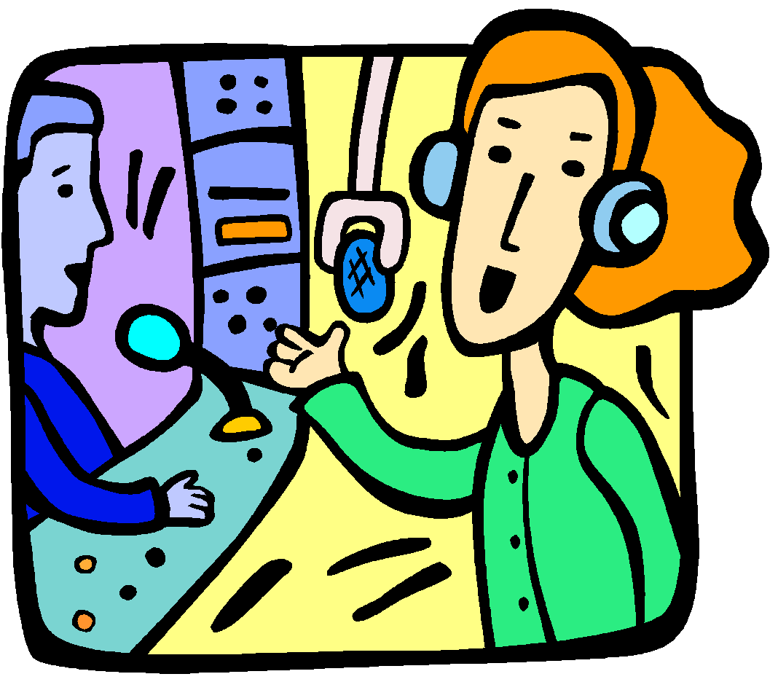
Personality Matching for Careers
Understanding your own personality is crucial when looking at possible careers.There are no right or wrong answers here. Just give the highest score (3) to the statements you agree with most. Be honest with yourself and see how different you are from your neighbour!

How much of an extrovert are you? | 1,2 or 3 | How much of an introvert are you? | 1,2 or 3 | How much of a perceiver are you? | 1,2 or 3
Have high energy |  | Listen more than talk |  | Like to keep their options open
Talk more than listen |  | Think quietly inside their heads |  | Are less aware of time and may run late
Think out loud |  | Think, then act |  | Play first, work later
Act, then think |  | Feel comfortable being alone |  | May have difficulty making some decisions
Like to be around people a lot |  | Prefer to work "behind-the-scenes" |  | Question the need for many rules
Can sometimes be easily distracted |  | Have good powers of concentration |  | Want the freedom to be spontaneous
Prefer to do lots of things at once |  | Prefer to focus on one thing at a time |  | Like to  start new things
Total |  | Total |  | Total
How much of a thinker are you? | 1,2 or 3 | How instinctive are you? | 1,2 or 3 | How much of a judger are you? | 1,2 or3
Enjoy solving problems using logic |  | People think you are warm and friendly |  | Like to know what’s going to happen next
Appear calm and keep your distance |  | Make decisions based on what feels right |  | Like to make & stick with plans
Are honest and direct |  | Try not to upset people |  | See the need for rules
Like people to be honest with you |  | Avoid arguments |  | Work first, play later
Don’t get upset by what people say |  | Are quick to complement others |  | Like to finish one job before moving on to the next
Good at spotting mistakes |  | Worry about what other people say about you |  | Take responsibilities seriously
Enjoy working to achieve something |  | Enjoy working to help or impress others |  | Like to stick to a timetable
Argue for fun |  | Like to get on with everyone |  | Usually on time
Total |  | Total |  | Total

Most people will have a mixture of personality traits. Try to think of three jobs which would be suitable for someone with high scores in these areas:
Extrovert 1 2 3
Introvert 1 2 3
Thinker 1 2 3
Instinctive 1 2 3
Judger 1 2 3

Below are 3 scenarios from 3 different roles that can be found in Health and Social Care. Read through each role and then choose one that appeals most to you. Highlight your choice.

Scenario 1 - Helen is a paediatric nurse for a large hospital in the city centre.
My shift was a day shift, 7am - 7:30pm, on a busy general paediatric ward, where we admit children from the ages 0-15 years. I go to hand-over where the nurse in charge from the night shift tells us all about the patients on the ward. Generally, when I am in charge I don’t have patients, but occasionally due to staffing or the dependency of the patients, the nurse in charge takes patients too. Today I have two – a child admitted with a wheeze, and a teenage girl with abdominal pain waiting for an appendectomy. The child with a wheeze is due a nebuliser at 8am so I record his observations – this includes temperature, heart rate, respiratory rate, oxygen saturations and respiratory effort. I ask the doctors to review him – our aim is to gradually decrease the frequency of the nebulisers until the child is well enough to go on to inhalers and then they can continue these at home. The doctors review and decide this child can wait for a nebuliser until the ward round starts and the consultant can see him. Next I see the teenager with abdominal pain. She is nil by mouth awaiting an appendectomy. I check her pain score – she is fairly comfortable at the moment. She knows she can’t eat or drink now so I leave her to rest. She is on intravenous fluids so I check the volume infused and record this. I also check her cannula site to make sure it is still working well. Her mum is resident and she knows the plan – we are just waiting for a phone call from theatres to say they are ready. I tell mum where she can make a cup of tea if she wants one.

Scenario 2 - David is a social worker in a local community of the city area.
The first job of the day is to check through emails that have arrived overnight and open any mail. In order to minimise time spent on administrative work it is essential to prioritise, which means highlighting tasks that must be completed today, diarising those that can be left for later and in some cases disregarding certain items altogether. The key point is not to overlook anything of importance. The next part of the day may be taken up preparing for meetings with clients; for example in relation to a household in which a child has suffered suspicious injuries, or maybe regarding a client who has been identified as having learning disabilities and who needs care plan-preparing. Prior to attending any meeting, it is essential that I read the relevant case notes thoroughly in order to ensure I have a clear understanding of what the issues are. It may also be necessary to write up notes from client visits that I have carried out the previous day and add a proposed action plan and assessments that have to be forwarded to my supervisor. The longer that writing up notes is delayed, the more difficult it is to remember potentially important points. A regular part of my role is to attend meetings that have a diverse number of people involved. Many of the issues dealt with can be extremely delicate, and it is inevitable that discussions may become heated and occasionally physical.

Scenario 3 - Jordan is a paramedic within the NHS, based within the city area.
It is 4.30am on Saturday morning and my alarm goes off - time to wake up and get ready for my shift. I am on the 6am-6pm Fast Response Vehicle (FRV) shift today. The role of the FRV is to attend the more serious 999 calls. These are Red 1 and Red 2 calls where an ambulance is required at the scene within a target time of eight minutes. The FRV carries a LUCAS, a machine that automates chest compressions in a cardiac arrest patient. This allows the paramedic to carry out Advanced Airways and Intravenous Access for drug and fluid therapy if required. We start off with the Red checklist, which needs to be completed before we can book on with control. This includes defibrillator checks, gas checks and drug bag checks. We book on with control and immediately our radios start vibrating and alarming. A case has been allocated to our vehicle. The message on the radio screen advises 'Return to Vehicle Emergency Call'. Back in the vehicle we have a look at the Mobile Data Terminal System (MDT) that gives us all the details we need. This is a Green 1 call, also known as a G1. This is classified as an emergency call but not life threatening, meaning that an ambulance or FRV needs to be on scene in 18 minutes. As I get in the vehicle I read the screen and it states 'vehicle RTC (road traffic collision) rollover car on fire'. The patient has been ejected from the care. We attend the patient who is quickly assessed for C-spine as she needs to be moved. My mentor immediately calls for assistance from Helicopter Emergency Medical Services (HEMS) and additional crew. He also checks that the fire service is en route and confirms the details of the incident with control.
Challenge: What made you choose this scenario? Did something appeal to you/stand out? Explain your thoughts below.

From your choice on the previous page, answer the question below. Be as honest as you can and really think about each.

What skills, qualities, attitudes and positive behaviour attributes do you think the role requires?

Skills | Qualities | Attitudes and positive behaviour

Challenge: List one from each category, that you believe you would need to work on. State some ways you think you can do this.

Complete the word search below to find keywords linked to equality and diversity.

M | D | O | Y | X | S | G | O | E | I | S | S | I | E | X
R | R | I | C | T | E | T | T | G | E | M | E | N | C | A
A | E | U | V | N | I | H | H | C | B | T | I | C | A | S
J | W | S | D | E | N | L | N | G | F | Z | T | L | R | N
A | U | E | P | I | R | E | A | V | I | G | I | U | Z | O
S | R | Z | C | E | R | S | G | U | U | R | N | S | C | I
E | C | I | O | E | C | F | I | I | Q | Y | U | I | U | G
S | T | B | F | X | C | T | S | T | P | E | T | O | L | I
Y | L | F | V | B | S | C | J | S | Y | B | R | N | T | L
D | I | S | A | B | I | L | I | T | Y | D | O | C | U | E
D | E | L | Y | T | S | E | F | I | L | S | P | N | R | R
L | F | A | I | R | N | E | S | S | L | X | P | N | E | E
C | V | L | A | G | E | I | V | R | R | X | O | T | R | B
H | O | S | E | U | L | A | V | G | Q | B | P | A | S | J
P | X | N | X | C | R | H | I | P | D | J | C | E | I | Q

AGE GENDER FAIRNESS
INCLUSION VALUES RIGHTS
LIFESTYLE CARE ETHNICITY
OPPORTUNITIES CULTURE
POLITICS DIFFERENCES
RACE DISABILITY
RELIGION DIVERSITY
RESPECT EQUALITY

Answers to the keywords linked to equality and diversity wordsearch.

M | D | O | Y | X | S | G | O | E | I | S | S | I | E | X
R | R | I | C | T | E | T | T | G | E | M | E | N | C | A
A | E | U | V | N | I | H | H | C | B | T | I | C | A | S
J | W | S | D | E | N | L | N | G | F | Z | T | L | R | N
A | U | E | P | I | R | E | A | V | I | G | I | U | Z | O
S | R | Z | C | E | R | S | G | U | U | R | N | S | C | I
E | C | I | O | E | C | F | I | I | Q | Y | U | I | U | G
S | T | B | F | X | C | T | S | T | P | E | T | O | L | I
Y | L | F | V | B | S | C | J | S | Y | B | R | N | T | L
D | I | S | A | B | I | L | I | T | Y | D | O | C | U | E
D | E | L | Y | T | S | E | F | I | L | S | P | N | R | R
L | F | A | I | R | N | E | S | S | L | X | P | N | E | E
C | V | L | A | G | E | I | V | R | R | X | O | T | R | B
H | O | S | E | U | L | A | V | G | Q | B | P | A | S | J
P | X | N | X | C | R | H | I | P | D | J | C | E | I | Q

Challenge: Define the following terms:

Equality -

Diversity -

Why are these important in health and social care?

Match up the command words below with their descriptions of what is required to achieve them.

Outline |  | Provide key points about different ideas or strengths and weaknesses of an idea.
Suggest |  | Set out main characteristics. Give a brief statement to show main features but not the detail.
Discuss |  | Make an idea, situation, or problem clear (to someone) by describing it in detail by revealing data or facts. Usually includes how and why.
Describe |  | Put forward for consideration (a viewpoint).
Explain |  | Use information acquired and your own knowledge to consider evidence for and against.
Evaluate |  | Separate information into step by step components and identify their characteristics. Say how one thing impacts on another.
Analyse |  | Give an account in words (of someone or something) including all the relevant characteristics, qualities or events.

Answers to the above key word match up activity.

Outline |  | Provide key points about different ideas or strengths and weaknesses of an idea.
Suggest |  | Set out main characteristics. Give a brief statement to show main features but not the detail.
Discuss |  | Make an idea, situation, or problem clear (to someone) by describing it in detail by revealing data or facts. Usually includes how and why.
Describe |  | Put forward for consideration (a viewpoint).
Explain |  | Use information acquired and your own knowledge to consider evidence for and against.
Evaluate |  | Separate information into step by step components and identify their characteristics. Say how one thing impacts on another.
Analyse |  | Give an account in words (of someone or something) including all the relevant characteristics, qualities or events.

Challenge: Look at your mobile phone, put it in front of you on your work space! Now try to-

Outline your phone…..

Describe your phone…..

Explain your phone…..

Challenging Behaviour in the workplace.

In your future career, there will be times that you come up against some challenging behaviour. This may be on a hospital ward, in a care home, in a school setting or in your daily home life. Watch the video (follow the link by clicking on it, or cut and paste the link into a new browser window, then answer the following questions).

https://www.youtube.com/watch?v=WE65yrnsrPk

- Which situations did you think were challenging for the student nurse worker?

- Did the student nurse manage the situation well? Explain why you think this.

- What would you have done differently?

- What did the female nurse do differently to build the relationship up from the student nurse?

- How did the female nurse change her body language and tone to accommodate the patient?

- What issues are there addressing patients with dementia and the techniques seen in this video?

Challenge: What challenges do you believe you will face in your future career? State your career choice first.

COVID 19

This has been a difficult time for all of us. You may have found this frustrating, lonely, scary or isolating. But you may also have found this time stimulating, challenging, found opportunities to develop new skills and ways to deal with things. Safety has been a key concept throughout this time. Considering this answer the questions below.

- What sort of PPE (Personal Protective Equipment) should be worn by those in the NHS treating people suffering from COVID-19?

- If someone had told you 6 months ago that the lockdown was going to happen, what would you have done to prepare?

- What are 3 things you have done well during the pandemic?

- How have you helped others during the pandemic?

Challenge: What have you learned about your attitude towards your education during the lockdown?

Psychology - How do we learn…?

There are many ways we can learn new things; think about the examples below and describe how you might learn it:
Riding a bicycle

Swimming

Reading

Writing

Some Psychologists suggest that we learn how to behave by watching others. One example of this can be seen in this video. Please watch this video clip (https://www.youtube.com/watch?v=kJppnQsBNzs)
Give 4 examples of behaviours that you believe are learned in this way; to give an example, it has long been believed that if someone significant in your life e.g., parents, siblings, relatives, friends, smoke cigarettes then YOU would also smoke cigarettes.
It is important to note that the opposite is seen quite often; for example, children/youths who see their parents smoking may feel that it is wrong/disgusting etc., therefore will not smoke cigarettes.
 | The observed behaviour | The response…..
1.
2.
3.
4.

The 5 wells to a balanced life.

Many believe that to live a balanced, healthy and happy life we need to have a good balance from the 5 wells

- Cognitive well –Something for the brain to work on reading books, watching plays, debating, planning, college work.
- Emotional well – fun time, friendship, family, love, expressing feelings.
- Creative well – senses, imagination, arts, write, sing, music.
- Physical well – exercise, relax, eat well and sleep well.
- Spiritual well/ mindfulness well – religion, meditation, nature.

These ‘wells’ cover every part of our lives and if we make time for each of them during the week, our lives will be more stable, happier, more productive and more energetic.
Thinking about your week and your daily activities ask yourself if you have a balanced life:
Such activities include

- · Gardening – emotional, creative, physical, spiritual
- · Yoga – physical, spiritual, creative
- · Read Novels – cognitive, emotional
- · Write my blog – creative, cognitive, emotional
- · Eat dinner with my family – emotional, physical
- · My job – cognitive, emotional, creative, physical
- · Visit family - emotional

After filling in the 5 wells (see diagram on the next page), observe which well is fuller.
Then look at the less full wells and think about things you can do to fill this more. (Write your ideas in the space below the text).

When you have a similar number in all the wells you should be living a more balanced life try new things and add to the wells.
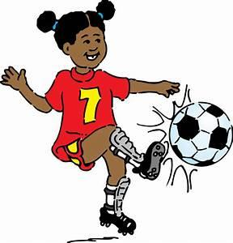
Physical Activity
Mindfulness

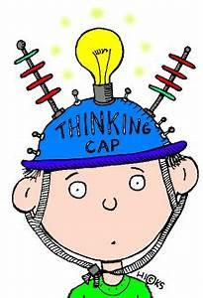
Cognitive
The 5 wells to a balanced life
Cognitive
Creativity
Fun and enjoyment

Health and Safety

When visiting a patient at home, it is vital you ensure your own safety too. The patient may not be able to move around as freely as before or have all the help available at all times. Having things to hand can sometimes mean clutter. A patient that is home-bound may also suffer from depression. Depression is a mental health related disorder that really impacts on a person's health and wellbeing. Their desire to carry out the simplest of tasks can be diminished. They can get into a cycle and find it difficult to break this without medical support. If you visit a patient that is home-bound and find hazards, you should ensure you take extra care to protect yourself.

Look at the image below, circle all the hazards you can see that may cause you or the harm.

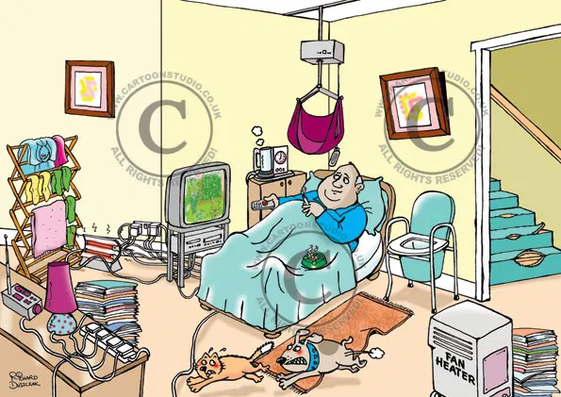

Challenge: Pick 5 of the hazards state what harm they can cause you and what precautions you can take to avoid/remove this hazard. Record your results in the table below.

Hazard | Risk | Precaution

Health and Social Care quiz

We are looking forward to the next academic year and in preparation for that we have designed a quiz to test your understanding of the topics we will cover.
We will be looking to test your subject knowledge on a range of units we teach on the Level 3 qualification.

We will be looking at your understanding of the following: Human Body, Disease, Safeguarding, Nutrition, Communication, Life-stages, Professional practise and some multidisciplinary topics.

Please follow the link below to the quiz:
https://docs.google.com/forms/d/11Y6nC5Mj1PCtNvkFxBcfiboQQ6ooQZUHrbdQnVD1ejQ/edit?ts=5ebc2831

Extra sources of information:

Maria Ferreiro Peteiro, Elizabeth Rasheed, Linda Wyatt, Pete Wedlake- CACHE Level 3 Extended diploma in Health and Social Care
John Ovretvei - Interprofessional Working for Health and Social Care
Jon Glasby - Understanding Health and Social Care (Third Edition)
Anne Claveirole & Martin Gaughan - Understanding Children and Young People's Mental Health.
World Health Organisation.
UK GOV Legislation.
NHS.UK/Conditions.
Social Care Institute for Excellence (SCIE).
Nursing and Midwifery Council (NMC).
Health Care Professions Council (HCPC).

Before you start the course:

Make sure you have completed the quiz above

Come prepared with any resources you may need such as pens, paper and books or a laptop.

Think about the questions you may have for the start of the course. If you have any questions you need answering before you start, please contact info@sheffcol.ac.uk

