Level 1 Land-based Studies
Pre-Enrolment Pack
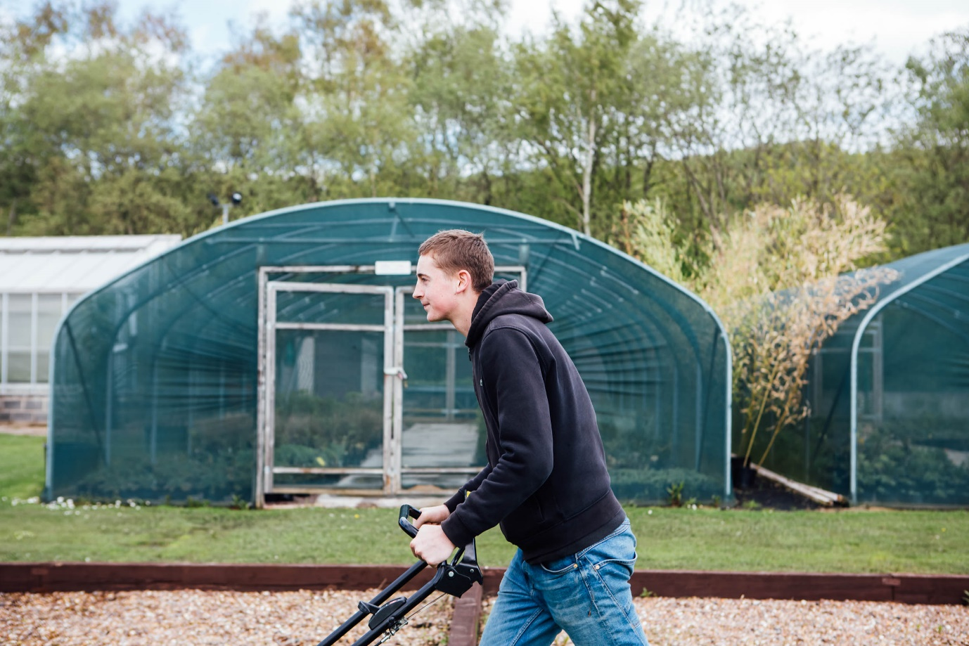

This pack has been produced to give you an indication of some of the work you will undertake whilst studying at The Sheffield College. Much of the work is practical but this will give you some background knowledge prior to starting your studies.

Section 1
This section is based around plant identification, look at the pictures of plants and try to identify them. You may have seen them in your local community, park, or even your own garden.
Good luck.
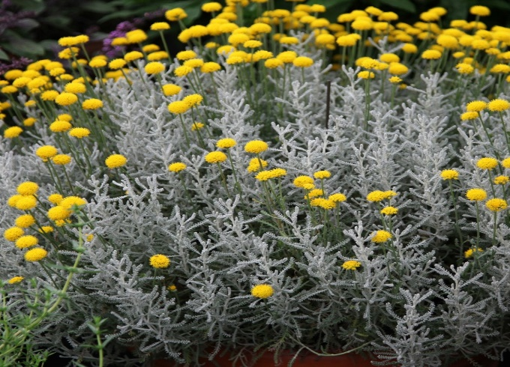

Plant name ……………………………………

Plant name…………………………………….

Plant name…………………………………..

Plant name…………………………………..

Plant name……………………………………

Section 2
This section relates to tools you will use whilst studying your chosen qualification. Try to work down the list and write the name in the space provided.

Tool name………………………………….

Tool name…………………………………..

Section 2 continued

Tool name……………………………………..
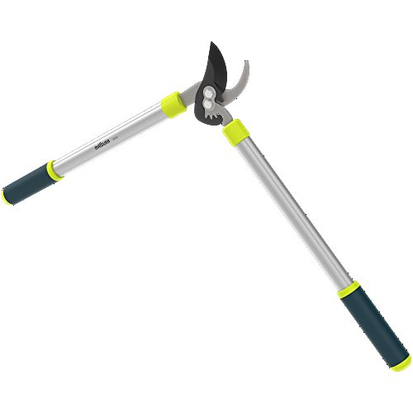

Tool name……………………………………
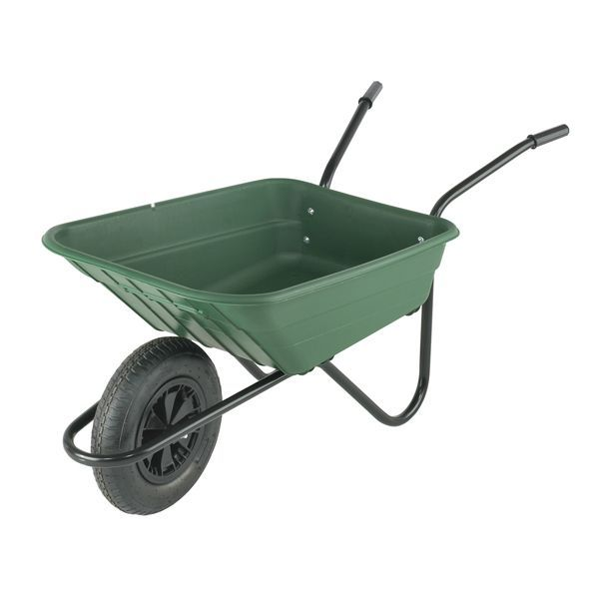

Tool name…………………………………..

Section 3
This section relates to famous Horticulturalists, see if you can identify the celebrity.

BBC Presenter (A) ……………………………………

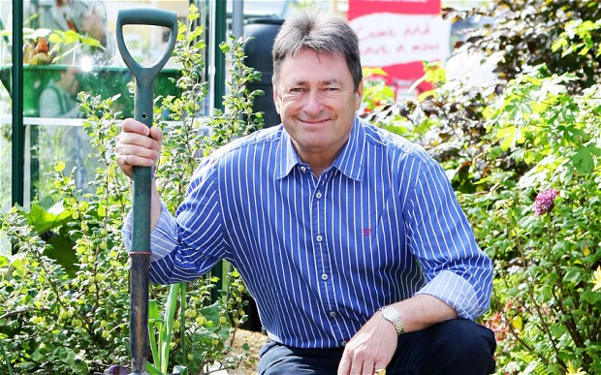

ITV Presenter (B) ……………………………………….

Name the TV programmes they present? Presenter A……………………….
Presenter B……………………….

Section 4
This section is question based, try to answer the questions. Anything you do not understand can be clarified once you start college.

Q1 Name two practical tasks you expect to undertake once you start at
college?

…………………………………………………………………………………………………………………….

…………………………………………………………………………………………………………………….

Q2 Do you enjoy practical or classroom-based work the most?

…………………………………………………………………………………………………………………….

Q3 Can you name the machines below, these are machines you may use
whilst studying level two courses?

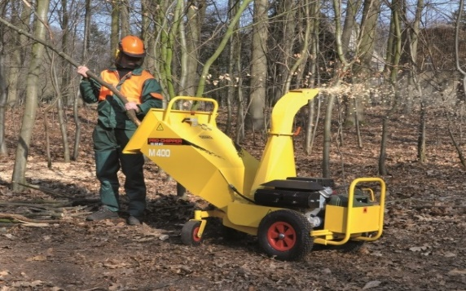

Name………………………………………… Name……………………………………….

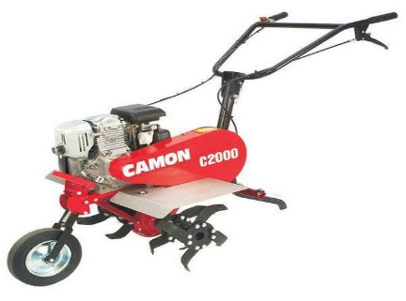

Name……………………………………….. Name……………………………………….

Section 5
You have now completed your tasks which have hopefully given you an insight into the Land-based industry.
If you have any questions do not hesitate to contact the department on 0114 2602541. Alternatively, you can write them down on the space provided below and ask then on your first day.
We look forward to seeing at the start of your course.
Thank you.

Questions

……………………………………………………………………………………………………..

………………………………………………………………………………………………………

………………………………………………………………………………………………………

………………………………………………………………………………………………………

………………………………………………………………………………………………………

………………………………………………………………………………………………………

………………………………………………………………………………………………………

………………………………………………………………………………………………………

