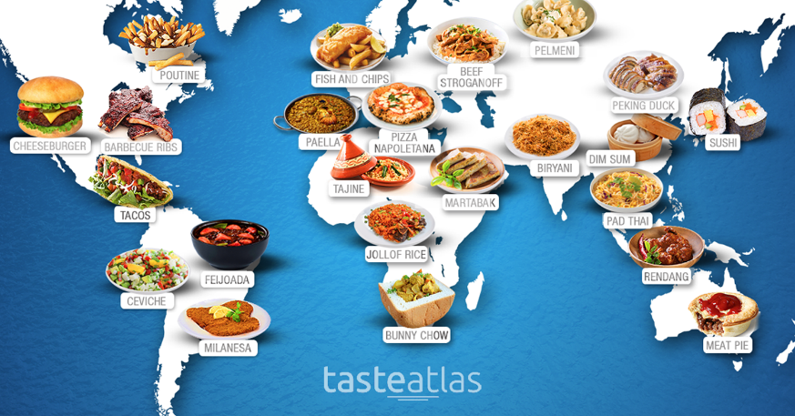

Exploring Gastronomy
Task 1
Describe what gastronomy is?
Task 2
Identify a country to investigate
Explore the food culture of the country
What influences the countries gastronomy with regards to the countries landscape, people and economics?
Task 3
Create a presentation either in word or PowerPoint to show your findings
Include examples of dishes, recipes, videos, information leaflets etc.

Note:
You must reference your work i.e. what book, journal, website etc
Do not just use one source of information, research several to get a more informative view.
Please note there is no minimum amount of words required and it can be hand-written if preferred.
Please bring your completed work to College on the first day of term to be marked.
If you have any questions, please contact me on l.unwin@sheffcol.ac.uk
Kind regards,
Catering and Hospitality at The Sheffield College

