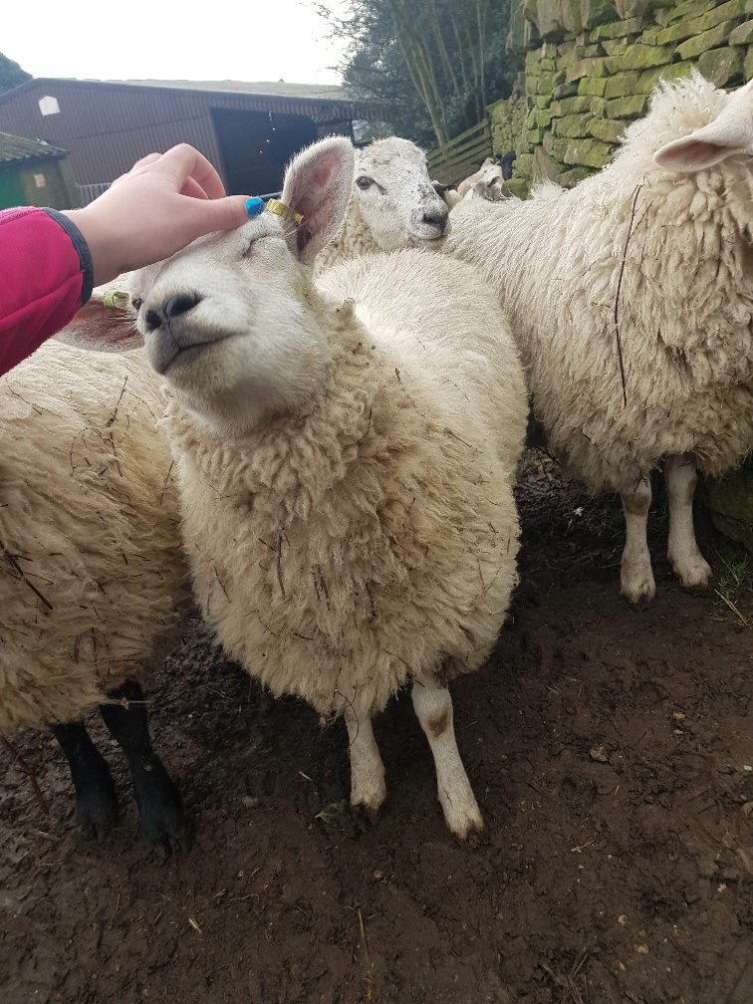

Name:

Date:

Level 3 Animal Management Workbook

  - 2020

Be Honest

03

Be Committed

02

Be Ready

Be Ready
This workbook is to give you an idea of some of the activities you may be given during your time studying with us. Use this workbook to prepare yourself for the start of your college course. Please bring it with you on your first day in Animal Management so we can see your progress.

Be Committed
Within the Level 3 course, the theoretical study makes up about 70% of the course. You will be required to complete many forms of activities, assessments and even exams! Upon completion of this workbook you will be showing us your dedication to the subject, but also really showing if you will love this career!

Be Honest
Try and get into the practice of answering using your existing knowledge for as much of the workbook as you can! You can then go back and research the areas you were not sure of.
Try using two different coloured pens. Demonstrate your existing knowledge in one colour and then where required use a different colour to show answers you have researched.
This can then even be kept and used as revision material when you are completing assignments or preparing for your exams.

Introduction
  - Level 3 Animal Management

01

Ready for the Qualification
The Level 3 qualification is split into two separate years. Upon completion of the first year, you will obtain a BTEC Level 3 Foundation Diploma in Animal Management. You can use this to progress into some jobs, Apprenticeships or university level courses. If you wish to progress onto the second year of study, you will be reviewed on your performance, attendance and other qualities by the course leader and other staff members. When you have completed the second year of the course you will have achieved a BTEC Level 3 Extended Diploma in Animal Management. This then opens up opportunities for you to progress onto university level courses or into a career.

Commitments on the Course
When you are a student on the course you have made a commitment to attend, engage and progress. You will be required to attend Whirlow Hall Farm for which you will need steel toe capped wellies, waterproof gear and not to forget gloves! Another commitment you will have is to attend a work placement. The best policy for this is to attend a placement one day a week when you are not in lectures. Please start considering now where you would like your placement to be and what animals you would like to work with. Remember, this should link to the career you want so some research may be required.
Stick to the timetable you will be given upon starting the course. Make sure you are always on time and ready to learn. Think about the stationary you will need, such as pens, pencils, ruler, highlighters etc. A vital piece of equipment is a memory stick, you will need it for working in and out of college.

Honesty is the best policy
While you are a student with us we ask you to always be honest with us! If there is a reason you are going to be late or not attend for a day then give an honest reason. You will have to provide evidence where possible to explain any absence.
If there is a problem at any time we are always here to help but we do not know if there is a problem if you do not tell us!
Plagiarism is the deliberate copying of anyone else’s work and passing it off as your own. This will not be accepted at any time on the course. All the work you submit will be yours and not copied or pasted, or just copied from someone else!

Be Ready

01

Be Honest

03

Be Committed

02

Course Guide
  - Level 3 Animal Management

Label the Dog Skeleton
Use the labels below and place them where you think they are on this dog skeleton diagram.
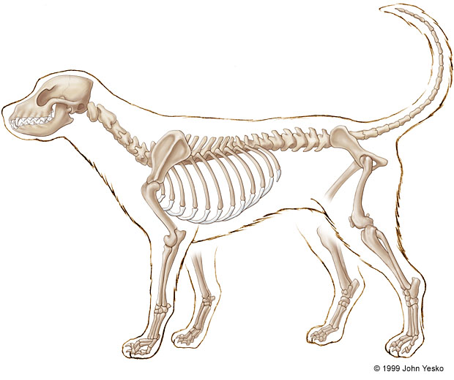
Skull Scapula Orbit Phalange Metacarpus Maxilla Mandible Humerus Ulna Carpus Radius Fibula Ribs Metatarsus Tibia Pelvis Femur Tarsus Sacrum Cervical Vertebrae Caudal Vertebrae Thoracic Vertebrae Lumbar Vertebrae Phalange
Skeleton Adaptations
Think about the dog skeleton you have just labelled. Look at the two skeletons below and answer the following questions.
How is this skeleton different from the dog skeleton you can see on the previous page?
Answer:
How do these adaptations benefit this animal to function?
Answer:

What animal is this?.........................................................
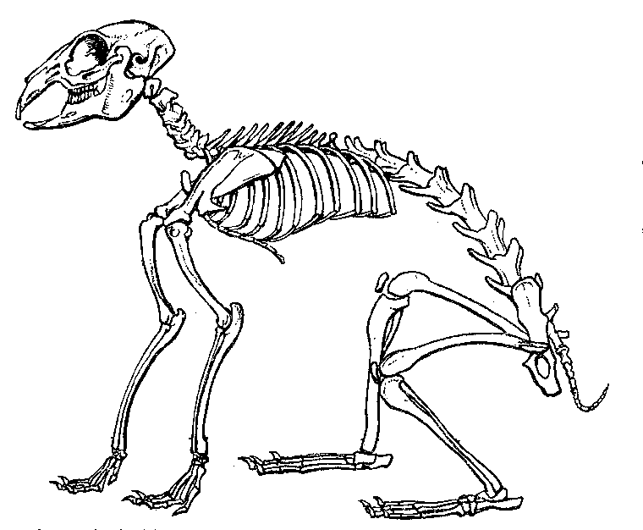

How is this skeleton different from the dog skeleton on the previous page?
Answer:
How do these adaptations benefit this animal to function?

Answer:

What animal is this?.........................................................
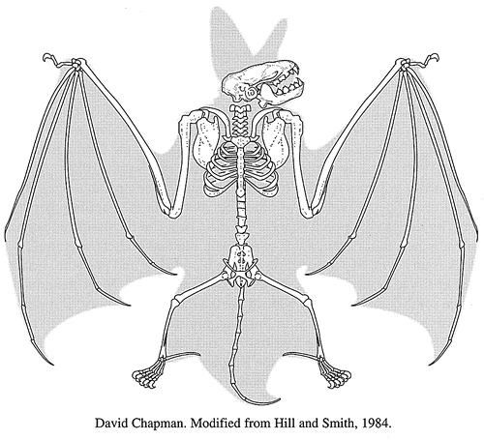
Extension: Try and label the two skeletons, using the dog skeleton labels

Tissue Types
In the areas below write a description of the structure and function for each type of tissue.
Tissue | Structure (shape/size etc.) | Function (what it does)
Simple epithelial

Stratified epithelial

Loose connective

Dense irregular connective

Bone

Adipose

Smooth muscle

Skeletal muscle

Cardiac muscle

Nervous

Joint Types
Complete the descriptions for the structure and function of the types of joint. Then label an example of each on the horse skeleton.
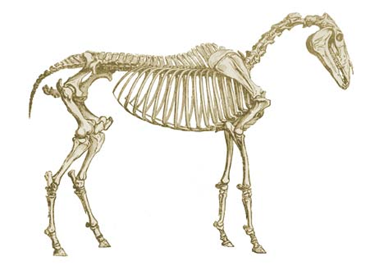

Types of joint | Structure (shape/tissue type etc.) | Function (what it does)
Fibrous

Cartilaginous

Pivot

Ball & socket

Hinge

Gliding

Essential Nutrients
You have been given the essential nutrients for animal diets, answer the sections below.
Nutrient | Function in the diet | 2 sources in an animal diet
Carbohydrates
Fats
Fibre
Protein
Vitamins
Minerals
Water

Personal Analysis (Part 1)
Time for a little reflection about yourself. Tick the boxes below, BE HONEST. Reflection is really important throughout your course and your career to help you achieve goals.
It will also help us guide you in gaining a work placement.

Does this apply to you? | Agree strongly | Agree slightly | Neither agree  nor disagree | Disagree slightly | Disagree strongly
Good communication skills

Good at IT skills

Good
numeracy skills

Good at working with other people
Enjoys
working outdoors
Always punctual

Always has 100% attendance
Reliable

Remains
calm in a crisis
Good at working independently
Good at working in a group/team

Personal Analysis (Part 2)
Answer the boxes below thinking about the Level 3 Animal Management Course and all that will be involved.
You can use the tick boxes on part 1 to get you started.
Strengths  What are you good at that you can use on the course?  What skills do you have, how will these help? | Weaknesses  What weaknesses do you have, what would you like to improve?  Any skills you think you will need that you do not currently have?
Opportunities  What opportunities do you think the course will give you?  How will a work placement help you?  How will the course increase your chances of employment within the sector? | Threats  Any concerns about the course?  Any concerns about getting to college?  Anything else you can think of that might make the course difficult for you to complete?  e.g. family commitments, work commitments, transport difficulties, health

Possible Career Idea
Even though you have not started the course yet, it is important to have an idea about the careers where this course could take you. Pick 1 animal career and display the answers below, using the box to guide you.
It must show the following:
A brief overview of the job (what is involved)
Qualifications needed (starting at GCSE, including courses needed)
Skills required
Experience required (do you need so many hours of work experience, voluntary work, etc.)
Requirements (driving license, own car, fitness level, flexibility etc.)

Career Chosen: ………………………………………………………………………………………………………………………

Work Experience
Have a think about the sort of work experience placements you might want to apply for.
What type of employer? What type of job role?

First possible job role/type of employer:

What sort of tasks would you do each day in this job?

Why do you want to try this kind of work?

Why would this type of work particularly suit you? What are your strengths for this type of work?

Are there any drawbacks, or any ways in which you feel it could be difficult for you to do this work?

Second possible job role/type of employer:

What sort of tasks would you do each day in this job?

Why do you want to try this kind of work?

Why would this type of work particularly suit you? What are your strengths for this type of work?

Are there any drawbacks, or any ways in which you feel it could be difficult for you to do this work?

Parasites
When working with animals you will come across a variety of parasites.
Identify the two most common shown below. (These are not to scale)
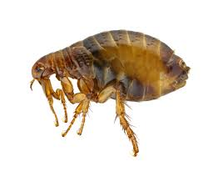

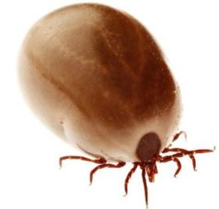

These above are both an example of Ectoparasites. Give a definition of the following:

ECTOPARASITE:

ENDOPARASITE:

Give an example of an Endoparasite:

Temperature, Pulse and Respiration
You will learn how to monitor the health of animals and why this is important.
Have a go at the questions below

- The normal resting pulse rate range for a dog?
a) 40 – 80 beats per minute
b) 60 – 180 beats per minute
c) 80 – 120 beats per minute
d )100 – 120 beats per minute

- What is the normal body temperature range of a rabbit?
a) 36.6 – 37.1°C. (97.9 – 98.8°F)
b) 37 – 37.7°C. (98.6 – 99.9°F)
c) 37.8 – 38.2°C (100 – 100.8°F)
d) 38.5 – 40°C. (101.3 – 104°F)

- What is the normal body temperature range of a cat?
a) 38 – 38.5°C. (100.4 – 101.3°F)
b) 39 – 39.3°C. (102.2 –102.7°F)
c) 38.3 – 38.7°C. (100.9 –101.7°F)
d) 37 – 38.5°C. (98.6 –101.3°F)

- What is the normal body temperature range of a dog?
a. 38 – 38.5°C. (100.4 – 101.3°F)
b. 39 – 39.3°C. (102.2 –102.7°F)
c. 38.3 – 38.7°C. (100.9 –101.7°F)
d. 37 – 38.5°C. (98.6 –101.3°F

- CRT stands for?
- Cat refill Time
- Capillary Response Time
- Capillary Refill Time

- TPR is?
- Tachy Pulse Rate
- Temperature Pulse Respiration
- Tachy Pulse Respiration
- All of the above

- The normal resting pulse rate range for a cat is?
a) 60 – 140 beats per minute
b) 100 – 120 beats per minute
c) 110 – 180 beats per minute
d) 150 – 200 beats per minute.

- What is the normal respiration rate range in the dog?
a) 10 – 30 breaths per minute.
b) 20 – 30 breaths per minute.
c) 20 – 40 breaths per minute.
d) 50 – 60 breaths per minute.

- The normal resting pulse rate range for a rabbit is?
a) 100 – 120 beats per minute
b) 130 – 325 beats per minute
c) 190 – 250 beats per minute
d) 200 – 300 beats per minute.

- What is the normal respiration rate range in the cat?
a) 10 – 30 breaths per minute.
b) 20 – 30 breaths per minute.
c) 20 – 40 breaths per minute.
d) 50 – 60 breaths per minute.

14. What is the normal respiration rate range in the rabbit?
a) 10 – 30 breaths per minute.
b) 20 – 160 breaths per minute.
c) 30 – 60 breaths per minute.
d) 40 – 180 breaths per minute.

REMEMBER: TRY AND IT GIVE IT A GO FIRST IN ONE COLOUR AND THEN LOOK UP THE ANSWERS AFTER.
You can circle the correct answers in a different colour to see how well you did.

Animal Cell
Draw and label an animal cell using the labels provided.
Under each label provide a function (what it does)

Cell membrane Nucleus Cytoplasm Nucleolus Golgi apparatus

Smooth endoplasmic reticulum Rough endoplasmic reticulum Lysosome Ribosomes

Mitochondria Centriole Nuclear membrane

Scientific Names
In your coursework at Level 3 you will be required to use the scientific names of that animal alongside the common name. Please research and fill in the answers below.
TIPS: A scientific name, (or Latin name), is always at least 2 words.
The first letter is always a capital
When written on a computer it should be in italics.

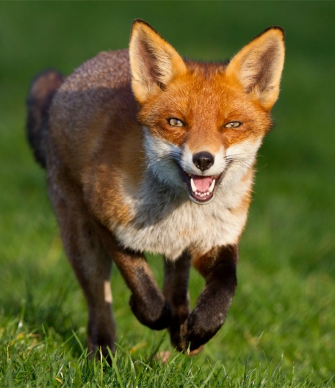
COMMON NAME;
Fox

SCIENTIFIC NAME:
Vulpes vulpes

(Not all scientific names have two repeated words)
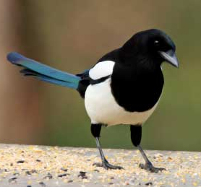
COMMON NAME;

SCIENTIFIC NAME:

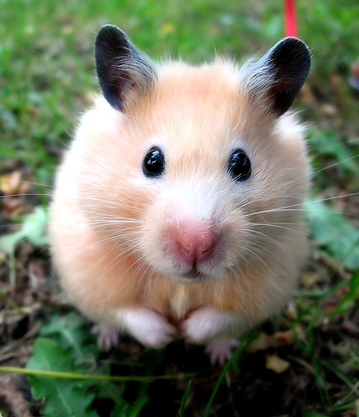
COMMON NAME;

SCIENTIFIC NAME:

COMMON NAME;

SCIENTIFIC NAME:

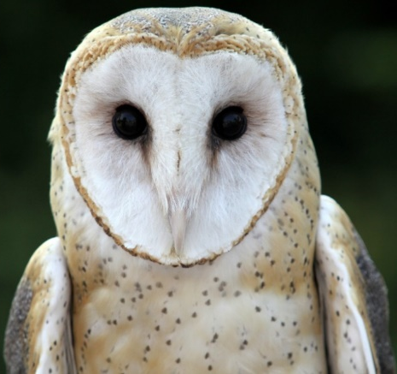

COMMON NAME;

SCIENTIFIC NAME:

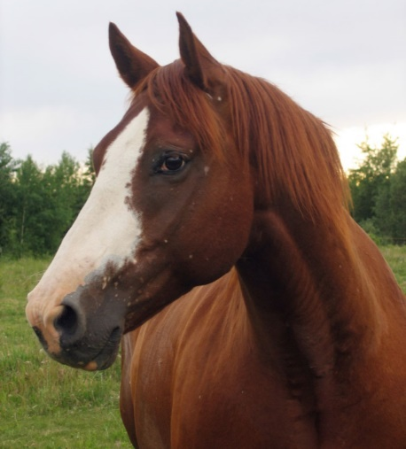
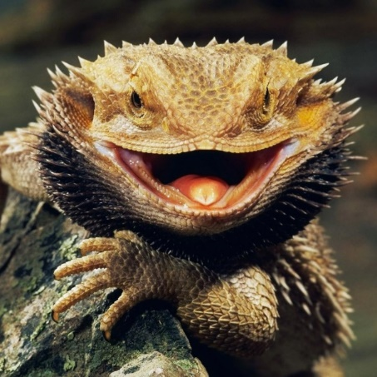
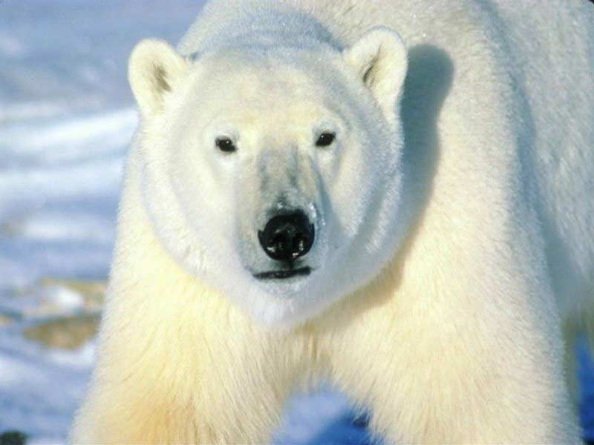
COMMON NAME;

SCIENTIFIC NAME:

COMMON NAME;

SCIENTIFIC NAME:

