Travel & Tourism
NCFE Level 2

Dear applicant,
As part of the Induction process for Travel and Tourism, there is some preparatory work that you will need to complete before you start. This work will give you a feel for the type of tasks you will be doing throughout the course and help you make the best possible start to your studies. This will be your first piece of college coursework so doing your best will allow us to assess your abilities early on.

Visitor Attractions

Visitor attractions are the main reason tourists visit destinations. They can be built, like theme parks and museums, or natural, like beaches and country parks.
If they are purpose built it means they are built solely for the purpose of leisure and tourism. This would not include castles, monuments and stately homes as these were not originally built to attract tourists.
A visitor attraction must be open to the public, without prior booking for published periods each year and should be capable of attracting day visitors as well as local residents.
(Visit Britain 2019)

Task:
Make a poster to show seven purpose built visitor attractions in the UK. Name each attraction and put in an image of it. Describe and explain what it is in no more than three sentences per attraction. This can be done using the internet or by cutting pictures from magazines/newspapers.
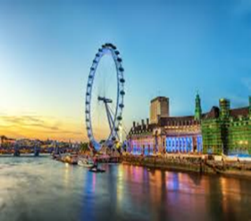
Example: The London Eye
The London Eye is a purpose built observation wheel on the South Bank of the Thames in London. It is the tallest observation wheel in Europe. The London Eye attracts over three million visitors per year.

Best Regards,
Travel & Tourism Team

