Travel & Tourism
Btec Level 3

Dear applicant,
As part of the Induction process within Travel and Tourism, and to help you make the best possible start to your studies at Sheffield City College, we have put together some preparatory work that you will need to complete before you start. This work will enable you to get a feel for the type of tasks you will be undertaking throughout the course. It is important to note that this will be your first piece of college coursework so doing your best will allow us to assess your capabilities early on.

Customer Service
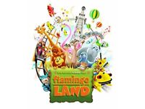
Select an organisation/company related to travel and tourism, preferably one that you have experienced. This could be an airline, a tour operator, a visitor attraction/theme park, a hotel or apartment, a holiday centre, etc…

Imagine you explaining to a new member of staff how the organisation provides excellent customer service in each of the following categories:
- First impressions
- Speed and accuracy of service
- Products and services offered
- Offering information and advice
- Dealing with complaints & problems
If the organisation failed to provide excellent customer service suggest three possible consequences of this.
Present your work as a word document of between 250-500 words. If you prefer to handwrite it, make sure your writing is clear, neat and legible, and remember to include your name.
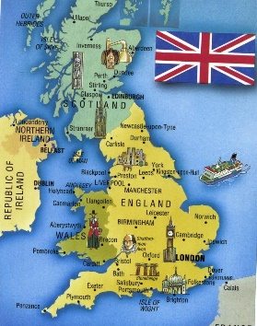
UK Destinations
Research three tourism areas in the UK and provide your findings for each of the following:

1 The Peak District National Park
2 The city of Bath
3 The coastal resort of Newquay

The areas of research are highlighted in Bold and you should provide information for each section. Examples provided in some instances.

Describe the location and accessibility
Where is it in the country?
How accessible is it /what transport links be used? Provide examples of road links, ferry routes and airports where applicable
Describe which type of visitor would be most likely to use which transport, e.g a student with not much money may travel there by coach where as a family with young children might take their car so that they can pack lots of luggage.

Natural features
Not man made eg sea coast, rivers, caves, beaches, forests, natural lakes
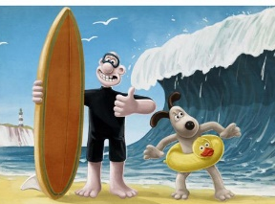
Provide examples where they are applicable
For example, Newquay has a wide array of beaches – one type of activity available is surfing. Most natural features are free but activities on or in the destination may have a cost such as a boat trip on a river.

Built attractions
Make sure you differentiate for example Chatsworth House in the Peaks was originally built as a private residence but now it is a popular visitor attraction.
An example in the Peaks would be Hathersage outdoor swimming pool; this has been built as an attraction.

General Tourism and Locational Geography

As well as the set tasks above it will be a good idea if you use some time that you have prior to September to become familiar with the Travel and Tourism sector, and to try and learn about different destinations and where they are located.
There are many websites and quizzes online but the following links are to a website called Lizard Point that contains lots of interactive, clickable, geography quizzes. To start with, we recommend that you check out the following:

World Continents  https://lizardpoint.com/geography/world-quiz.php | World Countries (30 most populated)  https://lizardpoint.com/geography/world-countries-magnifier-quiz.php?qid=1844
European Countries  https://lizardpoint.com/geography/europe-quiz.php | UK Cities  https://lizardpoint.com/geography/uk-cities-quiz.php
These will help your progress in 3 separate units of the course.
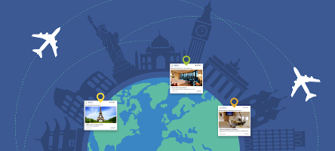
Also, try to do some general reading (and watching), of articles and clips relating to tourism and travelling. You could look out for mentions of travel companies, job roles, destinations etc…
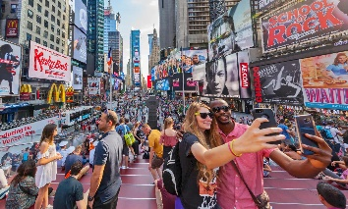
If you see an amazing picture of a place or hotel on social media, do a little extra research about it.

Best Regards,
Travel & Tourism Team

