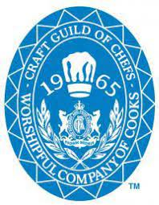
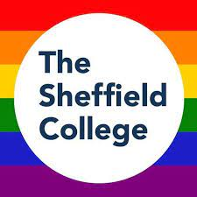

All our coffees are made using Fairtrade Altura Arabica beans supplied by local company Cafeology.
Single Espresso | £1.95
Double Espresso | £2.10
Macchiato | £1.95
Americano | £2.10
Cappuccino | £2.30
Latte | £2.30
Cafeology Hot Chocolate | £2.00
Cafeology Mocha | £2.00
Speciality Tea Menu
Why not try one of our Ridgways speciality teas?
We have got a tea range to tickle your taste buds at just £1.80 per pot for normal tea & £2 for speciality teas.
English Breakfast

Earl Grey
Chai
Darjeeling
Assam
Citrus/Red Berries
Peppermint/Rooibos
Green Tea
Coffee

1
Stuffed breast of lamb Epigram served with celeriac remoulade
Grilled Thai prawns with nam prik num dressing
Homemade linguine with a lemon, dill & cream sauce
Soup of the day

Two courses for £13
Three courses for £16

Starters.

Five spiced duck breast, basmati rice & baby bok choi
Baked salmon with puy lentils & beetroot, grain mustard & honey sauce
Paneer mater with basmati rice
Please ask for the special main course of the day

Mains.
Tea
Chocolate brownie with salted caramel & popcorn ice cream
Lemon tart, Chantilly cream
Baked Alaska

If you have a food allergy please inform a member of the team or a manager, who will show you a full list of the allergens present in today’s menu.
Desserts.

