Meeting Notes

Meeting | Health and Safety Committee
Date of Meeting | 04 November 2021
Venue | TG04- City Campus (New Boardroom)

Present |  | Apologies
Adam Clark (AC) | John Bacon (JB)
Andrew Hartley (AH) | Lance Nortcliffe (LN)
Angela Bradley (AB) | Mark Thomason (MT)
Angela Foulkes (AF)- Chair | Rosheen Hodgkiss Bernard (RHB)
Beth Smith (BS)- Meeting Notes | Saleem Rashid (SR)
James Smythe (JS) | Shaun Cook (SC)
Jo Hardy (JH) | Stewart Alexander (SA)

Agenda Items
- Apologies for Absence and Introductions | 6. Health & Safety Policy
2. Draft meeting notes from the meeting of the H&S Committee held on 10 June 2021 | 7. Health & Safety report  - Legislation update  - Fire  - Fire Risk Assessment  - Fire Strategy  - Fire Evacuations  - First Aid  - Incident reporting  - Establishment of H&S Working Groups  - Other issues for consideration by the Committee
- Action tracker log update | 8. Any other business
4. COVID-19 update:  - Positive Case numbers and monitoring update  - Risk Assessment  - Other | 9. Date and time of next meeting:
5. Health & Safety KPI 2021/22 performance

Meeting Notes | Action Owner | Action Tracker Log Ref
- Apologies

1:1: No apologies have been received.

- Draft meeting notes from the previous meeting:

2:1: The draft meeting notes from the meeting of the H&S Committee held on 10 June 2021 were checked page by page for accuracy and subsequently approved by the committee.

- Action Tracker Log Update:

3.1: The Committee reviewed the latest version of the action tracker log and updates were provided as necessary.

- COVID-19 Update  John Bacon, Head of Health Safety & Business Continuity, presented to the committee.  - Positive Case Numbers and Monitoring Update  The number of new COVID-19 cases is slightly rising in line with the reporting of cases nationally. It was noted there has been a small increase in the number of COVID cases from September 2021 as the national data also shows. The current data is as follows:  - Risk assessment  The Committee had been provided with a copy of the latest snapshot of the COVID-19 Risk Assessment, taken on 28th October 2021, covering the College and Nurseries. AF asked members if they had any comments or questions in relation to the risk assessment.  AC raised the question as to why we have stopped reporting staff COVID cases on the all staff email. AF to liaise with Holly Anderson about considering communicating data to all staff this term at an appropriate point.  - Other  Lateral Flow Testing – students and staff are being strongly encouraged to home test in line with Government guidance.  Face coverings- AC- raised a concern about cleaning. Action- SA to raise with team.  COVID communication to include a reminder to clean as you go. All staff email to include estates email and the correct reporting procedure.  SR- Asked for guidance for a student showing symptoms. JB clarified that guidance has not changed. Question was passed to JS, Duty Manager to be called and info sent to Health and Safety. | AF  SA  JB | ASAP  ASAP
- Health & Safety KPI 2021/22 Performance  5:1: The Committee were provided with the following visual update on the Health and Safety KPI performance for the period August 2018 to October 2021.  JB and his team to complete more analysis and report back to the committee.  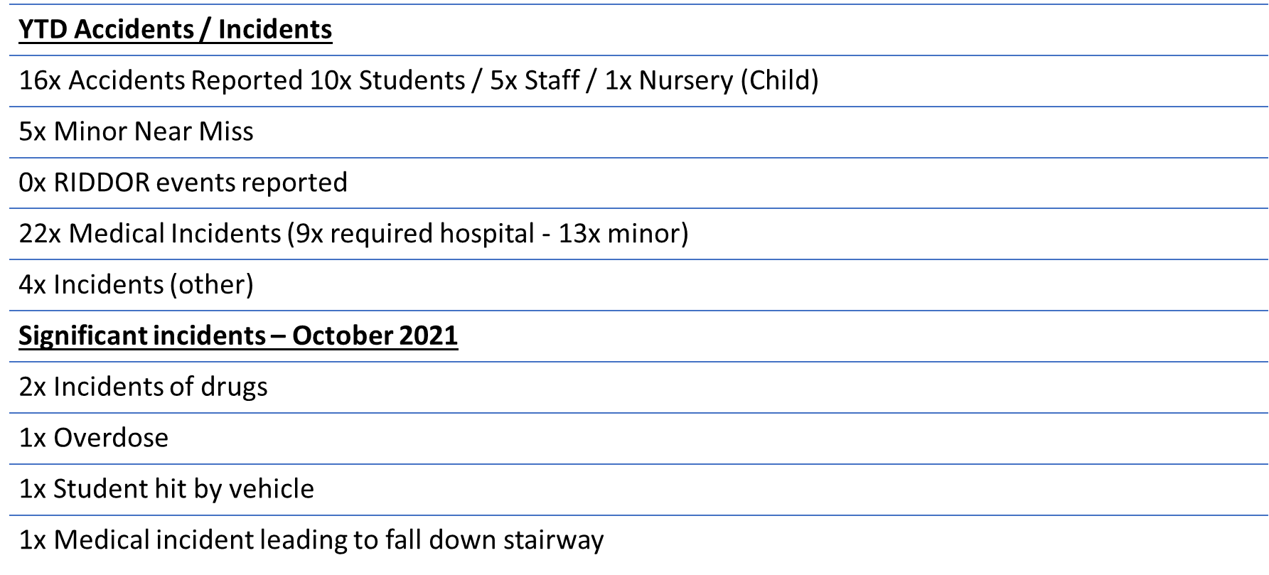  5:2: The Committee were also provided with a visual update of the Health and Safety KPI performance for the year to date period of August 2021 to October 2021.  5:3: JB presented to the Committee the Causational Analysis His findings include:  - Policy responsibilities not concise  - Failure to communicate change in policy  - Training requirements not clear  - No measuring or monitoring  - Human error  RHB commented that her team are really pleased with the data provided and thinks this is a step in the right direction. | JB | Next meeting
- Health & Safety Policy

6:1: The Committee were provided with the updated draft Health and Safety Policy for October 2021.

JB noted the main changes are as follows:

- Introduction of Health and Safety Operations/Working Groups.
- Additional paragraph on infectious diseases included in the policy statement
- New Role and Job titles amended
  - People Development Manager / Head of People Experience
  - New Role added Health and Welfare Officer
  - New Role added Senior Health and Safety Adviser

AF stated the Exec team are recommending approval to the Governing Body and this will be discussed on 24th November at the Governing Body Meeting. AF reported that the ELT anticipated that the policy would be approved.

- Health & Safety Report  - Legislation Update  JB reported there is no legal updates from HSE. Just priorities over the next 3-5 years. The main priorities detailed in the update are:  - emphasising ill health, with a focus on  - work-related respiratory diseases  - musculoskeletal disorders  - work-related stress  - promoting proportionate approaches, to ensure effective application of risk-based regulations.  - investing in the science and capability that allows us to respond to the future world of work.  - Fire  - Fire Risk Assessment  On the recommendation of the former Head of Health & Safety and Business Continuity, the College commissioned an external consultant to undertake a fire risk assessment of the college sites.  AH reported we are currently at medium risk status and the intention is to get to low. An independent consultant is to undertake an assessment, this will be in the final quarter of the term.  - Fire Strategy  SA briefed the Committee on where his team is. SA has commissioned reports on fire strategy for City and Hillsborough. SA to go to another company for Olive Grove and Peaks due to time constraints.  - Fire Evacuations  JB reported that his team are currently assessing availability of fire wardens as hybrid working has impacted on this.  JB also reported that a Fire drill is planned for this month. JB will let kitchens know when fire drills will be.  c. First Aid  JB reported the Health and Welfare Officer commenced 1st November and is settling in well into the new role. He also updated on the following:  - Certificated First Aiders being reviewed (departments/availability)  - Risk assessment being completed – to assess numbers /requirements based on risk profile  - Duty first aid- communal areas/to support departments  AC reported there is some unrest with staff about not being able to get hold of reception or duty staff.  d. Incident Reporting  LN raised the question as to whose responsibility it is to ring the ambulance. JB said it must be the first aider. JS to pick up a conversation with reception regarding first aid responsibilities.  e. Establishment of H&S Working Groups  f. Other issues for consideration by the Committee | JS
- Any other business  8:1: RHB reported that there have been 3 reports of injection spiking in clubs in Sheffield in the last week as well as drink spiking. The committee agreed that it is something we need to educate staff and students on. JS is to have conversation with RHB to plan for tutorials. | JS/RHB
- Date and time of next meeting

9:1: The next meeting will be held on 31st March 2022 in TG04- City Campus (New Boardroom) at 15:00pm- 16:30pm

